
East Texas A&M University
Department of Engineering and Technology

Electrical Engineering Program

Fall 2025 - Spring 2026

Senior Design Project Report

UAV Tracking System for Azimuth, Elevation, Range Estimation for Indoor/Outdoor Application

In partial fulfillment of the requirements for the
Degree of Bachelor of Science in Electrical Engineering

Team Members
Student Name | Student ID
Logan Boxdorfer | 50309021
Alden Edwards | 50319819
Brandon Lewis | 50309642
Parker Reeves | 50307495
Colton Vandenburg | 50276539

Project Advisors:
Advisor Name: Dr. Nizar Tayem
Co-Advisor Name: Dr. Redha M. Radaydeh

Abstract
This project presents the study and implementation of the UAV Tracking System for Azimuth, Elevation, Range Estimation for Indoor/Outdoor Application. Direction-of-Arrival (DoA) estimation is a key component of RF localization systems; however, performance is highly dependent on array geometry, environmental conditions, and algorithm selection. This research presents a hybrid antenna array system designed to estimate the azimuth, elevation, and range of a moving RF source using subspace-based DoA techniques. The system combines a vertical uniform linear array with either a circular or horizontal linear array configuration and processes received signals using the MUSIC and ESPRIT algorithms implemented on the FMComms5/Zynq software-defined radio (SDR) platform.
By separating the antenna geometry into orthogonal array structures, the system reduces the two-dimensional DoA estimation problem into two independent one-dimensional estimations for azimuth and elevation. This approach significantly reduces computational complexity and enables more efficient real-time processing. System performance was evaluated through Monte Carlo simulations as well as experimental testing with both static and moving RF sources. Results demonstrate that array geometry significantly influences estimation accuracy and snapshot requirements, while both algorithms provide stable DoA estimates under realistic indoor conditions. These findings highlight the practical advantages and limitations of hybrid antenna array configurations for real-time RF localization.

Keywords— Direction-of-Arrival (DoA), Azimuth, Elevation, Localization, Uniform Linear Array (ULA), Uniform Circular Array (UCA)

Table of Contents
Abstract 2
1. Introduction 4
1.1 Project Definition 4
1.2 Project Objectives & Deliverables 4
1.3 Project Specifications & Constraints 5
1.4 Project Architecture and Components 5
1.5 Application 9
2. Literature Review 10
2.1 Direction-of-Arrival Techniques 10
2.2 Antenna Array Geometries 13
2.3 Real-Time DoA Constraints 15
2.4 Previous Work 15
2.5 Comparative Study 16
2.6 Research Contribution 20
3. System Design 21
3.1 Design Constraints 21
3.2 Design Methodology 22
3.3 Subsystems and Components 22
3.4 Full System Implementation 25
4. System Testing and Analysis 29
4.1 Transmit Subsystem (Brian) 29
4.2 Reciver SubSystem (Brian) 30
4.3 Overall Results, Analysis and Discussion (Brian) 31
5. Project Management 39
5.1 Project Plan (Casey) 39
5.2 Contribution of Team Members (Casey) 41
5.3 Project Execution Monitoring (Casey) 41
5.4 Challenges and Decision Making (Casey) 42
5.5 Project Bill of Materials and Budget (Cameron) 42
6. Project Analysis 43
6.1 Life-long Learning (Casey) 43
6.2 Impact of Engineering Solutions (Brian) 44
6.3 Contemporary Issues Addressed (Cameron) 45
7. Conclusions and Future Recommendations 46
7.1 Conclusions (Cameron) 46
7.2 Future Recommendations (Ernesto) 47
8. References (Ernesto) 49
Appendix A: Progress Reports (Casey) 50
Appendix B: Bill of Materials (Cameron) 55
Appendix C: Datasheets (Ernesto) 56
Appendix D: Program Codes (Brian) 57
Appendix E: Operation Manual (Cameron) 58
Appendix F: Poster and brochure (Cameron) 63

Introduction

1.1 Project Definition
The purpose of this project is to design, implement, and compare a hybrid real-time radio frequency (RF) localization system capable of estimating the Direction-of-Arrival (DoA) of a single moving source. The system combines subspace-based signal processing algorithms with multiple antenna array geometries and a LiDAR-based range finding subsystem. By performing angular estimation in both the azimuth and elevation planes and integrating these results with range measurements, the system achieves full spatial localization of the RF emitter.
This scope expands beyond traditional single-plane DoA estimation by integrating a vertical Uniform Linear Array (ULA) with either a horizontal ULA or a Uniform Circular Array (UCA). By leveraging advanced signal processing algorithms across these array configurations, the system is able to perform accurate angular estimation and determine the RF source position.
This work includes both simulation and real-time implementation, enabling direct comparison of algorithm performance and array geometry. These comparisons provide insight into optimal system configurations under varying signal conditions and practical deployment constraints.

1.2 Project Objectives & Deliverables
The primary objective of this project is to develop an RF localization system capable of estimating the azimuth, elevation, and range of a single moving source. Angular localization (azimuth and elevation) is achieved through DoA estimation techniques, while range information is obtained using a LiDAR-based ranging system. The estimated angular coordinates are used to mechanically steer a pan-and-tilt LiDAR apparatus, enabling full localization in spherical coordinates (φ, θ, r).
To achieve this, multiple antenna array geometries—including ULA/UCA and ULA/ULA configurations—are implemented and evaluated for their effectiveness in two-dimensional DoA estimation. In addition to hardware configuration comparisons, multiple subspace-based estimation algorithms are investigated, including Multiple Signal Classification (MUSIC) and Estimation of Signal Parameters via Rotational Invariance Techniques (ESPRIT). Performance is assessed under consistent indoor testing conditions using a single 2.4 GHz RF source.
Quantitative evaluation metrics include mean angular error, and the standard deviation of azimuth and elevation estimates across both Monte Carlo simulations and experimental trials. These metrics are used to determine the most accurate and stable array–algorithm configuration for single-source localization. The overall goal is to identify a system architecture that provides reliable, low-variance angular estimation suitable for real-time implementation.

Table 1.2.1 – Summary of Team Objectives Across Hardware, Software, and Professional Domains
HARDWARE | SOFTWARE | PROFESSIONAL
- Establish reliable interfacing with the FMComms5/Zynq RF front-end.  - Implement a hybrid vertical ULA/UCA antenna configuration.  - Implement a hybrid vertical ULA/horizontal ULA antenna configuration.  - Design and develop the LiDAR pan-and-tilt subsystem. | - Implement MUSIC for ULA and UCA array geometries.  - Implement ESPRIT for ULA-based estimation  - Fuse LiDAR range data with RF-based DoA estimates.  - Support simulation-mode operation for demo scripts. | - Fully document design and implementation of system.  - Maintain effective team collaboration and task allocation.  - Publication of experimental results and presentation in the AFRL University Design Challenge.

While completing this project, several deliverables are required to demonstrate successful system development and validation. The primary deliverable is a functioning real-time RF localization system that meets the performance parameters outlined in the project proposal. The final system demonstration will display azimuth and elevation direction-of-arrival (DoA) estimates produced by the antenna array processing chain while operating on the full competition hardware stack. When integrated, the system will also incorporate LiDAR-based ranging controlled by the DoA estimation results, enabling full spatial localization of the RF emitter in the form of azimuth, elevation, and range (ϕⓜ,θⓜ,r) within the defined test environment.
Throughout the duration of the project, progress will be documented through periodic design reports and presentations that demonstrate development milestones, testing procedures, and system integration progress. These reports provide verification that project goals are being met and allow for evaluation of both the design methodology and implementation results.
Additional deliverables include documented software and hardware support packages to ensure the reproducibility of experimental results. These materials consist of MATLAB simulation and processing scripts, antenna array CAD drawings, system configuration files, experimental datasets, and setup instructions describing required dependencies and operating procedures. A formal testing procedure will also be provided outlining the experimental configuration, calibration steps, parameter settings, and evaluation metrics used to assess system performance. Supporting documentation will be included within this report or provided as supplemental appendices for further reference.

1.3 Project Specifications & Constraints
The project will involve the design and testing of various subsystems. Each subsystem will perform to the following target specifications:
- The operational frequency of the system is designed to be a narrowband 2.4GHz continuous wave, this was selected because that is the frequency most drones operate at.
- Phase synchronization of the system will be completed using the FMComms5 AD9361 on-board multi-chip sync.
- Algorithms should process the received signals and perform the DoA estimation in less than 1 second per snapshot.
- The UCA should achieve azimuth estimation in 360º with accuracy of ±5 degrees of the actual source location.
- The horizontal ULA should achieve azimuth estimation in 180º with accuracy of ±3 degrees of the actual source location.
- The vertical ULA should achieve elevation estimation in 90º with accuracy of ±3 degrees of the actual source location.
- The LiDAR should be directed by the azimuth/elevation estimations and perform range finding in less than 1 second per trial.
- When operating with the MUSIC algorithm, the system shall provide high-resolution DoA estimates with improved accuracy under high SNR and sufficient snapshot conditions.
- When operating with the ESPRIT algorithm, the system shall provide computationally efficient DoA estimates with reduced processing time.
- System should be able to operate effectively within noisy environments and resist noise when possible.
Along with those specifications the project is also limited in its setup and complexity; either because of hardware, software or testing environment:
- The FMComms5/Zynq configuration cannot be externally synced to each other, limiting the number of elements per antenna array is limited to 4.
- Environmental multipath when testing/presenting the active system will affect the overall performance no matter what.
- The UCA does not have enough elements to effectively use the ESPRIT algorithm and therefore will only use MUSIC.
- The project is on a limited timeline and budget which will constrain optimization and efficiency.

1.4 Project Architecture and Components
This project represents the integration of multiple subsystems that must operate cohesively to achieve accurate real-time RF localization. The system begins with an RF source transmitting a narrowband 2.4 GHz continuous wave signal, representative of common communication frequencies used by many commercial devices. This signal propagates through the environment and is received by a multi-array antenna configuration designed to enable full spatial DoA estimation. For elevation estimation, a vertical Uniform Linear Array (ULA) is utilized, while azimuth estimation is performed using either a Uniform Circular Array (UCA) or a horizontal ULA, depending on the configuration under evaluation. These array geometries are selected to compare performance trade-offs between full 360° azimuth coverage (UCA) and higher resolution over a limited angular span (ULA). Each antenna element captures the incoming signal with a phase offset corresponding to its spatial position, forming the basis for DoA estimation. All antenna elements are connected to the FMComms5/Zynq RF front-end using carefully length-matched coaxial cables to preserve relative phase information across channels, which is critical for accurate subspace-based processing. The FMComms5, which incorporates the AD9361 transceivers, performs coherent multi-channel reception and analog-to-digital conversion, ensuring that sampled data maintains phase alignment across all receive paths. This synchronized data is then streamed to a host PC for further processing.
On the host system, digital signal processing is performed in MATLAB, where covariance matrices are formed from the received data and processed using high-resolution subspace-based algorithms such as MUSIC and ESPRIT. These algorithms exploit the structure of the signal and noise subspaces to estimate the direction of arrival in both azimuth and elevation with high precision. The system is designed to produce these estimates within a near real-time timeframe, enabling dynamic tracking of a moving RF source. Once the angular estimates are obtained, they are used to control a pan-and-tilt servo mechanism that physically orients a LiDAR sensor toward the estimated source location. The LiDAR subsystem then performs range measurements, allowing the system to combine angular and distance information to achieve full spatial localization of the RF emitter. This hybrid approach enhances system capability by integrating RF-based angular estimation with optical range finding.
Figure 1.4.1 illustrates the complete system architecture, providing a comprehensive block diagram of the signal flow from RF transmission through reception, signal processing, and final localization output.
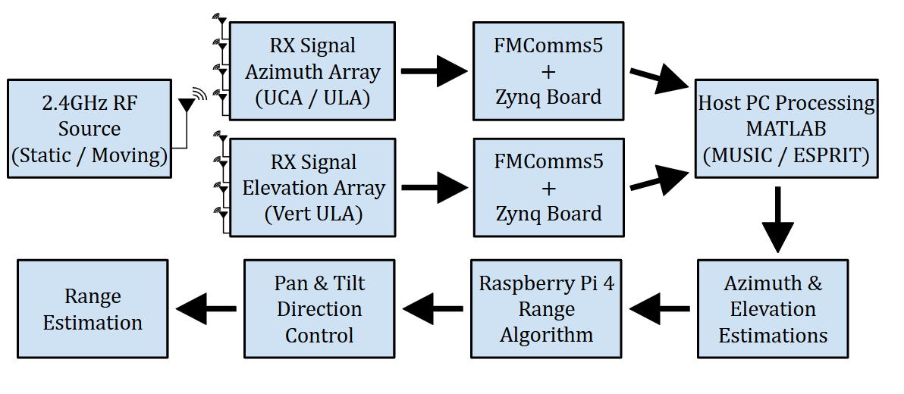
Figure 1.4.1 – Overall System Architecture for Hybrid RF Localization and LiDAR Integration

The RF front-end of the system is implemented using the Analog Devices FMComms5 platform, which integrates dual AD9361 transceivers to provide a flexible, high-performance software-defined radio solution. This board enables simultaneous multi-channel transmission and reception, making it well-suited for phased array and direction-of-arrival (DoA) applications. Each AD9361 device supports configurable gain control, frequency tuning, and bandwidth selection, allowing the system to operate at the desired 2.4 GHz narrowband frequency. In addition, the FMComms5 supports multi-chip synchronization, which is critical for maintaining phase coherence across all receive channels. This phase alignment ensures that the relative phase differences between antenna elements are preserved during digitization, a requirement for accurate subspace-based DoA estimation using algorithms such as MUSIC and ESPRIT. The digitized in-phase and quadrature (I/Q) data streams are then passed to the Zynq processing platform, where they are transferred to the host PC for further signal processing and localization.
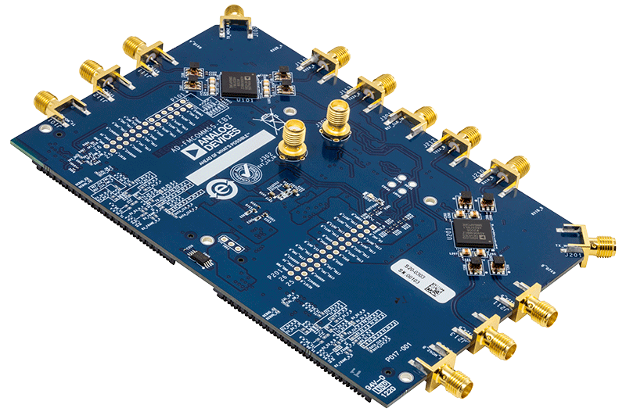
Figure 1.4.2 – Analog Devices FMComms5 Rf Transceiver

The processing backbone of the system is provided by the Xilinx Zynq System-on-Chip (SoC), which combines programmable logic (FPGA) with an embedded ARM processing system in a single platform. This heterogeneous architecture enables efficient handling of high-throughput data streams from the FMComms5 while maintaining flexibility for system control and data management. The FPGA fabric is responsible for interfacing with the RF transceivers, managing data buffering, and ensuring deterministic timing for multi-channel acquisition. This is particularly important for preserving synchronization across channels, as any timing misalignment would directly degrade phase-based DoA estimation accuracy. Meanwhile, the ARM processor facilitates communication with the host PC, handles configuration of the RF front-end, and manages data transfer protocols. By offloading low-level data handling and real-time interfacing tasks to the Zynq platform, the system ensures reliable acquisition of coherent I/Q samples, which are then transmitted to the host computer for computationally intensive signal processing using MATLAB-based MUSIC and ESPRIT algorithms.
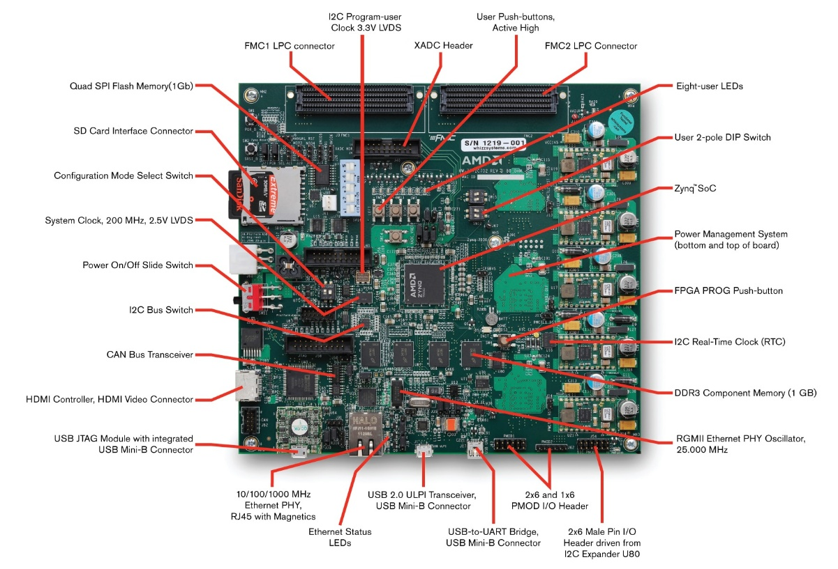
Figure 1.4.3 – Xilinx Zynq System-on-Chip (SoC) ZC702

Following the RF received front-end the host PC serves as the primary system for the digital signal processing. Once the digital data from the Zynq board is captured, the computationally intensive algorithms can be executed in real-time. In this system, MATLAB is utilized to process the received multi-channel data, form sample covariance matrices, and apply subspace-based direction-of-arrival (DoA) estimation techniques, including the MUSIC and ESPRIT algorithms. These methods require matrix decompositions and spectral searches, which benefit from the increased computational resources and flexibility of a general-purpose processor. Additionally, the host PC manages data visualization, real-time plotting of pseudo-spectra, and system diagnostics, allowing for rapid evaluation of system performance during both simulation and experimental testing. By centralizing advanced digital signal processing and analysis on the host PC, the system achieves a balance between real-time data acquisition and high-accuracy estimation, enabling robust and adaptable RF localization.
The range-finding subsystem is implemented using a TF-02 LiDAR sensor integrated with a pan-tilt mechanical assembly. While the RF subsystem provides angular estimates of the signal source, it does not inherently provide distance information. The TF-02 LiDAR addresses this limitation by performing time-of-flight measurements to determine the range to the target once the direction has been established. The pan-tilt mechanism is driven based on the estimated azimuth and elevation angles, allowing the LiDAR sensor to be physically oriented toward the RF source. This integration enables the system to achieve full spatial localization by combining angular and range measurements. Additionally, the dynamic control of the pan-tilt assembly introduces a feedback component to the system, where updated DoA estimates can continuously refine the pointing direction, improving overall localization accuracy in real-time operation.
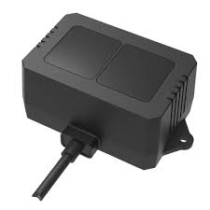
Figure 1.4.4 – Benewake TF-02 40m LiDAR

Due to indoor testing constraints and regulatory limitations associated with operating a drone-based RF emitter, an alternative signal source was required for system validation. As a result, the RF signal source for the system is generated using the NI B200-Mini USRP, which serves as a flexible software-defined radio transmitter. This device is configured to produce a continuous wave (CW) signal at 2.4 GHz, representing the target emitter to be localized. The use of a USRP platform allows for precise control over transmission parameters such as frequency, power level, and modulation, enabling both controlled testing and future expansion into more complex signal scenarios. By generating a stable and known RF source, the USRP provides a reliable reference for evaluating system performance under both static and dynamic conditions. Its programmability also allows for potential extension of the system to multiple emitters or modulated signals, making it a versatile component for both experimentation and validation of the DoA estimation algorithms.
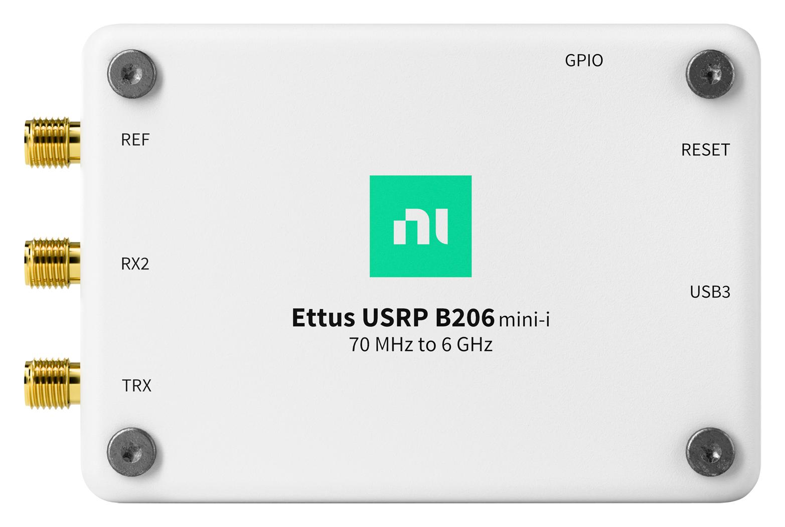
Figure 1.4.5 – NI Ettus USRP B200 Mini-i

1.5 Application
The system developed in this work demonstrates a practical and scalable approach to real-time RF source localization by combining DoA estimation with LiDAR-based range finding. A key design feature that elevates this system is the decomposition of the two-dimensional localization problem into two independent one-dimensional estimations—azimuth and elevation—through the use of orthogonal antenna array geometries. By structuring the system into modular components, overall computational complexity is reduced, enabling more robust and faster real-time performance.
This hybrid sensing architecture is highly applicable to a range of modern engineering challenges. In navigation and control, it enables autonomous platforms to localize signal sources and navigate dynamically. In surveillance and security, it provides rapid detection and tracking of unauthorized RF emitters. In defense applications, it supports situational awareness, signal intelligence, and counter-UAS operations. Together, these capabilities highlight the system’s versatility and demonstrate its potential for deployment across both civilian and military domains.

The proposed real-time DOA estimation system has a wide range of practical applications:

- Navigation and Control: Hybrid RF and LiDAR sensing systems are highly applicable to autonomous navigation and control in both aerial and ground-based platforms. Unmanned aerial systems (UAS), mobile robots, and distributed sensor networks can utilize real-time DoA estimation to determine the direction of signal sources while simultaneously using LiDAR for precise range measurement. This combination enables full spatial awareness, allowing systems to perform tasks such as target tracking, obstacle avoidance, and cooperative navigation. The ability to localize RF emitters in real time also supports applications such as beacon-based navigation and coordinated swarm behavior, where multiple platforms rely on shared signal sources for positioning and guidance.

- Surveillance and Security Systems: In surveillance and security operations, the system provides enhanced situational awareness through rapid and accurate localization of RF emitters. This capability is particularly valuable in applications such as airspace monitoring, perimeter security, and unauthorized signal detection. For example, the system can be used in counter-UAS operations to detect and track drone communication signals, enabling early identification of potential threats. Additionally, the integration of angular and range estimation allows for precise target localization, which is critical for monitoring restricted areas and protecting critical infrastructure. The real-time nature of the system ensures timely response and decision-making in dynamic environments.

- Military and Defense Systems: The proposed system directly aligns with modern defense requirements for low-cost, adaptable sensing solutions. RF localization systems are widely used in electronic warfare, signal intelligence (SIGINT), and battlefield awareness. By combining DoA estimation with LiDAR-based ranging, this system enables rapid geolocation of emitters, which can support threat detection, targeting, and tracking operations. Furthermore, the modular and software-defined nature of the system allows for adaptability across different frequency bands and signal types, making it suitable for evolving operational scenarios. Its ability to operate in real time and under dynamic conditions highlights its potential for deployment in both tactical and strategic defense environments.

2. Literature Review

2.1 Direction-of-Arrival Techniques
Direction-of-Arrival (DoA) estimation techniques can generally be classified into two primary categories: conventional (beamforming-based) methods and subspace-based methods. Conventional approaches, such as classical beamforming and Capon’s method, estimate the signal direction by scanning the spatial spectrum and identifying peaks corresponding to the angle of arrival. While these methods are computationally simpler and robust to certain modeling errors, they are often limited in angular resolution and performance under low signal-to-noise ratio (SNR) conditions. In contrast, subspace-based techniques exploit the underlying structure of the received signal covariance matrix to separate the signal and noise subspaces. Methods such as MUSIC (Multiple Signal Classification) and ESPRIT (Estimation of Signal Parameters via Rotational Invariance Techniques) achieve significantly higher resolution and accuracy, particularly in scenarios involving closely spaced sources. These advantages make subspace-based approaches well-suited for high-precision localization systems, despite their increased computational complexity.
For this project, subspace-based methods were selected due to their superior angular resolution and robustness in noisy environments. These techniques leverage the eigen structure of the received signal covariance matrix to separate signal and noise subspaces, enabling highly accurate estimation of signal direction even in challenging conditions.

2.1.1 Mathematical Signal Modeling
DoA estimation algorithms operate by analyzing the phase differences between signals received at spatially separated antenna elements. When a far-field electromagnetic wave impinges on an antenna array, the signal arrives at each sensor with a slightly different phase due to the propagation delay between array elements. By modeling these phase differences, it becomes possible to estimate the direction from which the signal originated. To illustrate this relationship, consider a narrowband source transmitting a signal $s_{1}(t)$ that is received by an antenna array consisting of $M$ elements. Under the far-field assumption, the incoming wavefront can be approximated as planar across the array aperture. As a result, the signal observed at each antenna element differs only by a phase shift determined by the propagation distance between elements and the direction of arrival.
For a uniform linear array with inter-element spacing $d$, the signal received at the $m^{th}$antenna element can be written as
$$y_{m}(t)=s_{1}(t)e^{-j2π\frac{d}{λ}msin⁡(θ)}+n_{m}(t)$$
Where:
- $s_{1}(t)$ is the transmitted signal
- $n_{m}(t)$ is additive noise at the $m^{th}$ antenna element
- $d$ is the spacing between antenna elements
- $λ$ is the signal wavelength
- $θ$ is the direction of arrival
Where the wave number, k, is expressed as:
$$k=\frac{2π}{λ}$$
The exponential terms describe the progressive phase shift across the antenna elements caused by the spatial propagation of the incoming signal.
This expression can be written in a compact vector equation as:
$$y(t)=a(θ)s_{1}(t)+n(t)$$
Where the received signal vector:
$$y(t)=\left[\begin{aligned}y_{1}(t) \\ y_{2}(t) \\ ⋮ \\ y_{M}(t)\end{aligned}\right]$$
The additive noise vector can also be expressed the same way:
$$n(t)=\left[\begin{aligned}n_{1}(t) \\ n_{2}(t) \\ ⋮ \\ n_{M}(t)\end{aligned}\right]$$
And the array steering vector, which characterizes the spatial response of the antenna array to a signal arriving from direction $θ$:
$$a(θ)=\left[\begin{aligned}1 \\ e^{-jkdsin⁡(θ)} \\ ⋮ \\ e^{-jkd(M-1)sin⁡(θ)}\end{aligned}\right]$$

To visualize the structure of the received signals, the case of a four-element antenna array that is used in this project, can be written explicitly as:
$$\left[\begin{aligned}y_{1}(t) \\ y_{2}(t) \\ y_{3}(t) \\ y_{4}(t)\end{aligned}\right]=\left[\begin{aligned}1 \\ e^{-jkdsin⁡(θ)} \\ e^{-j2kdsin⁡(θ)} \\ e^{-j3kdsin⁡(θ)}\end{aligned}\right]s_{1}(t)+\left[\begin{aligned}n_{1}(t) \\ n_{2}(t) \\ n_{3}(t) \\ n_{4}(t)\end{aligned}\right]$$
In practice, the DoA estimation algorithms operate on multiple time samples of the received vector $y(t)$. These samples are collected over $N$ time instances, referred to as snapshots, and are used to estimate the spatial covariance matrix required for subspace-based DoA estimation methods such as MUSIC and ESPRIT.

2.1.2 Covariance Matrix
The spatial covariance matrix provides a statistical representation of these relationships by measuring the correlation between signals received at each pair of antenna elements. Because signals arriving from the same source exhibit a predictable phase progression across the array, the covariance matrix preserves this spatial structure while also incorporating the effects of measurement noise. As a result, the covariance matrix contains information about both the underlying components and the noise present in the received data.
In practice, the received signal vector $y(t)$ is sampled over $N$ time instances to form a collection of snapshots. These snapshots can be arranged into a data matrix:
$$Y=[ y(1) y(2) … y(N) ]$$
Where each column represents the received signal vector at a given time sample.
Using this snapshot matrix, the spatial covariance matrix of the received signals can be expressed as:
$$R_{yy}=E[y(t)y^{H}(t)]$$
Where $E[⋅]$ denotes the expectation operator and $\left( ⋅ )^{H}\right.$ represents the Hermitian transpose. In practical implementations the true statistical expectation is unknown, so the covariance matrix is estimated using the sample average of the collected snapshots:
$$R_{yy}=\frac{1}{N}YY^{H}$$
Substituting the signal model developed in the previous section:
$$y(t)=a(θ)s_{1}(t)+n(t)$$
Into the covariance expression yields:
$$R_{yy}=E\left[(a(θ)s_{1}(t)+n(t))(a(θ)s_{1}(t)+n(t))^{H}\right]$$

Which expands to:
$$R_{yy}=a(θ)R_{s}a^{H}(θ)+σ^{2}I$$
Where $R_{s}=E[s_{1}(t)s_{1}^{H}(t)]$ represents the source covariance and $σ^{2}I$ represents spatially white noise across the antenna elements.
This decomposition shows that the covariance matrix consists of two components: a structured signal term determined by the array steering vector and the incoming signal, and an unstructured noise term. Subspace-based DoA estimation methods such as Multiple Signal Classification (MUSIC) and Estimation of Signal Parameters via Rotational Invariance Techniques (ESPRIT) exploit this structure by separating the covariance matrix into signal and noise subspaces to estimate the direction of arrival of the received signal.

2.1.3 MUSIC (Multiple Signal Classification)
The Multiple Signal Classification (MUSIC) algorithm is a high-resolution subspace-based direction-of-arrival (DoA) estimation method that exploits the structure of the spatial covariance matrix. By decomposing the covariance matrix into orthogonal signal and noise subspaces, MUSIC can identify the directions from which signals arrive with significantly higher resolution than conventional beamforming techniques.
From the covariance matrix defined in the previous section:
$$R_{yy}=E[y(t)y^{H}(t)]$$
An eigenvalue decomposition can be performed such that:
$$R_{yy}=UΛU^{H}$$
Where $U$ contains the eigenvectors of the covariance matrix and $Λ$is a diagonal matrix containing the corresponding eigenvalues. These eigenvectors can be separated into two orthogonal components corresponding to the signal subspace and noise subspace:
$$U=\left[\begin{matrix}U_{s} & U_{n}\end{matrix}\right]$$
- $U_{s}$contains the eigenvectors associated with the signal components
- $U_{n}$contains the eigenvectors associated with noise
Because the steering vectors of the true signal sources lie within the signal subspace, they are orthogonal to the noise subspace. This orthogonality property forms the basis of the MUSIC algorithm and can be expressed as
$$U_{n}^{H}a(θ)=0$$
For the true direction of arrival.
Using this relationship, the MUSIC spatial spectrum is defined as
$$P_{MUSIC}(θ)=\frac{1}{a^{H}(θ)U_{n}U_{n}^{H}a(θ)}$$
Where $a(θ)$is the array steering vector defined in the signal model section.
The MUSIC algorithm has another version not based on the eigenvalue decomposition of the covariance matrix. Instead, it utilizes the singular-value decomposition (SVD) which uses a different but similar model. The SVD of the data matrix is given by:
$$Y=UΣV^{H}$$
Where $U∈C^{M×M}$ contains the left singular vectors, $Σ$ is a diagonal matrix of singular values, and $V^{H}$ contains the right singular vectors. For the single-source case considered in this system, the dominant singular value corresponds to the signal subspace, while the remaining singular values correspond to noise. Accordingly, the matrix $U$ can be partitioned as
$$U=[\begin{matrix}U_{S} & U_{N}\end{matrix}]$$
The MUSIC algorithm exploits the orthogonality between the noise subspace and the true steering vector. For the correct direction of arrival, the steering vector lies entirely within the signal subspace and is therefore orthogonal to the noise subspace:
$${U_{N}}^{H}*a\left(θ\right) ≈0$$
Using this property the DoA estimate is obtained by searching over 𝜃 and selecting the angle corresponding to the maximum value:
$$P_{MUSIC}\left(θ\right)=\frac{1}{a^{H}\left(θ\right)U_{N}{U_{N}}^{H}a\left(θ\right)}$$

As can been seen, the fine angular estimation does not change when switching between eigenvalue decomposition and the SVD. By evaluating this spectrum over a range of possible arrival angles, the estimated directions of arrival correspond to the angles where the denominator approaches zero and the MUSIC spectrum exhibits sharp peaks. In practice, the algorithm computes the spatial spectrum across a predefined angular search range, and the locations of the dominant peaks are taken as the estimated DoA values.

2.1.4 ESPRIT (Estimation of Signal Parameters via Rotational Invariance Techniques)
The Estimation of Signal Parameters via Rotational Invariance Techniques (ESPRIT) algorithm is another high-resolution subspace-based direction-of-arrival (DoA) estimation method. Similar to MUSIC, ESPRIT utilizes the signal subspace obtained from the spatial covariance matrix. However, instead of performing a spectral search over possible angles, ESPRIT exploits the rotational invariance property that exists between overlapping subarrays within a uniform array structure. This allows the DoA to be estimated directly from the eigen structure of the signal subspace.
Consider an antenna array that can be partitioned into two identical subarrays that are separated by a fixed displacement. Because both subarrays observe the same incoming signal field, the signal subspace associated with one subarray is related to the other by a phase rotation determined by the direction of arrival.
Let the signal subspace obtained from the covariance matrix decomposition be represented by:
$$U_{s}$$
This subspace can be partitioned into two overlapping matrices corresponding to the two subarrays:
$$U_{s}=\left[\begin{aligned}U_{1} \\ U_{2}\end{aligned}\right]$$Due to the shift invariance property of the array geometry, the two subspaces are related by a rotational operator:
$$U_{2}=U_{1}Ψ$$
Where $Ψ$is an unknown matrix that contains the phase information associated with the direction of arrival.
The matrix $Ψ$can be estimated using a least-squares solution:
$$Ψ=(U_{1}^{H}U_{1})^{-1}U_{1}^{H}U_{2}$$
The eigenvalues of $Ψ$contain the phase shifts associated with the incoming signals:
$$Ψv_{i}=λ_{i}v_{i}$$
For a uniform linear array, the eigenvalues are related to the direction of arrival by:
$$λ_{i}=e^{-jkdsin⁡(θ_{i})}$$Where $k=\frac{2π}{λ}$is the wave number and $d$is the inter-element spacing.
The direction of arrival can therefore be estimated from the phase of the eigenvalues as
$$θ_{i}={sin⁡}^{-1}\left(\frac{∠λ_{i}}{kd}\right)$$
Because ESPRIT directly estimates the DoA from the eigenvalues of the rotational operator, it avoids the spectral search required by MUSIC and can provide faster estimation when the required shift-invariant array structure is present.
In this work, both the MUSIC and ESRPIT algorithms are applied to different antenna array configurations to estimate the azimuth and elevation of an RF source as described in the main body of this paper.

2.2 Antenna Array Geometries
Antenna array geometry plays a fundamental role in the performance of Direction-of-Arrival (DoA) estimation systems, as it directly determines the spatial sampling of the incoming wavefront and the resulting phase relationships between received signals. These phase differences are essential for constructing the steering vectors used in subspace-based algorithms such as MUSIC and ESPRIT. The selection of array geometry therefore impacts angular resolution, field of view, and algorithm compatibility.
The Uniform Linear Array (ULA) is one of the most widely used configurations due to its simplicity and well-defined structure. A ULA consists of equally spaced antenna elements arranged along a straight line, typically with an inter-element spacing of half a wavelength to prevent spatial aliasing. As illustrated in Figure 2.2.1, an incident plane wave arriving at an angle $θ$ produces a progressive phase shift across the array elements. This linear phase progression enables straightforward formulation of the array steering vector and makes the ULA particularly well-suited for subspace-based DoA estimation. However, the ULA is inherently limited to a field of view of approximately ±90°, and it may exhibit directional ambiguity depending on the signal environment.
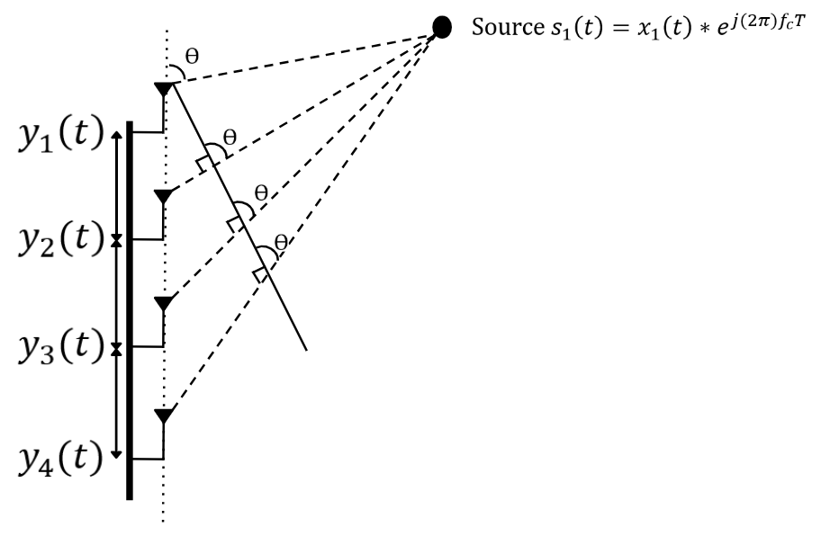
Figure 2.2.1 – Signal propagation and phase progression across a Uniform Linear Array (ULA) for DoA estimation using MUSIC.

The Uniform Circular Array (UCA) provides an alternative geometry that enables full 360-degree azimuth coverage. In this configuration, antenna elements are evenly distributed along a circular perimeter. As shown in Figure 2.2.2, the phase difference at each element depends on its angular position relative to the direction of the incoming signal. This geometry offers uniform sensitivity in all azimuth directions and eliminates many of the directional limitations associated with linear arrays. As a result, UCAs are highly effective for applications requiring complete angular coverage, although they typically involve more complex signal modeling and processing.
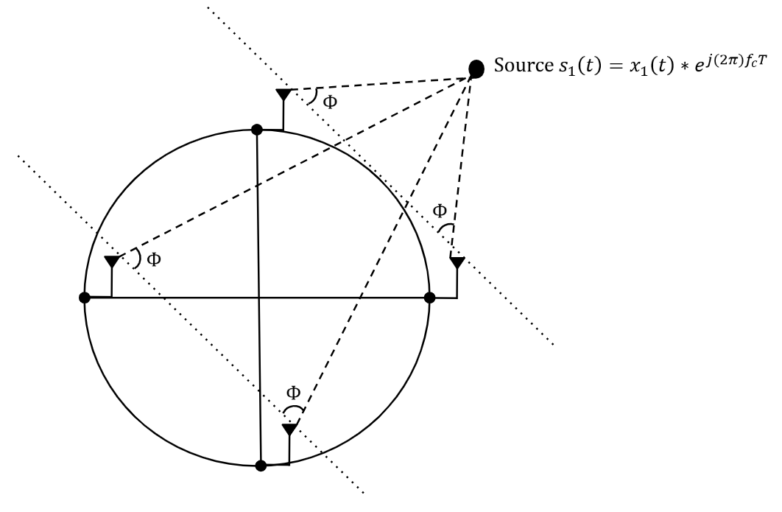
Figure 2.2.2 – Geometry of a Uniform Circular Array (UCA) illustrating phase differences for azimuth estimation using MUSIC.

The choice of array geometry is closely tied to the requirements of the DoA estimation algorithm. While subspace-based methods such as MUSIC can be applied to both ULA and UCA configurations, the ESPRIT algorithm requires a structure that exhibits translational invariance. This requirement is satisfied by the ULA through the use of overlapping subarrays. As illustrated in Figure 2.2.3, the array can be separated into two identical subarrays that observe the same signal with a consistent phase shift. ESPRIT exploits this relationship to directly estimate the angle of arrival without the need for spectral searching, resulting in improved computational efficiency.
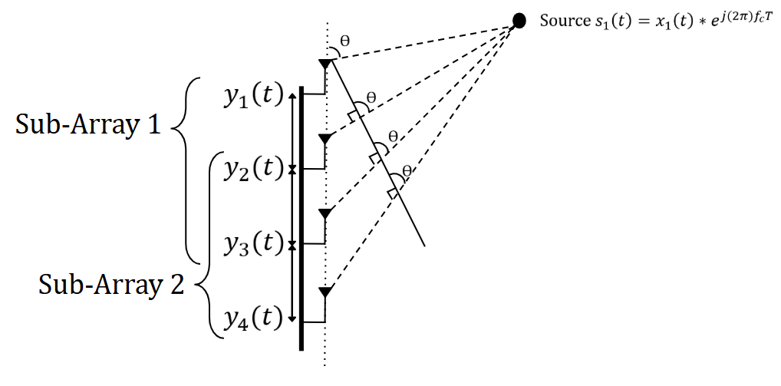
Figure 2.2.3 – Subarray structure of a Uniform Linear Array used for ESPRIT-based DoA estimation.

2.3 Real-Time DoA Constraints
While subspace-based Direction-of-Arrival (DoA) algorithms such as MUSIC and ESPRIT provide high-resolution angular estimation, their implementation in real-time systems introduces several practical constraints. These limitations arise from computational complexity, data acquisition requirements, hardware synchronization, and environmental effects, all of which must be carefully considered in system design.
One of the primary challenges in real-time DoA estimation is computational complexity. Algorithms such as MUSIC require eigenvalue decomposition of the received signal covariance matrix, followed by a spectral search across a range of possible angles. This process can be computationally intensive, particularly as the number of array elements and angular resolution increases. Although ESPRIT reduces computational load by eliminating the need for spectral searching, it still requires matrix operations that can impact real-time performance, especially when operating under strict timing constraints.
Another critical factor is the number of snapshots used to estimate the covariance matrix. A higher number of snapshots improves estimation accuracy and stability; however, it also increases processing time and system latency. In dynamic environments where the RF source is moving, excessive snapshot accumulation can lead to outdated estimates, reducing tracking performance. This trade-off between accuracy and responsiveness is a key consideration in real-time implementations.
Hardware synchronization and phase coherence also play a significant role in system performance. Subspace-based methods rely on precise phase relationships between antenna elements, requiring tightly synchronized receiver channels. Any mismatch in timing, phase, or gain across channels can degrade the accuracy of the estimated signal subspace and lead to incorrect DoA results. Systems such as multi-channel software-defined radios must therefore implement synchronization mechanisms to ensure coherent sampling across all antenna inputs.
In addition to system-level constraints, environmental factors such as noise, multipath propagation, and interference can significantly impact real-time DoA performance. Multipath reflections, in particular, can introduce additional signal components that distort the covariance matrix and reduce estimation accuracy. Robust algorithm design and filtering techniques are often required to mitigate these effects in practical deployments.
To address these challenges, real-time DoA systems often adopt design trade-offs and optimizations, including reducing angular search resolution, limiting snapshot counts, or selecting algorithms that balance accuracy and computational efficiency. In this work, these constraints are considered in the selection and implementation of both MUSIC and ESPRIT algorithms, enabling reliable operation within real-time processing limits while maintaining high localization accuracy.

2.4 Previous Work
Recent senior design efforts at Texas A&M University–Commerce and East Texas A&M University have progressively advanced the implementation of Direction-of-Arrival (DoA) estimation systems, particularly in the context of real-time RF localization. These projects provide a clear developmental path from foundational multi-dimensional estimation techniques to practical real-time tracking systems, directly informing the design of the present work.
The 2024 TAMUC Senior Design team focused on two-dimensional (2-D) DoA estimation, addressing the increased computational complexity associated with simultaneous azimuth and elevation determination. Their system utilized an L-shaped antenna array in the ZY-plane, enabling decomposition of the 2-D estimation problem into two independent one-dimensional (1-D) searches. This approach significantly reduced computational burden while preserving estimation accuracy by avoiding exhaustive 2-D spectral searches.
To achieve high-resolution performance, the team implemented subspace-based algorithms including MUSIC and root-MUSIC, supplemented with orthogonal projection techniques such as Orthogonal Projection using Rank-Revealing QR (OPRRRQR) and Rank-Revealing LU (OPRRRLU) decompositions. These methods improved numerical stability and computational efficiency, particularly under limited snapshot conditions. While the system demonstrated strong performance in static 2-D localization, it was primarily focused on algorithmic development and did not incorporate real-time tracking or hardware-integrated validation.
Building upon this foundation, the 2025 ETAMU SDR Challenge team shifted focus toward real-time DoA estimation in practical environments. Their system implemented azimuth-only localization using an 8-element Uniform Linear Array (ULA), emphasizing low-latency processing and hardware integration for tracking unmanned ground vehicles (UGVs). A key advancement in this work was the use of a MUSIC-based algorithm enhanced with QR decomposition (QR-MUSIC), which reduced computational complexity by avoiding eigen decomposition while maintaining high estimation accuracy.
The 2025 system successfully demonstrated real-time tracking of moving RF sources, achieving angular accuracy on the order of ±2° in single-source scenarios and operating with low snapshot counts suitable for dynamic environments. Additionally, alternative algorithms such as QR-ESPRIT-like and Rank-Revealing QR methods were evaluated to compare performance and efficiency trade-offs.
Despite these advancements, several limitations were identified. Most notably, the system struggled to reliably resolve multiple simultaneous sources, with performance degrading due to multipath interference, limited array aperture, and incomplete phase synchronization between receiver channels. Furthermore, the system was constrained to a single dimension (azimuth), limiting its ability to perform full spatial localization.
Together, these prior works establish a clear progression in DoA system development: from computationally efficient multi-dimensional estimation techniques (2024) to real-time, hardware-integrated single-dimensional tracking (2025). The present project builds upon both efforts by combining their strengths—leveraging subspace-based methods and dimensional decomposition while extending the system to perform full localization of a moving RF source through hybrid antenna geometries and integrated range sensing.

2.5 Comparative Study
In addition to prior senior design implementations, it is essential to examine established research contributions within the broader field of Direction-of-Arrival (DoA) estimation. While the previously discussed projects provide valuable insight into practical system development and implementation challenges, published literature offers a deeper understanding of theoretical advancements, algorithmic performance, and emerging methodologies under a wider range of conditions. This section presents a comparative study of five selected research papers that focus on subspace-based DoA estimation techniques, antenna array configurations, and real-time processing considerations. These works were chosen based on their relevance to the core components of this project, including MUSIC and ESPRIT algorithms, array geometry design, multi-source resolution, and computational efficiency.

2.5.1 Detection, Identification, and Direction of Arrival Estimation of Drone FHSS Signals with Uniform Linear Antenna Array
The authors develop a complete signal-processing framework for detecting frequency-hopping spread-spectrum (FHSS) drone controller signals and estimating their direction of arrival using a uniform linear array (ULA). Their approach begins with cyclostationary analysis to separate drone RC signals from other ISM-band transmissions, followed by a short-time Fourier transform (STFT)–based reconstruction method that converts the wideband FHSS signal into a narrowband representation suitable for array processing. After reconstructing the baseband signal, the authors apply two variants of the MUSIC algorithm to estimate the arrival angle of the drone controller signal. Field experiments demonstrate an average DoA error of approximately 1.39°, highlighting the effectiveness of subspace-based methods for drone pilot localization in real-world conditions.
Figure 1 in the paper illustrates the geometry of the uniform linear array used for direction-finding, showing how an incoming plane wave with angle θ impinges on the antenna elements at different times. The figure depicts the incident wavefront, element spacing, and the progressive delays between sensors that form the basis of the MUSIC steering vector. By visually demonstrating how phase differences accumulate across the ULA as a function of the source’s angle, the diagram clarifies the physical interpretation of the array manifold that MUSIC relies on. This visualization directly supports the author’s signal model and explains how the ULA converts spatial information into measurable signal-phase relationships.
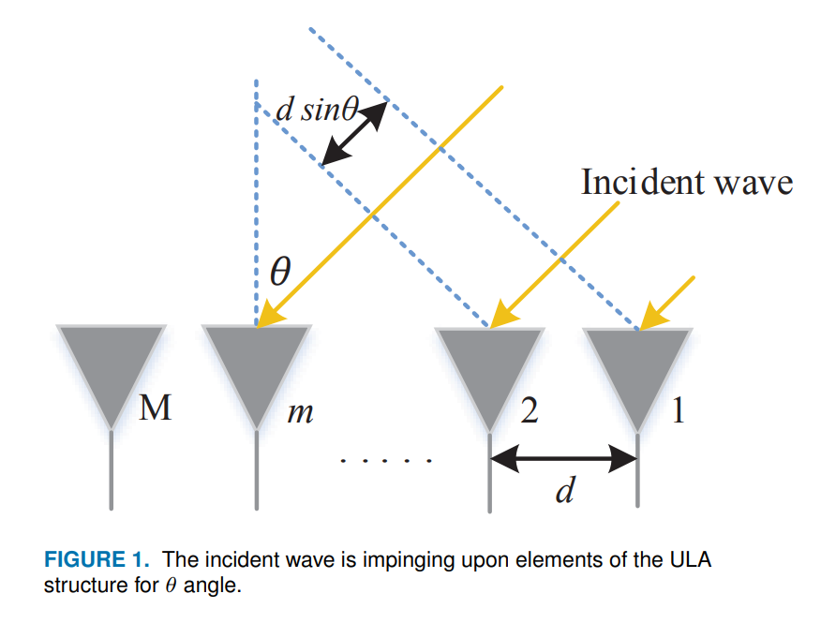
Figure 2.5.1 Figure.1 from the paper showing incident wave impinging on the ULA elements.

2.5.2 Direction-Finding for Unmanned Arieal Vehicles using Radio Frequency Methods
This author Martian presents an RF-based direction-finding (DF) testbed designed for the detection and localization of unmanned aerial vehicles using software-defined radio platforms and subspace-based signal processing algorithms . The system employs a phase-coherent four-channel SDR receiver and a uniform linear antenna array to estimate the direction of arrival of UAV downlink signals operating in the 2.4 GHz ISM band. The MUSIC algorithm is selected for angle estimation due to its high angular resolution and robustness to noise. Performance is evaluated using real-world flight experiments with a DJI Mavic Air UAV under both static and dynamic conditions, yielding average angular errors of approximately 1.15° and 1.86°, respectively. These results demonstrate that RF-based DF methods, when combined with coherent SDR hardware, can achieve accuracy comparable to or exceeding existing drone localization systems reported in the literature.
A key contribution of the paper is the characterization of the UAV downlink signal using both frequency-domain and time–frequency representations, as shown in the provided spectrogram figure. The time–frequency histogram reveals the structured spectral footprint of the UAV’s OFDM-based transmission, clearly distinguishing the signal’s occupied bandwidth from surrounding noise and interference. This visualization highlights the temporal persistence and spectral stability of the UAV signal within the 2.4 GHz ISM band, even in the presence of background RF activity. Such time–frequency analysis is particularly valuable for identifying candidate signal regions prior to direction-finding, enabling improved signal isolation and preprocessing. While the authors ultimately apply MUSIC directly to the received baseband signals, the spectrogram demonstrates an effective method for signal verification, interference assessment, and situational awareness in real RF environments.
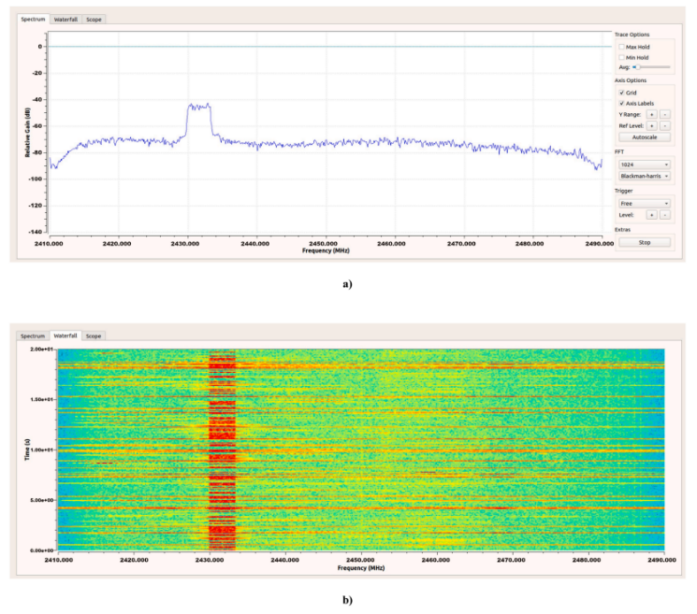

Figure 2.5.2 Time-Frequency Spectrogram Analysis
This work directly informs the proposed hybrid UCA–ULA direction-finding system by motivating the integration of time–frequency analysis as a complementary processing stage. In the context of this project, time–frequency representations can be used to validate signal presence, identify dominant transmission bands, and potentially gate or weight snapshots used in MUSIC-based azimuth and elevation estimation. This is particularly relevant for real-time operation, where interference, multipath, and competing emitters may degrade covariance matrix estimation. By incorporating spectrogram-based analysis alongside the live MUSIC implementation, the system can improve robustness while maintaining real-time performance. Inspired by Martian et al., this approach bridges signal-level characterization with spatial estimation, strengthening the reliability of the overall UAV tracking framework.

2.5.2 MUSIC 2D-DOA Estimation using Split Vertical Linear and Circular Arrays
Albagory and Ashour propose an efficient two-dimensional direction-of-arrival (2D-DOA) estimation technique based on a split array configuration that combines a vertical uniform linear array (VULA) with a horizontal uniform circular array (UCA). The key contribution of the paper is the reduction of computational complexity associated with conventional 2D MUSIC implementations, which typically require exhaustive searches over both azimuth and elevation dimensions. Instead of performing a blind 2D search, the authors decompose the problem into two sequential one-dimensional estimations: elevation angles are first estimated using the vertical linear array, and these estimates are then used to constrain the azimuth search performed by the circular array. Simulation results demonstrate that this approach maintains high angular resolution and robustness to noise while significantly reducing processing time compared to a conventional UCA-only 2D MUSIC implementation.
The split array geometry illustrated in the figure below clearly depicts the perpendicular placement of the vertical linear array along the z-axis and the circular array in the xy-plane, enabling independent sensitivity to elevation and azimuth angles. This physical separation directly supports the sequential estimation strategy proposed in the paper. Additionally, the beamforming block diagram in the figure below highlights the two-stage processing flow, where elevation DOA estimates from the linear array are passed forward as constrained search planes for azimuth estimation in the circular array. This figure collectively emphasize how the array geometry and processing architecture work together to reduce ambiguity and computational burden. By limiting the azimuth search to specific elevation planes, the MUSIC pseudospectrum exhibits sharper, more isolated peaks, which improves estimation stability and enables parallel azimuth processing for multiple sources.
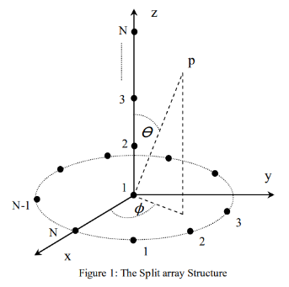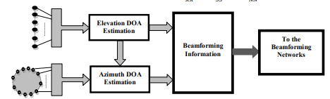
Figure 2.5.2 The Split Array Design and block diagram
This work directly informs the proposed hybrid UCA–ULA direction-finding system by motivating the integration of time–frequency analysis as a complementary processing stage. In the context of this project, time–frequency representations can be used to validate signal presence, identify dominant transmission bands, and potentially gate or weight snapshots used in MUSIC-based azimuth and elevation estimation. This is particularly relevant for real-time operation, where interference, multipath, and competing emitters may degrade covariance matrix estimation. By incorporating spectrogram-based analysis alongside the live MUSIC implementation, the system can improve robustness while maintaining real-time performance. Inspired by Martian, this approach bridges signal-level characterization with spatial estimation, strengthening the reliability of the overall UAV tracking framework.

2.5.3 Range and Angle Measurements based on Software Defined Radio Platform
Author Alawsh presents the design and implementation of a software-defined radar system capable of performing both range measurement and direction-of-arrival (DOA) estimation using an SDR platform. The system is implemented using NI-USRP hardware programmed in LabVIEW and employs cross-correlation techniques for distance estimation and the MUSIC algorithm for angular estimation. The authors focus on demonstrating the flexibility of SDR-based radar systems compared to traditional hardware-defined radars, highlighting their ability to adapt signal waveforms and processing techniques through software. Experimental results show that the system achieves meter-level range resolution and angular estimation errors on the order of a few degrees under indoor test conditions, validating the practicality of SDR-based DOA estimation.
The provided figure illustrates the fundamental DOA system model using a uniform linear array (ULA), where multiple antenna elements are spaced by a fixed distance and receive a plane wave impinging from angle θ. This visualization emphasizes the geometric relationship between the incident wavefront and the relative phase delays across the antenna elements, which form the basis of subspace-based DOA estimation methods such as MUSIC. The figure clearly conveys the far-field assumption, where incoming wavefronts are approximated as parallel, enabling a simple steering vector formulation based on element spacing and incident angle. This array model underpins the signal representation and covariance matrix formulation used in the paper and serves as the foundational geometry for implementing MUSIC-based DOA estimation on SDR hardware.
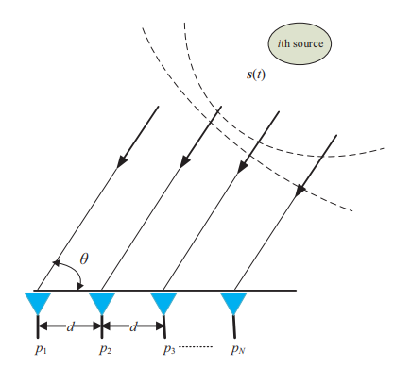
Figure 2.5.2 The ULA separated by the distance (d) = 1/λ
This work directly informs the development of the proposed UAV tracking system by reinforcing the feasibility of implementing MUSIC-based DOA estimation in real time on SDR platforms. While the paper focuses on a ULA for single-angle estimation, the underlying principles demonstrated—phase-based angle estimation, covariance matrix formation, and subspace decomposition—are directly extended in this project to a hybrid UCA–ULA architecture for full azimuth and elevation estimation. The array model and steering vector formulation shown in the figure align closely with the elevation estimation stage of the proposed system, while the SDR implementation validates the transition from simulation to hardware operation. By building upon these concepts, the current project expands the approach to multi-dimensional DOA estimation and integrates real-time visualization and tracking, addressing the additional challenges associated with dynamic UAV targets.

2.6 Research Contribution
This work presents the design and implementation of a hybrid RF localization system capable of performing real-time, two-dimensional Direction-of-Arrival (DoA) estimation of a moving signal source. As illustrated in Figure 2.6.1, the localization problem is defined in terms of azimuth (φ) and elevation (θ) angles relative to the antenna array geometry. Rather than solving this as a computationally intensive two-dimensional search, the proposed system decomposes the problem into two orthogonal one-dimensional estimations using specialized antenna array configurations. This approach enables accurate angular estimation in both planes while maintaining computational efficiency suitable for real-time operation.
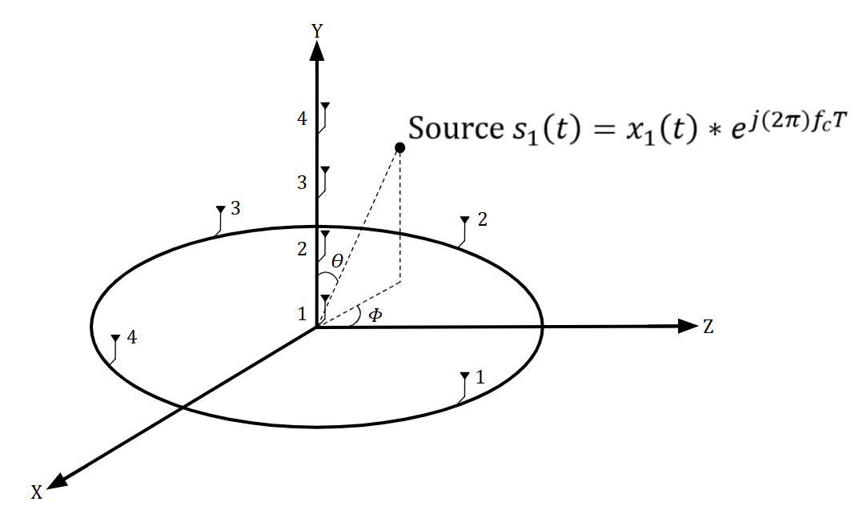
Figure 2.6.1 Direction-of-arrival split-array geometry showing the incident RF source and the azimuth (𝜙) and elevation (𝜃) angles used to construct the array steering vector.
A key contribution of this research is the incorporation of multiple antenna geometries to enhance system capability and flexibility. A Uniform Circular Array (UCA) is employed to achieve full 360° azimuth coverage, overcoming the directional limitations of traditional Uniform Linear Arrays (ULA). In parallel, ULA configurations are utilized for both azimuth and elevation estimation, enabling direct comparison between array geometries in terms of resolution, field of view, and robustness. This dual-geometry approach provides a comprehensive evaluation of array performance within a unified system.
In addition to geometric diversity, this work presents a comparative implementation of subspace-based DoA algorithms, specifically MUSIC and ESPRIT, across the different array configurations. By evaluating these algorithms under identical system conditions, the study highlights trade-offs in computational complexity, estimation accuracy, and real-time feasibility. This combined comparison of both algorithmic and geometric approaches represents a significant extension beyond prior work, which typically isolates these factors.
Furthermore, the system integrates a LiDAR-based range finding subsystem with the DoA estimation framework, enabling full spatial localization of the RF emitter. By combining angular estimation (φ, θ) with direct distance measurement, the system moves beyond traditional angular-only DoA solutions toward complete position determination in space.
Unlike many existing studies that focus primarily on simulation or theoretical analysis, the proposed system is fully implemented and validated on hardware. The integration of software-defined radios, real antenna arrays, and a pan-tilt LiDAR platform enables testing under realistic conditions, including dynamic target motion and environmental effects such as multipath. This practical validation bridges the gap between theoretical DoA methods and deployable real-time localization systems.
Collectively, this work advances the state of the art by combining multi-dimensional estimation, real-time implementation, algorithmic comparison, and sensor fusion into a single cohesive system, addressing key limitations identified in prior research.

3. System Design

3.1 Design Constraints
Before constructing any hardware design, it is essential to define the operational constraints that bound system performance and feasibility. These constraints directly influence architectural decisions, component selection, and algorithm implementation, ultimately shaping the achievable accuracy and real-time capability of the system. For this project, constraints are categorized into two groups: practical design constraints, which arise from hardware availability, budget limitations, and implementation challenges, and regulatory constraints, dictated by IEEE standards and RF spectrum considerations. Addressing both categories ensures that the system is not only feasible within a constrained development environment but also compliant with established communication standards.

3.1.1 Practical Design Constraints
- FMComms5 / Zynq Configuration: The FMComms5 platform provides a maximum of four phase-coherent receive channels. While the onboard RF transceivers can be synchronized, multiple boards cannot be reliably synchronized within the scope of this project. As a result, each antenna array is limited to four elements, constraining achievable angular resolution.
- Element Spacing: Antenna element spacing is determined by the operating frequency of 2.4 GHz, resulting in a fixed spacing requirement of approximately half-wavelength. This limits array geometry flexibility and impacts resolution and mutual coupling effects.
- Indoor Testing Environment: System testing is conducted indoors, where multipath reflections from walls, ceilings, and surrounding objects introduce signal distortion. These effects degrade Direction-of-Arrival estimation accuracy and challenge the assumptions of subspace-based algorithms.
- Real-Time vs. Accuracy Trade-off: Achieving real-time processing (sub-second estimation) imposes limits on computational complexity and snapshot averaging. As a result, improvements in processing speed may come at the cost of reduced estimation accuracy and stability.
- Project Timeline Constraints: The limited time remaining for project completion restricts the depth of algorithm optimization, hardware refinement, and experimental validation.
- Budget Constraints: The project operates under a restricted budget, limiting access to specialized RF equipment and requiring the use of cost-effective, commercially available components. This introduces trade-offs between performance, durability, and scalability.
- Coaxial Cable Limitations: Length-matched coaxial cables are required to preserve phase integrity across antenna elements; however, the current cables are excessively long and lack flexibility. This complicates system integration, reduces portability, and introduces physical layout challenges.

    - Regulatory Constraints (IEEE Standards)
- ISO/IEC/IEEE 15288 – System Life Cycle Processes: Defines a structured framework for system development, including concept, design, implementation, verification, and validation. This standard guides the overall project workflow and ensures a disciplined engineering process.
- ISO/IEC/IEEE 42010 – System Architecture Description: Establishes best practices for documenting system architecture, ensuring that system components, interfaces, and design decisions are clearly defined and traceable.
- ISO/IEC/IEEE 29119 – Software Testing: Provides standardized procedures for software testing, including test planning, execution, and evaluation. This ensures consistent validation of signal processing algorithms and system performance.
- IEEE 1936.1-2021 – Drone Applications Framework: Offers guidelines for systems related to unmanned aerial platforms. While the system is tested in a controlled environment, this standard supports alignment with real-world drone detection and tracking applications.
- IEEE / ISO/IEC 26514-2021 – User Documentation: Defines standards for the design and development of user-facing documentation, ensuring clarity, usability, and consistency in system reporting and operation manuals.
- IEEE 829 – Test Documentation: Establishes standardized formats for test plans, procedures, and reports, enabling reproducible experimentation and structured performance evaluation.
- IEEE 1012 – Verification and Validation: Provides a framework for ensuring that the system meets both design requirements and intended operational performance through formal verification and validation processes.
- IEEE 730 – Software Quality Assurance: Defines requirements for software quality assurance plans, ensuring reliability and maintainability of the implemented signal processing and control algorithms.

3.2 Design Methodology
Following the definition of system constraints, the design methodology outlines the structured approach used to develop, integrate, and validate the RF localization system. A modular design philosophy was selected to enable independent development of key subsystems, including RF signal acquisition, Direction-of-Arrival (DoA) estimation, and range finding, prior to full system integration. This approach reduces overall system complexity and improves optimization in both hardware and software components.
The initial phase of the development process focuses on simulation and algorithm validation. During this stage, the MUSIC and ESPRIT algorithms are evaluated using generated data and Monte Carlo simulations to characterize performance under controlled conditions. The first parameter investigated is the signal-to-noise ratio (SNR) and its effect on DoA estimation accuracy. This parameter is particularly important due to its relevance in multipath and cluttered environments, which are expected during indoor system demonstrations. The second parameter evaluated is the number of snapshots, analyzed in relation to both estimation accuracy and algorithm execution time. Since the system is designed for real-time operation, it is necessary to determine the trade-off between computational speed and estimation performance. These simulations establish baseline expectations for resolution, accuracy, and robustness of the selected algorithms.
Following simulation and algorithm validation, the system transitions to hardware implementation. The RF front-end is constructed around the FMComms5/Zynq platform, which enables phase-coherent multi-channel signal acquisition. Antenna array geometries are fabricated using 3D printing techniques with tight tolerances to ensure consistent element spacing and structural stability. Maintaining phase integrity across channels is critical to system performance; therefore, length-matched coaxial cabling and proper phase synchronization are carefully implemented.
In parallel with RF processing, the LiDAR subsystem is integrated using a pan and tilt assembly to provide directional range measurements. The estimated azimuth and elevation angles obtained from the DoA algorithms are used to control the orientation of the LiDAR sensor, enabling alignment with the RF source for distance measurement. This closed-loop interaction between angular estimation and range sensing forms the foundation of the system’s full localization capability.
System integration is performed incrementally, beginning with independent validation of each subsystem, followed by combined operation under controlled conditions. Experimental testing is conducted using a known RF source generated by a software-defined radio, enabling repeatable and controlled evaluation of system performance. Both static and dynamic scenarios are considered to assess tracking capability and robustness in the presence of environmental effects such as multipath.
Overall, this methodology ensures that the system is developed in a structured, scalable, and testable manner, enabling reliable evaluation of both algorithmic performance and hardware implementation. By combining simulation, modular development, and iterative testing, the design approach supports the successful realization of a real-time RF localization system within the defined project constraints.

3.3 Subsystems and Components
To facilitate modular development and efficient system integration, the overall architecture is divided into three primary subsystems: the RF transmitter, the RF receiver, and the LiDAR range finding subsystem. These subsystems collectively enable full localization by separating the processes of signal generation, angular estimation, and distance measurement. This decomposition reduces system complexity and allows each subsystem to be independently designed, implemented, and validated. The architecture and key components of each subsystem are described in the following sections.

    - RF Transmitter Subsystem
The physical implementation of the RF emitter subsystem directly mirrors the high-level system architecture described previously. As shown in Figure 3.3.1, the RF source is realized using a USRP-2901 software-defined radio transceiver controlled by a Raspberry Pi 4. The system is configured to transmit a continuous wave (CW) signal at 2.4 GHz, representing the target emitter for Direction-of-Arrival (DoA) estimation and system validation. The Raspberry Pi 4 serves as the control interface for the USRP, managing signal generation parameters and enabling flexible configuration of the transmitted waveform. Communication between the Raspberry Pi and the USRP is achieved through a USB data connection, allowing real-time control and rapid reconfiguration during testing. A portable power supply is used to power the subsystem, ensuring complete mobility and eliminating the need for fixed laboratory infrastructure.
This compact and self-contained transmission module provides a stable and repeatable RF source, which is essential for consistent system evaluation. The use of a continuous wave signal simplifies the signal model while still capturing the key characteristics required for DoA estimation. Additionally, the portability of the emitter allows for both static placement and dynamic repositioning within the test environment, enabling comprehensive validation of tracking performance. By utilizing a software-defined radio platform, the subsystem also supports future expansion to more complex signal types, including modulated waveforms and multi-emitter scenarios.
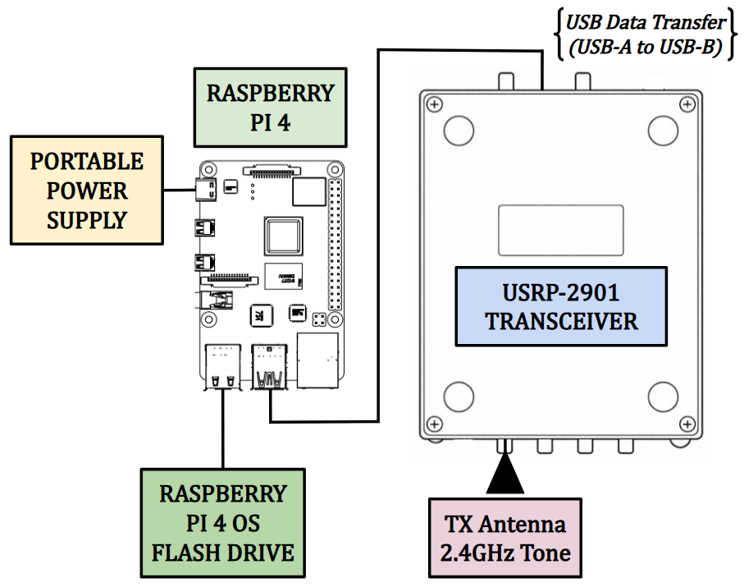
Figure 3.3.1 Live Demo Portable RF Source Testbed

    - Antenna Array Design
The proposed objective was to compare two different antenna array geometry combinations, the vertical uniform linear array (ULA) for elevation, paired with either the uniform circular array (UCA) or the horizontal ULA for azimuth estimation. The design of these array geometries has changed tremendously over the course of the project as components and design requirements change. Each iteration preserving the same underlying mathematical foundation while refining the mechanical structure for improved stability and practicality. Across all designs, the inter-element spacing has been fixed at one-half wavelength (λ/2) relative to the operating frequency of 2.4 GHz, ensuring spatial sampling requirements are met and preventing spatial aliasing for MUSIC-based direction-of-arrival estimation. While the electrical geometry and array topology remained consistent, successive generations focused on addressing mechanical challenges observed during testing, including structural rigidity, center-of-mass stability, mounting repeatability, and ease of integration with supporting subsystems. Early designs emphasized proof-of-concept validation of array geometry, whereas later generations introduced reinforced bases, improved mounting interfaces, and more compact form factors. The current design represents a balance between theoretical performance and real-world deplorability, providing a mechanically stable platform suitable for both controlled testing and future field deployment without compromising the array’s signal processing performance.

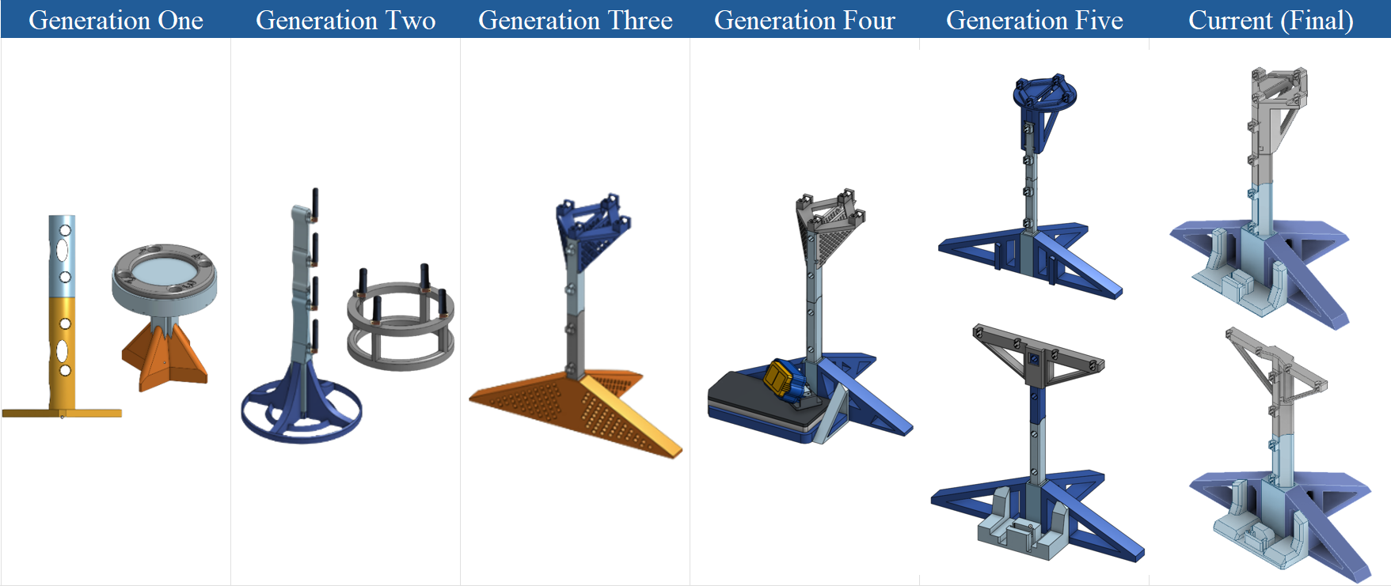
Figure 3.3.2 Antenna Array Geometry Generational Breakdown

    - RF Receiver Subsystem
The RF receiver subsystem represents the most critical component of the overall system, as it is responsible for acquiring the transmitted signal and enabling accurate Direction-of-Arrival (DoA) estimation. As shown in Figure 3.3.2, the receiver architecture consists of three primary stages: the antenna array for signal reception, the FMComms5/Zynq platform for RF down conversion and digitization, and the host PC for digital signal processing and DoA computation.
The signal acquisition process begins at the antenna array, where the incoming 2.4 GHz RF signal is captured across multiple elements. Depending on the selected configuration, either a hybrid Uniform Circular Array (UCA) with a vertical Uniform Linear Array (ULA), or a dual ULA configuration is used. These array geometries enable spatial sampling of the received signal, where phase differences between elements encode the angular information required for DoA estimation.
The received analog RF signals are then routed through length-matched coaxial cables to the FMComms5 boards, ensuring phase coherence across all channels. The FMComms5, integrated with the Zynq-7000 platform, performs RF down conversion, filtering, and analog-to-digital conversion, producing synchronized baseband I/Q samples for each antenna element. Maintaining synchronization and phase alignment at this stage is critical, as subspace-based algorithms such as MUSIC and ESPRIT rely heavily on accurate phase relationships between channels.
Following digitization, the sampled data is transmitted from the Zynq platform to the host PC, where further processing is performed in MATLAB. The signal processing chain includes covariance matrix estimation, eigenvalue decomposition, and spectral analysis for DoA estimation. Depending on the selected method, either the MUSIC algorithm is used for high-resolution spectral peak detection, or the ESPRIT algorithm is applied for computationally efficient parameter estimation.
This end-to-end signal chain—from spatial sampling at the antenna array to digital processing on the host computer—enables accurate extraction of angular information from the received RF signals. The modular design of the receiver subsystem also allows for direct comparison between array geometries and algorithmic approaches, supporting comprehensive evaluation of system performance under varying conditions.
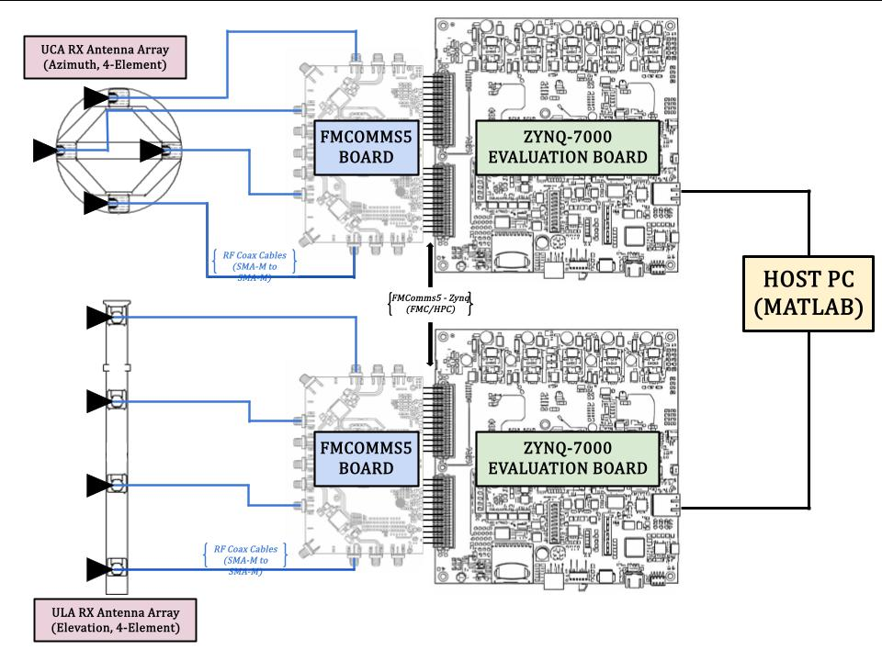
Figure 3.3.3 Live Demo RF Receiver Architecture (ULA/UCA)

    - Mechanical Range Finding Subsystem
Following the computation of azimuth and elevation estimates by the RF receiver subsystem, the resulting directional information is transferred to the mechanical range finding subsystem to complete source localization. As shown in Figure 3.3.X, this subsystem consists of a Raspberry Pi controller, a pan–tilt servo platform, and a TF-02 LiDAR sensor used for distance measurement.
The Raspberry Pi serves as the interface between the host PC and the mechanical actuation system. Estimated azimuth and elevation angles are transmitted from the host PC to the Raspberry Pi, which then generates the appropriate control signals to drive the pan and tilt servos. The pan servo provides rotation in the azimuth plane, while the tilt servo adjusts the elevation angle, enabling precise directional alignment of the LiDAR sensor. Once the sensor is oriented toward the estimated direction of the RF source, the TF-02 LiDAR performs a distance measurement along the line-of-sight. This measurement provides the range component required for full localization. By combining the angular estimates from the RF subsystem with the distance measurement from the LiDAR, the system can approximate the spatial position of the emitter.
This closed-loop interaction between angular estimation and mechanical positioning introduces additional sources of error, including servo resolution, alignment accuracy, and response time. However, it enables a practical and scalable approach to real-time localization by integrating RF sensing with active range measurement.
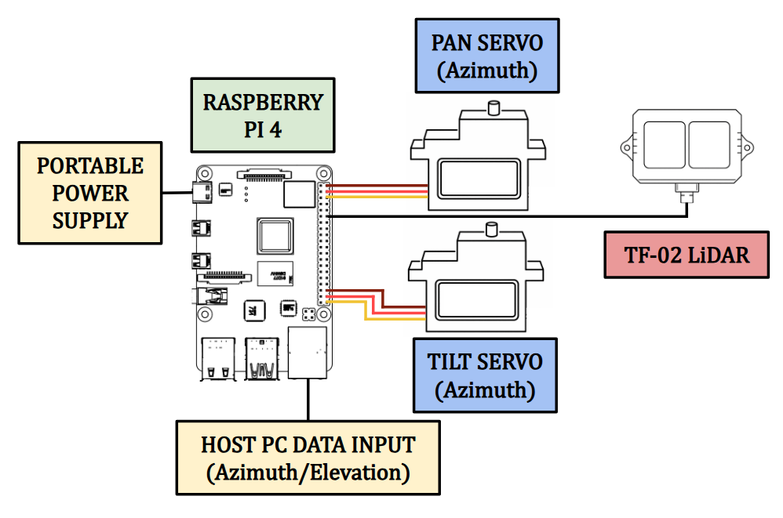
Figure 3.3.4 Live Demo Mechanical Range Finding Architecture

3.4 Full System Implementation
After completing the independent development of the RF emitter testbed, RF receiver subsystem, and LiDAR range-finding architecture, the final stage of the project involves integrating these components into a unified localization system. The complete system implementation is illustrated in Figure 3.4.1, highlighting the interaction between subsystems required to estimate the azimuth and elevation of the RF source and perform the final range measurement.
The process begins with the RF emitter testbed (Fig. 3.3.1), shown in the upper portion of Figure 3.4.1, where a continuous 2.4 GHz waveform is generated by the Raspberry Pi 4 and transmitted through the USRP-2901 software-defined radio. This signal propagates through the environment and serves as the target RF source for localization experiments.
Upon transmission, the signal is received by the antenna array, configured as either a UCA–ULA or dual ULA geometry depending on the test scenario. The multi-channel RF signals are then routed through length-matched coaxial cables to the FMComms5/Zynq signal acquisition platform, shown in the center of Figure 3.4.1. This platform performs simultaneous sampling of each antenna element while preserving phase coherence across channels, a requirement for accurate subspace-based DoA estimation. The digitized baseband data is then transferred to the host PC, where signal processing is performed using MATLAB-based implementations of the MUSIC and ESPRIT algorithms. These algorithms estimate the azimuth and elevation angles of the incoming signal by exploiting the spatial phase differences between antenna elements.
Following angular estimation, the computed azimuth and elevation values are transmitted to the Raspberry Pi 4, which controls the pan and tilt servo motors of the LiDAR subsystem. The servos orient the TF-02 LiDAR sensor toward the estimated direction of the RF source, enabling line-of-sight alignment. Once aligned, the LiDAR performs a distance measurement to obtain the range to the target. By combining the angular estimates from the RF receiver subsystem with the distance measurement from the LiDAR sensor, the system determines the spatial location of the emitter within the test environment. This integrated signal chain—from RF transmission to angular estimation and mechanical range measurement—demonstrates a complete and functional real-time localization system.
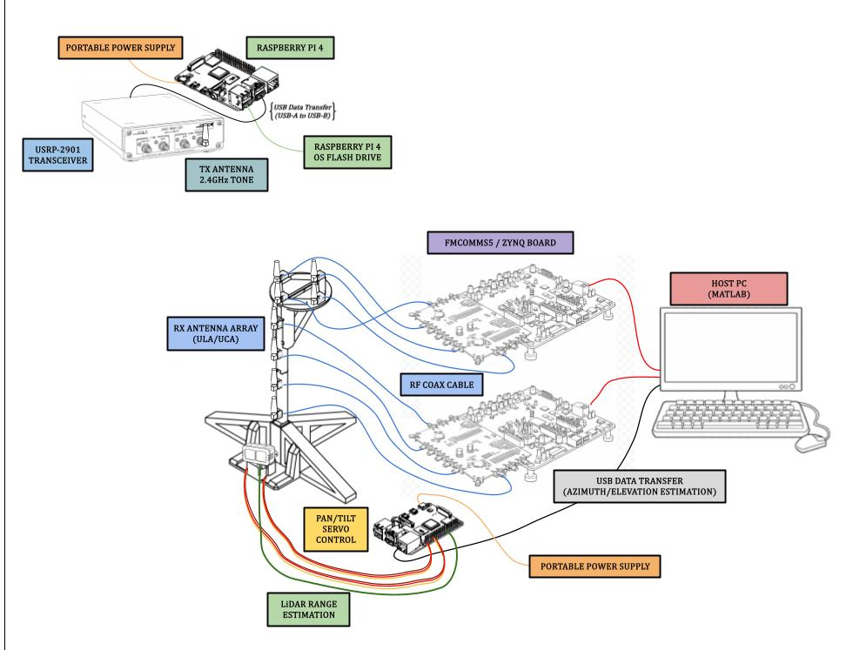
Figure 3.4.1 Live Demo Complete Implementation Visualization
Accurate phase synchronization is a critical requirement for any Direction-of-Arrival (DoA) estimation system, as subspace-based algorithms such as MUSIC and ESPRIT rely on precise phase relationships between received signals across antenna elements. Any phase mismatch or drift between channels directly degrades estimation accuracy and can result in incorrect angle calculations.
In this system, phase synchronization is achieved using the multi-chip synchronization (MCS) capability of the FMComms5 platform, which incorporates dual AD9361 RF transceivers. This configuration enables all receive channels to share aligned timing references, ensuring that the local oscillators, sampling clocks, and digital data paths operate in a deterministic and phase-coherent manner. As shown in Figure 3.4.2, the synchronization process is performed by routing known RF signals from the transmit (TX) channels to their corresponding receive (RX) channels using coaxial cables. This loopback configuration allows the system to calibrate and align phase offsets between channels, ensuring consistent phase relationships across all antenna inputs. Establishing this initial phase alignment is essential for maintaining the integrity of the covariance matrix used in DoA estimation.
A detailed step-by-step description of the synchronization procedure, including configuration parameters and calibration steps, is provided in the Appendix.

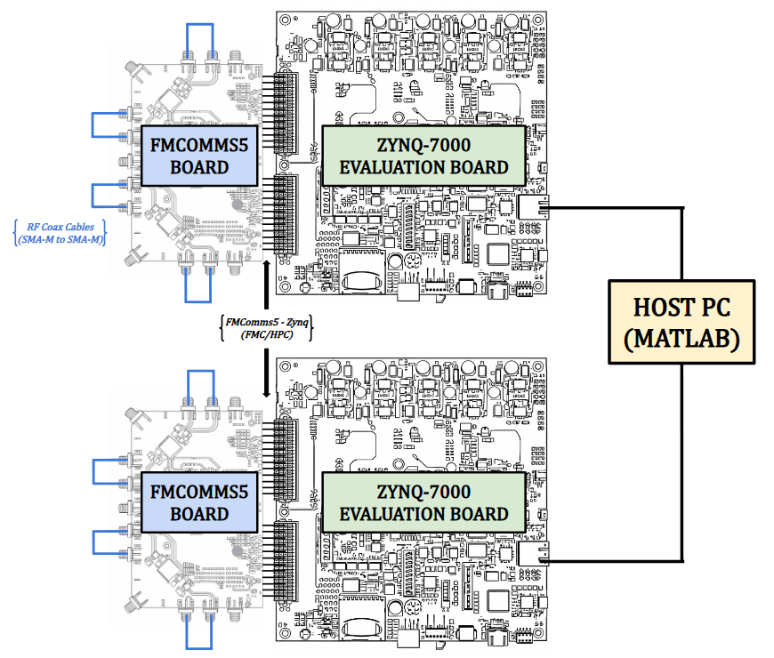
Figure 3.4.2 Receiver Phase Synchronization Set-Up

4. System Testing, Verification & Analysis

Simulation Performance
A central focus of this work is evaluating the practical performance of the eigen-MUSIC, SVD-MUSIC, and ESPRIT algorithms through a series of targeted simulations. Three simulation types are employed: SNR-based Monte Carlo trials, snapshot-dependent Monte Carlo trials, and full direction-of-arrival (DoA) estimation scenarios. Together, these experiments assess algorithm accuracy and robustness across a range of operating conditions. By systematically varying key system parameters; including signal-to-noise ratio and snapshot count; the strengths and limitations of each approach are exposed, yielding a comprehensive performance profile relevant to real-time RF source localization.
The first simulation parameter investigated is the signal-to-noise ratio (SNR), which directly governs subspace separability in MUSIC-based estimators. As SNR decreases, the signal and noise subspaces become increasingly indistinct, degrading spectral peak resolution and increasing RMSE. This makes the SNR sweep critical for defining the algorithm’s operational limits. In the SVD-MUSIC Monte Carlo simulation shown in Figure 4.1.1, the elevation and azimuth channels exhibit markedly different behavior across the SNR range of −15 to +15dB. Elevation RMSE begins near 50° at −15 dB and decreases sharply to approximately 0.2° by +15dB. This reduction is not uniform; a clear inflection occurs near −5 dB, below which improvement is gradual and above which it becomes significantly steeper. This transition corresponds to the point at which the signal subspace becomes reliably separable from the noise subspace, enabling proper estimator operation. In contrast, azimuth RMSE remains persistently high across the entire SNR range, decreasing only from approximately 80–90° at −15 dB to 20–25° at +15 dB. It never reaches the sub-10° accuracy threshold required for practical localization. This limitation arises from the sequential estimation structure, where azimuth estimation depends on the elevation estimate as a prior. As a result, residual elevation errors propagate into the azimuth solution, imposing an accuracy floor that cannot be mitigated by increasing SNR alone. This effect is further confirmed by the combined RMSE, which closely follows the azimuth trend, indicating that azimuth error dominates the overall performance metric. Bias and standard deviation plots reinforce this asymmetry. Elevation bias rapidly approaches zero for SNR > 0 dB, with remaining fluctuations attributable to estimator noise rather than systematic error, indicating that RMSE improvements are driven primarily by variance reduction. In contrast, azimuth bias remains large and largely unchanged across all SNR values, confirming the presence of a systematic, SNR-independent error. Similarly, azimuth standard deviation remains high and decreases only slightly, demonstrating that both variance and bias contribute significantly to the persistent azimuth error floor.
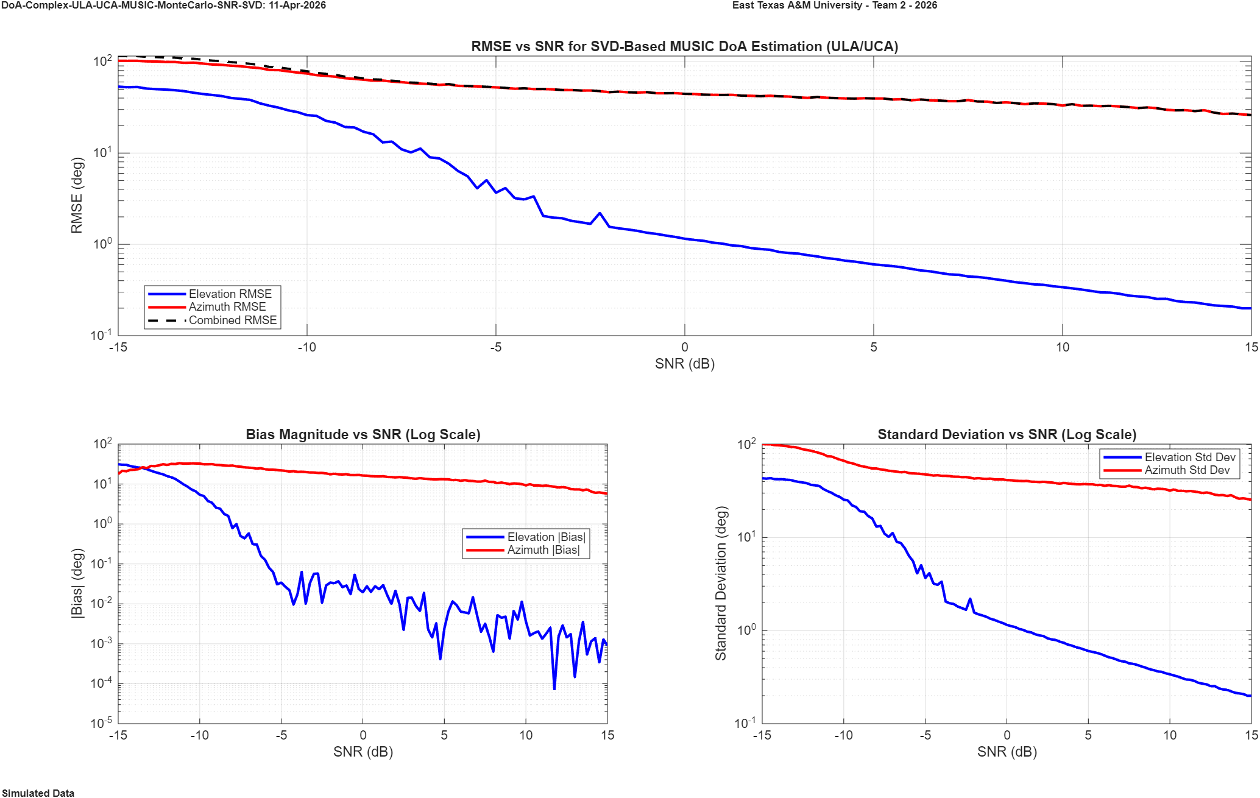
Figure 4.1.1 SVD - MUSIC ULA/UCA DoA SNR vs. Accuracy Simulation (Log Scale)
SNR: -15:15dB; Snapshots: 32, 768; Freq: 2.4GHz, Trials: 250; Single Moving Source;
Azimuth: 40ᵒ:80ᵒ; Elevation: 20ᵒ:60ᵒ
The results of the SVD-MUSIC SNR Monte Carlo simulation for the dual ULA (ULA/ULA) configuration are shown in Figure 4.1.2. In contrast to the ULA/UCA case, both elevation and azimuth channels exhibit consistent and well-behaved performance across the full SNR range from −15 to +15dB. Elevation and azimuth RMSE follow nearly identical trends, beginning at high error levels under low SNR conditions and decreasing steadily as SNR increases. Unlike the asymmetry observed in the ULA/UCA configuration, no persistent error floor is present in the azimuth estimate. Both channels achieve sub-degree accuracy at moderate-to-high SNR levels, with RMSE dropping below 1° near 0 dB and continuing to improve toward approximately 0.1° at +15dB. The combined RMSE closely tracks both individual channels, indicating balanced estimation performance and the absence of a dominant error source. The bias and standard deviation plots further reinforce this symmetry. Both elevation and azimuth bias rapidly decrease with increasing SNR, approaching near-zero values beyond approximately −5 dB, indicating that the estimator is effectively unbiased in moderate-to-high SNR regimes. Similarly, the standard deviation for both channels decreases monotonically and at nearly identical rates, confirming that RMSE reduction is driven primarily by variance reduction rather than systematic error. This balanced behavior highlights a key advantage of the dual ULA configuration: by decoupling azimuth and elevation estimation into independent, structurally similar problems, the system avoids the sequential dependency observed in the ULA/UCA approach. As a result, both angular dimensions benefit equally from improvements in SNR, yielding a more stable and accurate overall DoA estimation performance.
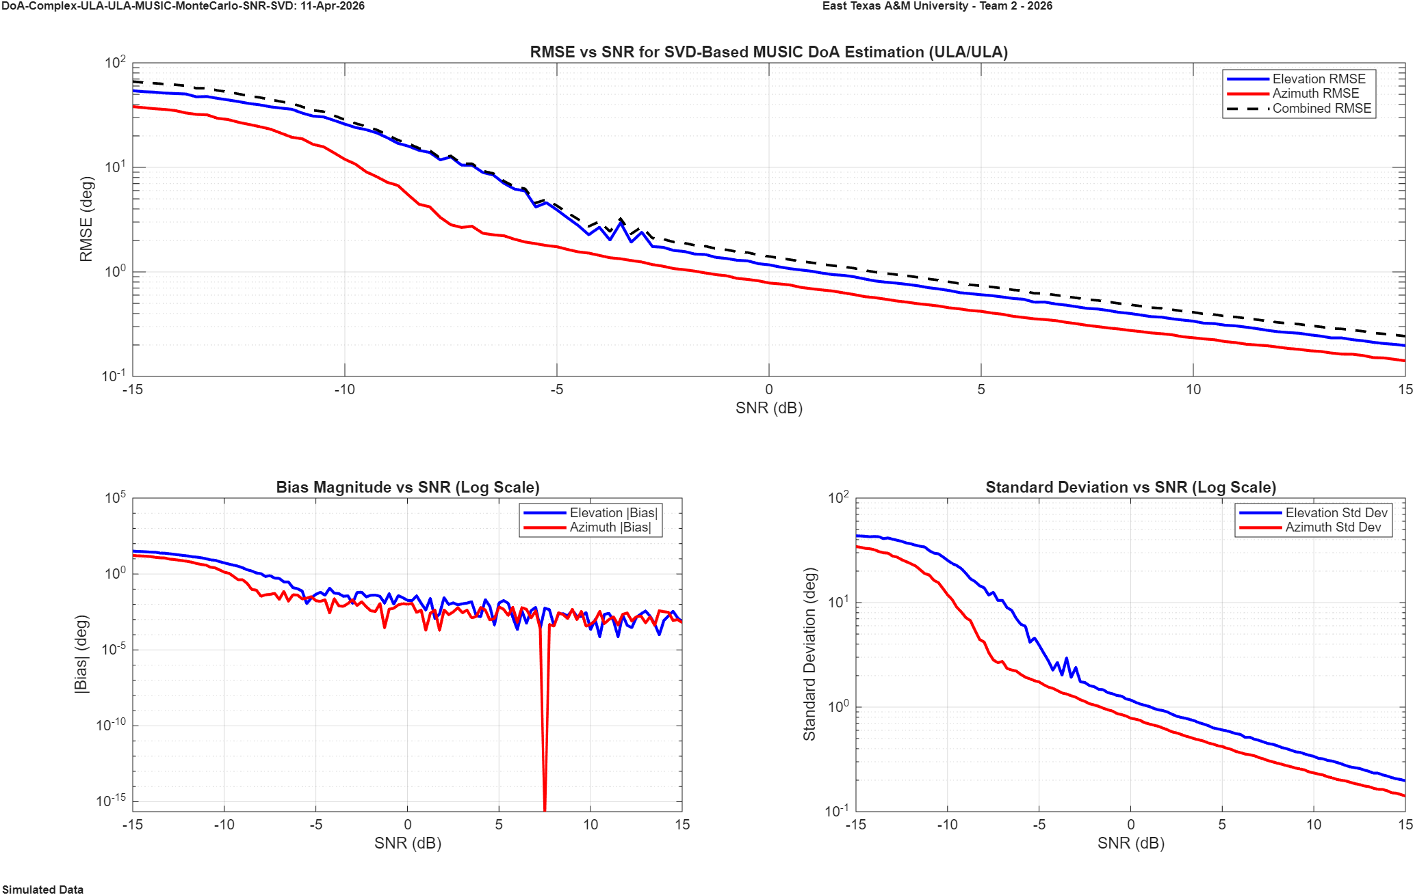
Figure 4.1.2 SVD - MUSIC ULA/ULA DoA SNR vs. Accuracy Simulation (Log Scale)
SNR: -15:15dB; Snapshots: 32, 768; Freq: 2.4GHz, Trials: 250; Single Moving Source;
Azimuth: 40ᵒ:80ᵒ; Elevation: 20ᵒ:60ᵒ
The next SNR simulation results correspond to the Eigenvalue-based MUSIC (EIG-MUSIC) algorithm applied to the ULA/UCA configuration, as shown in Figure 4.1.2. Overall, the performance trends closely mirror those observed in the SVD-based implementation, confirming that both decomposition methods extract equivalent signal and noise subspaces under ideal conditions. Elevation RMSE again demonstrates a strong dependence on SNR, decreasing significantly as SNR increases and exhibiting a clear transition region near −5dB where subspace separability becomes reliable. At moderate-to-high SNR levels, the elevation estimate achieves sub-degree accuracy, indicating that the eigenvalue-based approach maintains high-resolution capability comparable to SVD. In contrast, azimuth RMSE remains persistently elevated across the entire SNR range, closely tracking the behavior observed in the SVD-based ULA/UCA case. Despite modest improvement with increasing SNR, azimuth error does not approach the accuracy required for reliable localization, instead maintaining a significant error floor. This behavior confirms that the dominant limitation is not the choice of subspace decomposition method, but rather the sequential estimation structure inherent to the ULA/UCA configuration, where azimuth estimation depends on the prior elevation estimate. As a result, residual elevation errors propagate into the azimuth solution, constraining overall performance. The combined RMSE follows the azimuth trend, further reinforcing that azimuth error dominates the aggregate metric. Bias and standard deviation results exhibit the same asymmetry: elevation bias rapidly approaches zero with increasing SNR, while azimuth bias remains large and largely invariant, indicating a systematic, SNR-independent error source. Similarly, azimuth variance remains elevated relative to elevation, confirming that both bias and variance contribute to the persistent azimuth error floor. These results demonstrate that while EIG-MUSIC provides equivalent subspace estimation performance to SVD-MUSIC, it does not mitigate the structural limitations imposed by the hybrid array configuration.
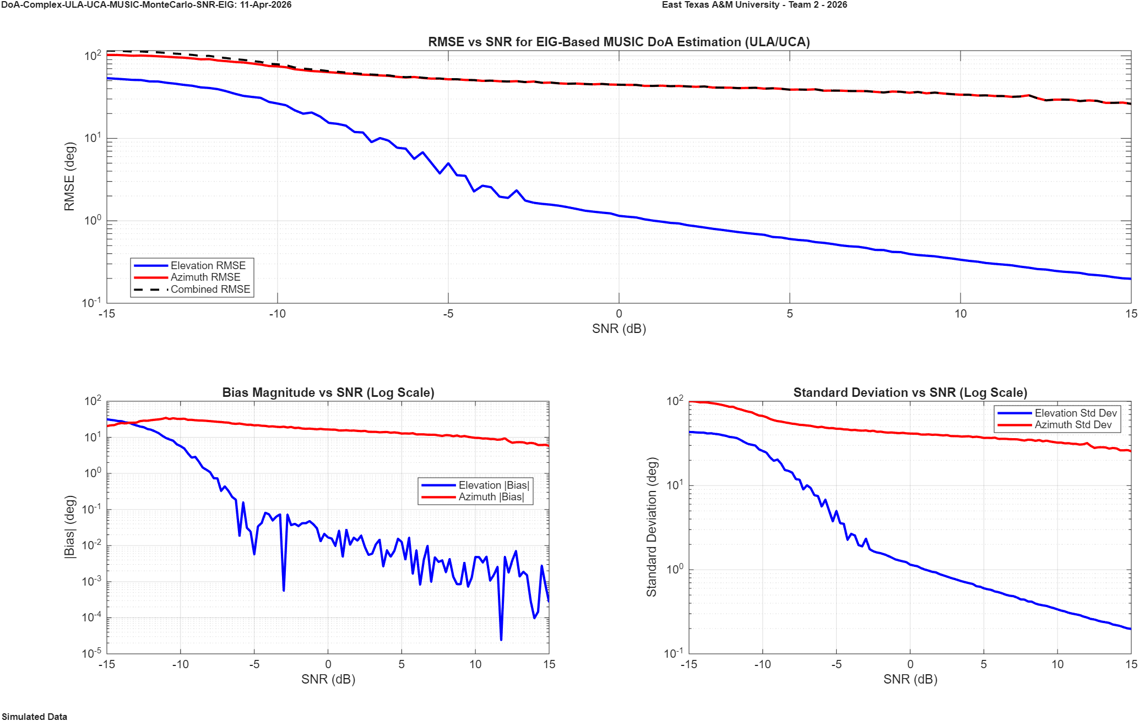
Figure 4.1.3 Eigen - MUSIC ULA/UCA DoA SNR vs. Accuracy Simulation (Log Scale)
SNR: -15:15dB; Snapshots: 32, 768; Freq: 2.4GHz, Trials: 250; Single Moving Source;
Azimuth: 40ᵒ:80ᵒ; Elevation: 20ᵒ:60ᵒ
The results of the SNR Monte Carlo simulation for the Eigenvalue-based MUSIC (EIG-MUSIC) algorithm applied to the dual ULA (ULA/ULA) configuration are shown in Figure 4.1.4. In contrast to the ULA/UCA configuration, both elevation and azimuth channels exhibit highly consistent and well-matched performance across the full SNR range from −15 to +15dB. Elevation RMSE decreases smoothly from approximately 40–50° at low SNR to below 0.3° at high SNR, while azimuth RMSE follows a nearly identical trend, differing only slightly at lower SNR values. Notably, both channels achieve sub-degree accuracy near 0 dB and continue improving with increasing SNR, with no evidence of a persistent error floor. The combined RMSE closely tracks both individual channels, indicating balanced estimation performance and confirming that neither dimension dominates the overall error. The bias and standard deviation plots further reinforce this symmetry. Both elevation and azimuth bias decrease rapidly with increasing SNR, approaching near-zero values beyond approximately −5 dB, which indicates that the estimator is effectively unbiased in moderate-to-high SNR regimes. Similarly, the standard deviation for both channels decreases monotonically and at comparable rates, confirming that RMSE reduction is driven primarily by variance reduction rather than systematic bias. The absence of divergence between elevation and azimuth performance highlights a key advantage of the dual ULA architecture: by treating azimuth and elevation estimation as independent but structurally identical problems, the system avoids the sequential dependency observed in the ULA/UCA configuration. As a result, both dimensions benefit equally from improvements in SNR, yielding a stable and uniformly accurate DoA estimation capability across all operating conditions.
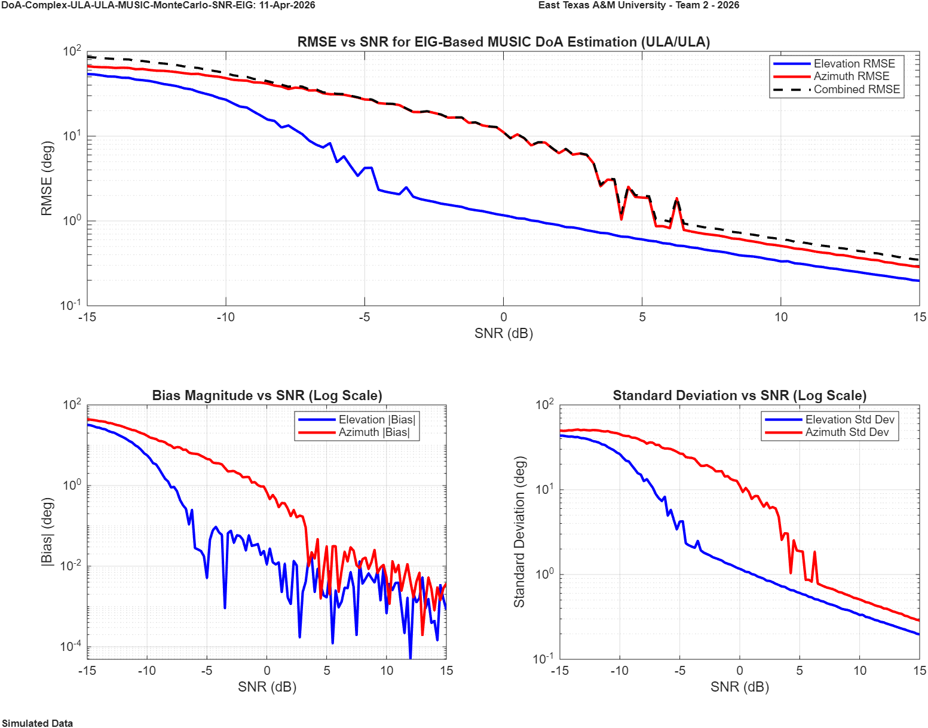
Figure 4.1.4 Eigen - MUSIC ULA/ULA DoA SNR vs. Accuracy Simulation (Log Scale)
SNR: -15:15dB; Snapshots: 32, 768; Freq: 2.4GHz, Trials: 250; Single Moving Source;
Azimuth: 40ᵒ:80ᵒ; Elevation: 20ᵒ:60ᵒ
The final set of SNR simulation results evaluates the performance of the ESPRIT algorithm for the dual ULA (ULA/ULA) configuration. As shown in Figure 4.1.5, both elevation and azimuth channels exhibit highly consistent and stable behavior across the full SNR range, closely mirroring one another in all performance metrics. Elevation and azimuth RMSE decrease smoothly with increasing SNR, achieving sub-degree accuracy near 0 dB and continuing to improve at higher SNR levels without any observable error floor. The combined RMSE closely follows both individual channels, confirming that estimation accuracy is balanced across both dimensions. Similarly, the bias magnitude for both elevation and azimuth rapidly approaches near-zero values beyond approximately −5 dB, while the standard deviation decreases monotonically, indicating that overall error reduction is dominated by variance reduction rather than systematic bias. This behavior highlights the strength of ESPRIT when applied to shift-invariant array structures such as ULAs, where both angular dimensions can be estimated independently and without the need for spectral searching.
In contrast, this type of ESPRIT-based simulation cannot be reliably extended to the ULA/UCA configuration used in earlier sections. Unlike the ULA, the UCA does not inherently satisfy the shift-invariance property required for ESPRIT, and with only four elements, the array lacks sufficient spatial resolution to support accurate phase-mode transformation into a virtual linear structure. As a result, azimuth estimation using ESPRIT on the UCA becomes highly unstable and does not produce meaningful or consistent results across SNR. This limitation reinforces a key conclusion of the study: while ESPRIT offers computational efficiency and high accuracy for linear array geometries, its applicability is fundamentally constrained by array structure, making the dual ULA configuration significantly more suitable for robust 2D DoA estimation in this implementation.

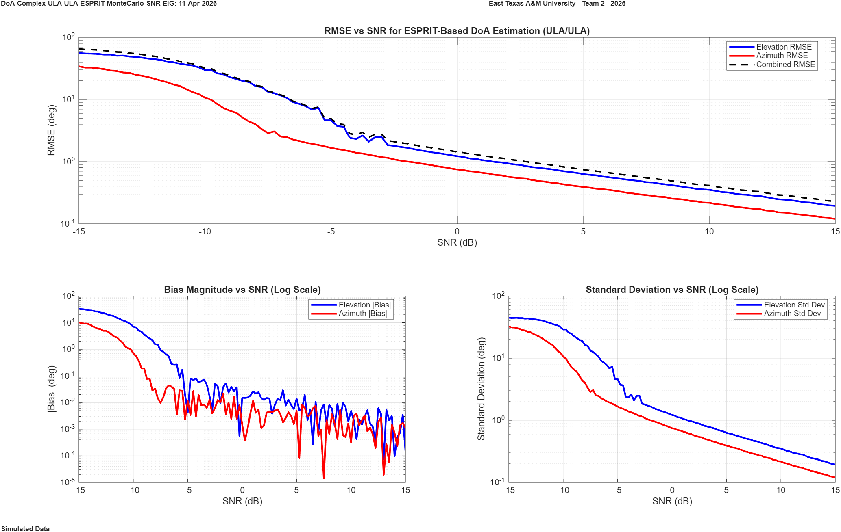
Figure 4.1.5 Eigen - ESPRIT ULA/ULA DoA SNR vs. Accuracy Simulation (Log Scale)
SNR: -15:15dB; Snapshots: 32, 768; Freq: 2.4GHz, Trials: 250; Single Moving Source;
Azimuth: 40ᵒ:80ᵒ; Elevation: 20ᵒ:60ᵒ
The second set of Monte Carlo simulations evaluates the performance of the MUSIC and ESPRIT algorithms under a limited number of snapshots. This is a critical factor for real-time systems, as increasing the number of snapshots generally improves estimation accuracy but also increases computational time, reducing real-time capability. The objective of this analysis is to identify a snapshot count that balances estimation accuracy and computational efficiency. By varying the number of snapshots, the impact on RMSE, bias, and estimation stability can be observed, providing insight into the minimum data requirements for reliable DoA estimation.
. This limitation reinforces a key conclusion of the study: while ESPRIT offers computational efficiency and high accuracy for linear array geometries, its applicability is fundamentally constrained by array structure, making the dual ULA configuration significantly more suitable for robust 2D DoA estimation in this implementation.

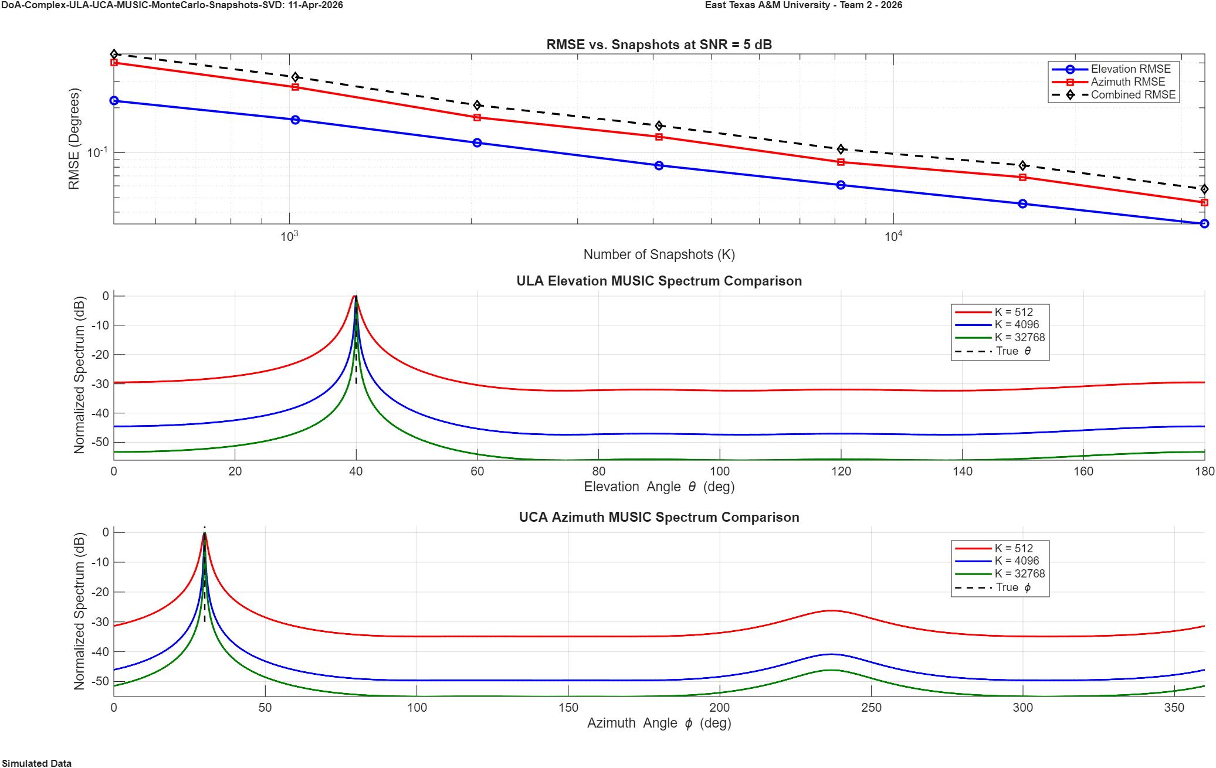
Figure 4.1.6 SVD - MUSIC ULA/UCA DoA Snapshots vs. Accuracy Simulation (Log Scale)
SNR: 5dB; Snapshots: 512: 32,768; Freq: 2.4GHz, Trials: 250; Single Static Source;
Azimuth: 30ᵒ; Elevation: 40ᵒ

4.2 Reciver SubSystem
- Objectives:
  - ed performance.
  - The Rx subsystem served as the functional front-end for all system-level DOA estimation tests, providing the necessary input data for the processing algorithms.

4.3 Overall Results, Analysis and Discussion (Brian)
The testing
more controlled RF environments.

5. Project Management

5.1 Project Plan
For any large-scale project to succeed, goals must be set with defined time allocations so that continuous progress can be maintained across all fronts. For this project, a modular development strategy was implemented wherein multiple subsystems were constructed concurrently, then individually tested and verified before full system integration. This parallel approach reduces development bottlenecks by allowing hardware fabrication, algorithm simulation, and system verification to proceed on independent timelines without one blocking another. The five major phases of this project are the Literature Review, Software Simulations, Array Construction and Testing, Algorithm Implementation and Verification, and Project Close, each of which is detailed below and reflected in the project schedule shown in Figure 5.1.1.
The Literature Review phase established the theoretical and comparative foundation upon which all subsequent work depends. This phase covered a survey of prior work in subspace-based DOA estimation, a comparative study of relevant algorithmic approaches, development of the mathematical background underlying MUSIC and ESPRIT, and formal project definition. Concentrating this work early in the project timeline ensured that algorithm design decisions and hardware choices were grounded in a thorough understanding of the existing literature before any implementation effort began.
The Software Simulations phase represents the most technically demanding portion of the project and spans the longest segment of the development timeline. This phase encompasses Monte Carlo trials for both linear and circular array geometries, antenna modeling and simulation, core algorithm development, combinational simulations integrating multiple system parameters, and range simulations. By exhaustively validating algorithm performance in simulation before committing to physical hardware, this phase provides a reliable performance baseline and surfaces any design issues at a stage where corrections are far less costly. The breadth of this phase reflects the central role that computational verification plays in the overall project methodology.
The Array Construction and Testing phase covers the physical realization and verification of both the linear and circular antenna arrays, alongside initial range finding trials using the LiDAR subsystem. Each array was constructed, tested, and verified independently before being considered ready for integration, consistent with the modular strategy guiding the project. This phase overlaps deliberately with the later stages of the Software Simulations phase, allowing hardware fabrication to proceed in parallel with the final rounds of algorithmic refinement rather than waiting for simulation work to fully conclude.
The Algorithm Implementation and Verification phase brings all three subsystems together for the first time, implementing azimuth estimation, elevation estimation, and range finding on physical hardware and validating each against known ground truth conditions. This phase culminates in real-world trials that serve as the definitive test of the full integrated system. The sequential structure within this phase — verifying each estimation dimension before proceeding to combined real-world trials — mirrors the modular philosophy applied throughout the project, ensuring that any integration issues can be isolated to a specific subsystem rather than the system as a whole.
The Project Close phase encompasses final data collection, compilation of the full project report, and preparation of the official publication. Data collection is noted as a continuous activity throughout this phase rather than a discrete endpoint, reflecting the fact that results from real-world trials may be gathered incrementally as testing conditions permit. This phase also marks the convergence of all documentation streams maintained throughout the project — hardware records, algorithm development logs, CAD files, and simulation results — into the unified final deliverables. A detailed scheduling appendix accompanies this report, containing the bi-weekly progress reports submitted throughout the project period as well as a day-by-day activity log providing a complete and auditable account of the project's execution.

Figure 5.1.1 Project Plan GNATT Chart

Contribution of Team Members
The successful execution of this project required clearly defined roles and distributed ownership across all major subsystems. Each team member assumed primary responsibility for a specific domain of the project while contributing to the broader collaborative effort, ensuring that hardware development, algorithm design, simulation, and documentation progressed in parallel without gaps in coverage.
Brandon Lewis served as Team Leader with a primary focus on project scheduling, comprehensive documentation, and algorithm development support. Brandon was responsible for maintaining the project timeline and ensuring that all phases advanced according to plan, while simultaneously keeping the project record thorough and organized across hardware, simulation, and experimental results. In addition to his organizational responsibilities, Brandon contributed directly to algorithm development through simulation work, bridging the coordination and technical sides of the project throughout its full duration.
Logan Boxdorfer served as the lead developer of the ESPRIT algorithm, carrying the implementation from its mathematical foundations through simulation and verification. In addition to his primary ownership of ESPRIT, Logan contributed to the development of the MUSIC algorithm, bringing familiarity with both subspace estimation approaches and allowing the two algorithms to be developed with a shared understanding of their underlying signal processing framework. His work across both algorithms made him a central contributor to the project's core computational deliverables.
Parker Reeves served as the lead developer of the MUSIC algorithm, taking primary ownership of its design, implementation, and validation across both simulation and live experimental conditions. Parker also contributed to the development of the ESPRIT algorithm alongside Logan, ensuring that both subspace methods were developed collaboratively and with cross-verified results. His combined involvement in both algorithms provided a strong link between the two estimation approaches and contributed to the consistency of the project's signal processing outcomes.
Alden Edwards led the physical fabrication effort for the project, designing and producing the 3D printed structural models for the antenna array configurations. His work translated the theoretical array geometries into physical hardware, providing the mechanical foundation necessary for real-world testing and experimental validation. Beyond fabrication, Alden contributed to the LiDAR range finding subsystem, supporting the integration of the mechanical and sensing components that enabled spatial localization within the full system.
Colton Vandenburg was the lead developer of the LiDAR-based range estimation algorithm, designing the system from the ground up and serving as the team's primary technical authority on range finding. In addition to his LiDAR contributions, Colton provided critical technical support for the RF system implementation in Linux, ensuring that the signal processing pipeline could operate reliably within the project's software environment. His expertise across both the range estimation and RF implementation domains made him essential to the integration of the system's sensing and processing subsystems.
Dr. Nizar Tayem served as the primary faculty advisor for the project, providing technical and strategic guidance throughout all phases of development. His advisory role encompassed helping the team define a clear and realistic project scope, establishing challenging but attainable goals, and ensuring that all technical decisions remained aligned with the project's overall research objectives. Dr. Tayem's expertise in array signal processing and subspace-based estimation methods provided the team with a strong theoretical foundation from which to develop and validate the MUSIC and ESPRIT algorithms. Dr. Redha Radaydeh served as a faculty advisor contributing additional technical oversight and guidance to the project. His involvement supported the team's efforts in algorithm development and system verification, providing an additional layer of expert review that strengthened the rigor of the project's methodology and results.

5.3 Project Execution Monitoring
Maintaining consistent progress across a multi-subsystem project of this scale required structured oversight mechanisms operating at regular intervals throughout the full development timeline. Project execution was monitored through three primary channels: recurring bi-weekly progress reports, periodic formal presentations, and submission deadlines associated with the Air Force Research Laboratory (AFRL) program.
Bi-weekly progress reports served as the primary instrument of ongoing project monitoring, providing a regular cadence of documented accountability across all phases of development. Each report captured the work completed during the preceding two-week period, identified any obstacles encountered, outlined the planned objectives for the following period, and tracked overall alignment with the project schedule. These reports ensured that progress was evaluated continuously rather than only at major milestones, allowing scheduling adjustments and resource reallocations to be made proactively. The complete collection of bi-weekly reports is included in the appendices and provides a granular, chronological record of the project's execution from initiation through close. At key intervals throughout the project, formal presentations were delivered to faculty advisors and relevant stakeholders to provide higher-level progress assessments and solicit technical feedback. These presentations complemented the written reporting cycle by creating structured opportunities for the team to synthesize progress across subsystems, demonstrate interim results, and receive guidance that informed the direction of subsequent development phases.
AFRL submission deadlines introduced additional fixed checkpoints into the project timeline, requiring that deliverables meet external standards on a defined schedule independent of internal project milestones. These deadlines reinforced the discipline of the development cycle and ensured that the project maintained a level of rigor and documentation quality consistent with the expectations of a formal research program. Together, the bi-weekly reports, presentations, and AFRL deadlines formed an integrated monitoring framework that kept the project on schedule and provided a complete and auditable record of its execution.

5.4 Challenges and Decision Making
No large-scale engineering project proceeds exactly as planned, and this project was no exception. Across hardware design, algorithm development, and system integration, the team encountered a series of meaningful challenges that required deliberate decision making to resolve. Each obstacle ultimately informed the direction of the project and contributed to a more robust final system than would have been achieved without the pressure of working through them.
The antenna array subsystem underwent the most visible design evolution of any hardware component in the project. The original design utilized Vert 2540 antennas, which, while capable, presented significant challenges in terms of physical size and form factor that made compact array construction difficult. Beyond the physical constraints, performance considerations further motivated a transition away from this form factor. Following evaluation of available alternatives, the team transitioned to Omni-Directional Mini-WiFi antennas, which offered a substantially reduced footprint while meeting the performance requirements of the array geometry. This change necessitated corresponding revisions to the 3D printed structural mounts designed by Alden Edwards, as the new antenna form factor required updated mechanical accommodations. While the transition added iteration cycles to the fabrication timeline, the resulting array was better suited to the project's spatial and performance requirements than the original design would have been.
The decision to expand the project scope from a single-algorithm implementation to a comparative study of both MUSIC and ESPRIT emerged organically during the Literature Review phase. As the team developed its theoretical foundation, the complementary nature of the two algorithms — and the analytical value of directly comparing their performance across shared simulation conditions — became apparent. Rather than treating ESPRIT as an afterthought, the team made the deliberate decision to develop it as a fully parallel workstream alongside MUSIC, with Logan Boxdorfer taking primary ownership of ESPRIT development and Parker Reeves leading MUSIC. While this decision broadened the project's scope and increased the total development burden, it produced a significantly more complete and publishable body of work, and the comparative simulation framework ultimately strengthened the conclusions that could be drawn about each algorithm's strengths and limitations.
One of the most technically demanding integration challenges encountered was achieving phase synchronization across the FMComms5 software-defined radio board using the multi-chip synchronization protocol. Proper phase coherence across all receiver channels is a fundamental requirement for subspace-based DOA estimation — without it, the phase relationships between array elements that MUSIC and ESPRIT rely upon are corrupted, rendering the algorithms unable to resolve source directions reliably. Resolving the synchronization issue required considerable debugging effort and consumed significantly more time than had been allocated in the original project schedule. The synchronization was ultimately achieved, and the system was brought to a state suitable for real-world trials, but the time cost of this resolution compressed the testing window available at the end of the project.
The timeline remained a persistent background pressure throughout the project. With five major phases spanning concurrent hardware and software development streams, the schedule left limited margin for the kinds of iteration and debugging that complex systems inevitably require. The phase synchronization challenge in particular cascaded into the later stages of the project, tightening the window available for full real-world testing and results development. While all core deliverables were completed, the compressed testing period meant that the depth of experimental validation achieved in the real-world trials was more limited than the team had originally targeted. This outcome reflects a common tension in project-based research between the thoroughness of validation and the realities of a fixed timeline, and it identifies extended real-world testing as the natural next step for future work building on this project.

5.5 Project Bill of Materials and Budget
A comprehensive accounting of all materials and equipment required for this project is provided in Table 5.5.1. The total estimated equipment value across all project hardware stands at $12,094, however the cost of new equipment purchased directly by the team amounts to only $210. This outcome reflects a deliberate and resourceful approach to hardware acquisition, most of the equipment was inherited from existing East Texas A&M University (ETAMU) laboratory inventory or provided through the Air Force Research Laboratory (AFRL) program, allowing the team to work with professional-grade hardware without drawing significantly on a direct procurement budget.
The most significant individual items in the budget are the AD-FMComms5-EBZ software-defined radio boards, valued at $1,386 each, of which one unit was provided by AFRL and three additional units were sourced from existing ETAMU inventory. The NI USRP 2901, valued at $2,817, was likewise inherited from existing university resources, as were the SMA coaxial cables, SMA coaxial connectors, host PC, and EK-Z7-ZC702-G boards. The Raspberry Pi 5 kits, RC truck platform, SDHC cards, and battery packs were procured through ETAMU at no direct cost to the team. The linear antenna array, circular antenna array, and RF moving track were designed and fabricated in-house by the team, representing a significant contribution of labor and engineering effort that carries no direct material line-item cost.
The only expenditure on new equipment charged for the project was the antenna hardware upgrade and the new LiDAR. Twenty 2.4 GHz Omni-Directional antennas were procured at $6 each, totaling $120, representing the transition away from the original Vert 2540 antennas to a smaller, better-performing alternative better suited to the array geometry and integration requirements. Despite being an unplanned design revision, the antenna upgrade was accomplished at minimal cost and stands as one of the few instances where the project's evolving hardware requirements translated into a direct expenditure. The TF-02 LiDAR was the other expenditure required because of the new range finding system being added.
Beyond equipment costs, the project incurred additional expenses that fell outside the scope of the formal Bill of Materials. Travel to Ohio to present project findings to AFRL stakeholders represented a real and unplanned project cost in transportation, accommodations, and time that does not appear in any hardware line item. Such dissemination-related expenses are an inherent feature of projects operating within formal research programs and represent a category of cost that should be explicitly budgeted for in future projects of similar scope. When considered alongside the $120 in equipment expenditure, the total out-of-pocket cost of executing this project remains remarkably low relative to the $12,004 in hardware value the team had access to, a testament to the value of the ETAMU and AFRL resource ecosystems supporting this work.
Table 5.5.1 Complete Project Bill of Materials
Materials/Equipment | Quantity | Expected Provider | Price
NI USRP 2901 | 1 | ETAMU - Existing | $2,817/ea.
SMA Coaxial Cable(s) | 10 | ETAMU - Existing | $1/ft
SMA Coaxial Connectors | 20 | ETAMU - Existing | $17/ea.
Raspberry Pi 5 Kit | 2 | ETAMU | $130/ea.
Kei RC Truck | 1 | ETAMU | $70/ea.
SDHC Cards 5 pack | 1 | ETAMU | $35/ea.
Battery Pack | 2 | ETAMU | $18/ea.
Host PC | 1 | ETAMU - Existing | N/A
Linear Antenna Array | 1 | Team | N/A
Circular Antenna Array | 1 | Team | N/A
2.4GHz Omni-Directional Ant. | 20 | ETAMU | $6/ea.
Tf-02 LiDAR Pro | 1 | ETAMU | $90/ea.
RF Moving Track | 1 | Team | N/A
AD-FMCOMMS5-EBZ | 1 | AFRL | $1,386/ea.
AD-FMCOMMS5-EBZ | 3 | ETAMU - Existing | $1,386/ea.
EK-Z7-ZC702-G | 2 | ETAMU - Existing | $1,386/ea.
Total Cost: |  |  | $12,094
Cost of New Equipment: |  |  | $210

Project Analysis

6.1 Life-long Learning
One of the most valuable outcomes of this project extends beyond the technical deliverables themselves — it is the practical engineering experience gained by operating within a real, large-scale project from the ground up. For every member of this team, this project represented the first time managing an engineering effort of this complexity, where external deadlines, multi-subsystem dependencies, and formal research obligations created a level of accountability that no standard coursework assignment can fully replicate.
Project management emerged as one of the most immediately demanding non-technical skills the project required. Managing a concurrent development schedule across algorithm design, hardware fabrication, and system integration meant that delays in one subsystem had real consequences for others. The phase synchronization challenge on the FMComms5 board served as the clearest example of this dynamic — what initially appeared to be a manageable integration task consumed significantly more time than planned, forcing the team to redistribute effort, compress timelines in other areas, and work harder across the board to absorb the schedule impact without sacrificing the integrity of the final deliverables. Learning to respond to that kind of unplanned pressure — not by cutting corners but by recalibrating priorities and increasing output — is a skill that cannot be taught in a lecture and is only developed by living through it.
The decision to pursue an exceptionally rigorous documentation standard throughout the project was a deliberate strategic choice, and one that this team believes distinguishes this work from comparable efforts. Maintaining thorough records of simulation results, experimental outcomes, and design decisions is common practice, but extending that rigor to areas like electrical CAD documentation for wire harnesses — a level of detail that no competing team had previously undertaken — reflected a conviction that completeness and professionalism in the project record would provide a competitive edge. That conviction proved correct, and the experience of building and maintaining that standard of documentation throughout a long and demanding project has fundamentally shaped how each team member will approach engineering record-keeping in their professional careers. The understanding that a well-documented project is not just easier to write up at the end, but is itself evidence of engineering competence, is one of the most transferable lessons this project produced.
Working within the AFRL program introduced a dimension of professional accountability that stands apart from the academic context in which the project was nominally situated. Bi-weekly reporting obligations, formal submission deadlines, and the upcoming presentation of results to AFRL stakeholders in Ohio collectively created an environment far closer to industry practice than to a typical senior design experience. Preparing technical work to a standard suitable for external review — where the audience has domain expertise and high expectations — required a level of polish, precision, and self-critical evaluation that pushed the team's communication and presentation skills in ways that internal academic review alone would not have.
Taken together, the experience of scoping a project, building and maintaining a schedule under real pressure, making strategic decisions about documentation and design, and producing work intended for a professional research audience has provided this team with a practical foundation that will inform how each member approaches engineering work throughout their career. The technical knowledge gained in subspace-based DOA estimation, array signal processing, and embedded system integration is significant — but it is this broader set of professional engineering competencies, developed under genuine constraints and real stakes, that may ultimately prove the more durable outcome of the project.

6.2 Impact of Engineering Solutions
The work produced by this project contributes to the broader engineering landscape in several meaningful ways, spanning the advancement of RF localization methodology, the practical guidance it offers to future system designers, and its demonstration that high-capability direction-of-arrival estimation can be realized within the constraints of accessible, low-cost hardware platforms.
At its most fundamental level, this project serves as a proof of concept for a true real-time RF tracking system built on subspace-based estimation algorithms. While MUSIC and ESPRIT are well-established in the academic literature, their practical implementation on physical hardware within an integrated system — combining software-defined radio, physical antenna arrays, and LiDAR-based range finding — demonstrates that these algorithms are not merely theoretical constructs but viable foundations for deployable RF localization systems. This distinction matters because the gap between a working simulation and a working physical system is rarely trivial, and closing that gap, as this project does, advances the engineering community's understanding of what these algorithms demand in practice and where their real-world limitations lie.
One of the most practically transferable contributions of this project is the direct comparative analysis between the MUSIC and ESPRIT algorithms across shared simulation conditions and array geometries. Rather than advocating for one approach universally, this work frames the selection between them as an engineering design decision governed by application-specific constraints. MUSIC, as a spectral search method, offers higher resolution and greater accuracy at the cost of increased computational complexity — making it better suited to applications where precision is the dominant requirement and processing resources are available. ESPRIT, by contrast, sacrifices some estimation accuracy in exchange for significantly reduced computational overhead by exploiting rotational invariance rather than performing an exhaustive spectral search — making it more appropriate for applications where speed, simplicity, or hardware constraints are primary concerns. By quantifying what is gained and lost in each direction, this project gives future engineers a concrete, empirically grounded basis for algorithm selection rather than relying solely on theoretical characterizations.
The investigation of both Uniform Linear Array and Uniform Circular Array geometries further extends the practical utility of this work. Array geometry is a foundational design decision in any RF localization system, and the choice between a ULA and a UCA carries significant implications for angular coverage, spatial resolution, and system complexity. By evaluating algorithm performance across both geometries, this project provides insight into how array configuration interacts with algorithm selection — a pairing of decisions that real system designers must make together rather than independently. This contribution is particularly relevant for engineers working on applications such as autonomous vehicle navigation, drone detection, spectrum monitoring, or any defense-adjacent RF sensing context where both the physical form factor of the array and the computational profile of the estimation algorithm must be jointly optimized.
The comparative simulation framework, the physical hardware implementation, and the documented performance characterization across SNR, snapshot count, and array geometry — constitute a reference foundation that future engineers and researchers can build upon. By demonstrating that a capable, multi-algorithm RF localization system can be realized and validated within the resource constraints of a university research program, this project lowers the barrier to entry for future work in this space and establishes a replicable methodology for proof-of-concept RF tracking system development.

6.3 Contemporary Issues Addressed
The proje

7. Conclusions and Future Recommendations

7.1 Conclusions
The project successfully developed a real-time Direction of Arrival (DOA) estimation system capable of tracking
of adaptive problem solving, thorough testing, and system-level thinking in the development of contemporary engineering solutions.

7.2 Future Recommendations
To advance the
will bridge the gap between controlled lab environments and complex real-world scenarios, unlocking applications in autonomous navigation, smart cities, and defense.

8. References (Ernesto)
[1] - Private communications with Dr. Nizar Tayem, East Texas A&M University
[3] – ni.com, USRP images. [Online] Available: USRP
[5] – “analog.com”, FMCOMMS5 image. Available: FMCOMMS5
[6] – “kamami.pl”, ZC702 image. Available: ZC702
[7] – “github.com”, PiSDR Image for Raspberry Pi SDR Applications. Available: PiSDR Image
[8] – “te.com”, MAF94300 Multi-Band Antenna Product Page. Available: MAF94300 Antenna

Appendix A: Progress Reports

Senior Design Project – Weekly Meeting Report (September 17, 2025)

Team Member Names | Present/Absent | Arriving on Time
Logan Boxdorfer | Yes | Yes
Alden Edwards | Yes | Yes
Brandon Lewis | Yes | Yes
Colton Vandenburg | Yes | Yes
Parker Reeves | Yes | Yes

Task Progress Report for Last Week’s Effort:
Task Number | Task Description | Members Assigned | Progress | Delivery Proof
1 | Literature Review: B. Kaplan, İ. Kahraman, A. R. Ekti, S. Yarkan, A. Görçin, M. K. Özdemir, and H. A. Çırpan,  “Detection, Identification, and Direction of Arrival Estimation of Drone FHSS Signals with Uniform Linear Antenna Array,” A. Martian, C. Paleacu, I.-M. Marcu, and C. Vladeanu,  “Direction-Finding for Unmanned Aerial Vehicles Using Radio Frequency Methods,” Y. Albagory and A. Ashour,  “MUSIC 2D-DOA Estimation Using Split Vertical Linear and Circular Arrays,” S. A. Alawsh, O. O. Al Basheer, A. O. Sirag, and A. H. Muqaibel,  “Range and Angle Measurements Based on Software Defined Radio Platform,” | All Team Members | 50%
2 | Complete an in-depth Mathematical Background review of the MUSIC Algorithm for both Linear and Circular Array Designs | All Team Members | 25%
3 | Design the 3D CAD Model of the Vertical Linear Array | Alden Edwards | 50%
4 | Understand how to use the FMComms5/Zynq Board as it communicates with the Host Computer to run MATLAB and receive data from the antennas | Colton Vandenburg, Parker Reeves, Logan Boxdorfer | 60%
5 | Document all research and progress | Brandon Lewis | --%

Task Allocation for Next Week:
Task Number | Task Description | Members Assigned
1 | Complete the Literature Review | All Team Members
2 | Finish Mathematical Background review of the MUSIC Algorithm for both Linear and Circular Array Designs | All Team Members
3 | Finish the design of the linear array and design the 3D CAD Model of the Circular Array | Alden Edwards
4 | Use the Host Computer Oscilloscope to receive data transmitted from the USRP-2901 | Colton Vandenburg, Parker Reeves
5 | Start the Linear Array Monte Carlo Trails | Logan Boxdorfer, Brandon Lewis
6 | Continue Documentation | Brandon Lewis

IEEE Standards & Codes
All of the following tasks mentioned above will follow the IEEE standards and codes as listed above to maintain technical consistency, safety, interoperability, and ethical engineering practices. Adhering to IEEE guidelines ensures that all hardware, software, and communication systems are designed and implemented according to globally recognized benchmarks for quality, reliability, and electromagnetic compatibility. Furthermore, compliance with these standards promotes uniform documentation, test procedures, and data reporting, allowing the project outcomes to be both verifiable and reproducible within the broader engineering community.

- ISO/IEC/IEEE 15288 – Systems and software engineering – System Life Cycle Processes
- ISO/IEC/IEEE 42010 – Systems and software engineering – Architecture description
- ISO/IEC/IEEE 29119 – Software and systems engineering – Software Testing
- IEEE 1936.1-2021 – Standard for Drone Applications Framework
- IEEE / ISO/IEC 26514-2021 – Design and development of information for users of software
- IEEE 829 – Standard for Software and System Test Documentation
- IEEE 1012 – Standard for Software Verification and Validation
IEEE 730 – Standard for Software Quality Assurance Plans

SEMESTER: | Fall | ACADEMIC YEAR: | 2025-2026
PROJECT TITLE: | UAV Tracking System for Azimuth, Elevation, and Range Estimation for Indoor/Outdoor  Application
SUPERVISORS: | Nizar Tayem
Senior Design Project – Weekly Meeting Report (October 1, 2025)
Team Member Names | Present/Absent | Arriving on Time
Logan Boxdorfer | Yes | Yes
Alden Edwards | Yes | Yes
Brandon Lewis | Yes | Yes
Colton Vandenburg | Yes | Yes
Parker Reeves | Yes | Yes

Task Progress Report for Last Week’s Effort:
Task Number | Task Description | Members Assigned | Progress | Delivery Proof
1 | Literature Review: B. Kaplan, İ. Kahraman, A. R. Ekti, S. Yarkan, A. Görçin, M. K. Özdemir, and H. A. Çırpan,  “Detection, Identification, and Direction of Arrival Estimation of Drone FHSS Signals with Uniform Linear Antenna Array,” A. Martian, C. Paleacu, I.-M. Marcu, and C. Vladeanu,  “Direction-Finding for Unmanned Aerial Vehicles Using Radio Frequency Methods,” Y. Albagory and A. Ashour,  “MUSIC 2D-DOA Estimation Using Split Vertical Linear and Circular Arrays,” S. A. Alawsh, O. O. Al Basheer, A. O. Sirag, and A. H. Muqaibel,  “Range and Angle Measurements Based on Software Defined Radio Platform,” | All Team Members | 100% | Documentation has been completed for all of the literature review that’s has been planned at this time.
2 | Complete an in-depth Mathematical Background review of the MUSIC Algorithm for both Linear and Circular Array Designs | All Team Members | 75% | Linear has been completed, circular next.
3 | Design the 3D CAD Model of the Linear & Circular Array | Alden Edwards | 75% | 3D Printed Linear
4 | Use the Host Computer Oscilloscope to receive data transmitted from the USRP-2901 | Colton Vandenburg, Parker Reeves | 100% | Successful transmission & reception of 2.4GHz signal.
5 | Continue Documentation. | Brandon Lewis | --% | Literature review has been documented.
6 | Linear Array Monte Carlo Trails | Logan Bocdorfer, Brandon Lewis | 45%

Task Allocation for Next Week:
Task Number | Task Description | Members Assigned
1 | Complete the Linear Array Monte Carlo Trails. | Logan Boxdorfer, Brandon Lewis
2 | Finish Mathematical Background review of the MUSIC Algorithm for both Linear and Circular Array Designs | All Team Members
3 | Finish design model of the Circular Array | Alden Edwards
4 | Start the Circular Array Monte Carlo Trails after mathematical background is completed | Colton Vandenburg, Parker Reeves
5 | Continue Documentation | Brandon Lewis

IEEE Standards & Codes
All of the following tasks mentioned above will follow the IEEE standards and codes as listed above to maintain technical consistency, safety, interoperability, and ethical engineering practices. Adhering to IEEE guidelines ensures that all hardware, software, and communication systems are designed and implemented according to globally recognized benchmarks for quality, reliability, and electromagnetic compatibility. Furthermore, compliance with these standards promotes uniform documentation, test procedures, and data reporting, allowing the project outcomes to be both verifiable and reproducible within the broader engineering community.

- ISO/IEC/IEEE 15288 – Systems and software engineering – System Life Cycle Processes
- ISO/IEC/IEEE 42010 – Systems and software engineering – Architecture description
- ISO/IEC/IEEE 29119 – Software and systems engineering – Software Testing
- IEEE 1936.1-2021 – Standard for Drone Applications Framework
- IEEE / ISO/IEC 26514-2021 – Design and development of information for users of software
- IEEE 829 – Standard for Software and System Test Documentation
- IEEE 1012 – Standard for Software Verification and Validation
- IEEE 730 – Standard for Software Quality Assurance Plans

Senior Design Project – Weekly Meeting Report (October 29, 2025)

Team Member Names | Present/Absent | Arriving on Time
Logan Boxdorfer | Yes | Yes
Alden Edwards | Yes | Yes
Brandon Lewis | Yes | Yes
Colton Vandenburg | Yes | Yes
Parker Reeves | Yes | Yes

Task Progress Report for Last Week’s Effort:
Task Number | Task Description | Members Assigned | Progress | Delivery Proof
1 | Complete the Linear Array Monte Carlo Trails. | Logan Boxdorfer, Brandon Lewis | 85% | Simulations run but need to be touched up before documentations.
2 | Finish Mathematical Background review of the MUSIC Algorithm for both Linear and Circular Array Designs | All Team Members | 100% | Documentation on the full mathematical breakdown of the MUSIC algorithm has been completed.
3 | Finish design model of the Circular Array | Alden Edwards | 100% | Both Arrays have been 3D printed
4 | Start the Circular Array Monte Carlo Trails after mathematical background is completed | Colton Vandenburg, Parker Reeves | 10%
5 | Continue Documentation | Brandon Lewis | --% | The mathematical documentation for the MUSIC algorithm has been completed.

Task Allocation for Next Week:
Task Number | Task Description | Members Assigned
1 | Finish Linear Array Monte Carlo Trails | Logan Boxdorfer, Brandon Lewis
2 | Redesign the Linear and Circular Antenna arrays for the smaller antennas and coax cable constraints. | Alden Edwards
3 | Continuing working on the Circular Array Monte Carlo Trails | Parker Reeves
4 | Start design on the Pan & Tilt subsystem for the LiDAR Range Finding and research how to data transfer from MATLAB to Arduino. | Alden Edwards, Colton Vandenburg
5 | Start the basics of the real-time algorithm for MUSIC | Brandon Lewis, Parker Reeves
6 | Continue Documentation | Brandon Lewis

IEEE Standards & Codes
All of the following tasks mentioned above will follow the IEEE standards and codes as listed above to maintain technical consistency, safety, interoperability, and ethical engineering practices. Adhering to IEEE guidelines ensures that all hardware, software, and communication systems are designed and implemented according to globally recognized benchmarks for quality, reliability, and electromagnetic compatibility. Furthermore, compliance with these standards promotes uniform documentation, test procedures, and data reporting, allowing the project outcomes to be both verifiable and reproducible within the broader engineering community.

- ISO/IEC/IEEE 15288 – Systems and software engineering – System Life Cycle Processes
- ISO/IEC/IEEE 42010 – Systems and software engineering – Architecture description
- ISO/IEC/IEEE 29119 – Software and systems engineering – Software Testing
- IEEE 1936.1-2021 – Standard for Drone Applications Framework
- IEEE / ISO/IEC 26514-2021 – Design and development of information for users of software
- IEEE 829 – Standard for Software and System Test Documentation
- IEEE 1012 – Standard for Software Verification and Validation
- IEEE 730 – Standard for Software Quality Assurance Plans

Senior Design Project – Weekly Meeting Report (November 13. 2025)

Team Member Names | Present/Absent | Arriving on Time
Logan Boxdorfer | Yes | Yes
Alden Edwards | Yes | Yes
Brandon Lewis | Yes | Yes
Colton Vandenburg | Yes | Yes
Parker Reeves | Yes | Yes

Task Progress Report for Last Week’s Effort:
Task Number | Task Description | Members Assigned | Progress | Delivery Proof
1 | Finish Linear Array Monte Carlo Trails | Logan Boxdorfer, Brandon Lewis | 99% | Ready to review for changes but completed.
2 | Redesign the Linear and Circular Antenna arrays for the smaller antennas and coax cable constraints. | Alden Edwards | 85% | Linear array has been redesigned and reprinted.
3 | Continuing working on the Circular Array Monte Carlo Trails | Parker Reeves | 80%
4 | Start design on the Pan & Tilt subsystem for the LiDAR Range Finding and research how to data transfer from MATLAB to Arduino. | Alden Edwards, Colton Vandenburg | 20%
5 | Start the basics of the real-time algorithm for MUSIC | Brandon Lewis, Parker Reeves | 5%
6 | Continue Documentation | Brandon Lewis | --% | Documentation of the individual components that will be used has been completed.

Task Allocation for Next Week:
Task Number | Task Description | Members Assigned
1 | Complete the Circular Array Monte Carlo Trails | Logan Boxdorfer, Parker Reeves
2 | Continue working on the Pan & Tilt subsystem for the LiDAR Range Finding | Alden Edwards, Colton Vandenburg
3 | Start real progress on the real-time MUSIC algorithm implementation. | Brandon Lewis, Parker Reeves
4 | Start documentation for the final semester report which should include all applicable results and simulations from the previous weeks. | Logan Boxdorfer, Brandon Lewis
5 | Complete Midterm Presentation and AFRL Presentation | Brandon Lewis

IEEE Standards & Codes
All of the following tasks mentioned above will follow the IEEE standards and codes as listed above to maintain technical consistency, safety, interoperability, and ethical engineering practices. Adhering to IEEE guidelines ensures that all hardware, software, and communication systems are designed and implemented according to globally recognized benchmarks for quality, reliability, and electromagnetic compatibility. Furthermore, compliance with these standards promotes uniform documentation, test procedures, and data reporting, allowing the project outcomes to be both verifiable and reproducible within the broader engineering community.

- ISO/IEC/IEEE 15288 – Systems and software engineering – System Life Cycle Processes
- ISO/IEC/IEEE 42010 – Systems and software engineering – Architecture description
- ISO/IEC/IEEE 29119 – Software and systems engineering – Software Testing
- IEEE 1936.1-2021 – Standard for Drone Applications Framework
- IEEE / ISO/IEC 26514-2021 – Design and development of information for users of software
- IEEE 829 – Standard for Software and System Test Documentation
- IEEE 1012 – Standard for Software Verification and Validation
- IEEE 730 – Standard for Software Quality Assurance Plans

Senior Design Project – Weekly Meeting Report (January 28. 2026)

Team Member Names | Present/Absent | Arriving on Time
Logan Boxdorfer | Yes | Yes
Alden Edwards | Yes | Yes
Brandon Lewis | Yes | Yes
Colton Vandenburg | Yes | Yes
Parker Reeves | Yes | Yes

Task Progress Report for Last Week’s Effort:
Task Number | Task Description | Members Assigned | Progress | Delivery Proof
1 | Reviewed the Total Least Squares (TLS) Matrix method and the Matrix Pencil method, to assess suitability for the project. | Parker Reeves  Brandon Lewis  Logan Boxdorfer | 40%
2 | Conducted initial outdoor system testing to verify hardware setup and operational procedures; no data collection was performed during this phase. | All Team Members | 10%
3 | Designed and constructed a mechanical testing platform capable of moving the USRP testbed in both azimuth and elevation for controlled angle-of-arrival experiments. | Alden Edwards, Colton Vandenburg | 30%
4 | Continued development and refinement of signal processing algorithms, forward-backward averaging, initial data input analysis. | Parker Reeves  Brandon Lewis  Logan Boxdorfer | 40%
5 | Continuing design manufacturing of portable “black-box” to surround the Zynq-FMComms5 board arrangement. | Alden Edwards  Colton Vandenburg  Brandon Lewis | 50%
6 | Conducted preliminary testing using a drone-based transmitter to evaluate whether the emitted signal could be successfully captured by the antenna array. | Parker Reeves  Logan Boxdorfer | 25%

Task Allocation for Next Week:
Task Number | Task Description | Members Assigned
1 | Finish conducting the TLS and Matrix Pencil applicability and decide how it will be represented in the paper. | Brandon Lewis, Parker Reeves
2 | Conduct more outdoor testing and record results. | All Team Members
3 | Finish design of the mechanical testing platform capable of moving the USRP testbed and the portable black-box (if all parts arrive). | Alden Edwards,  Colton Vandenburg
4 | Refine the drone-based transmission-reception and find out if flying the drone will be possible/allowed. | Parker Reeves,  Logan Boxdorfer
5 | Finish forward-backward averaging method and input data reduction. | Parker Reeves  Logan Boxdorfer  Brandon Lewis

IEEE Standards & Codes
All of the following tasks mentioned above will follow the IEEE standards and codes as listed above to maintain technical consistency, safety, interoperability, and ethical engineering practices. Adhering to IEEE guidelines ensures that all hardware, software, and communication systems are designed and implemented according to globally recognized benchmarks for quality, reliability, and electromagnetic compatibility. Furthermore, compliance with these standards promotes uniform documentation, test procedures, and data reporting, allowing the project outcomes to be both verifiable and reproducible within the broader engineering community.

- ISO/IEC/IEEE 15288 – Systems and software engineering – System Life Cycle Processes
- ISO/IEC/IEEE 42010 – Systems and software engineering – Architecture description
- ISO/IEC/IEEE 29119 – Software and systems engineering – Software Testing
- IEEE 1936.1-2021 – Standard for Drone Applications Framework
- IEEE / ISO/IEC 26514-2021 – Design and development of information for users of software
- IEEE 829 – Standard for Software and System Test Documentation
- IEEE 1012 – Standard for Software Verification and Validation
- IEEE 730 – Standard for Software Quality Assurance Plans

Senior Design Project – Weekly Meeting Report (February 11. 2026)

Team Member Names | Present/Absent | Arriving on Time
Logan Boxdorfer | Yes | Yes
Alden Edwards | Yes | Yes
Brandon Lewis | Yes | Yes
Colton Vandenburg | Yes | Yes
Parker Reeves | Yes | Yes

Task Progress Report for Last Week’s Effort:
Task Number | Task Description | Members Assigned | Progress | Delivery Proof
1 | Continue the development of the MUSIC algorithm but applying to both the ULA/UCA and ULA/ULA configurations. | Parker Reeves,  Logan Boxdorfer | 70%
2 | Develop the ESPRIT algorithm for both the ULA/UCA and ULA/ULA configurations. | Parker Reeves,  Logan Boxdorfer | 30%
3 | The mechanical testing apparatus has been constructed. Moving now to start data collection testing with measured out degree’s starting with stationary source. | Alden Edwards,  Colton Vandenburg,  Brandon Lewis | 30%
4 | Redesigning of the Range finding, hopefully to switch from Arduino to Raspberry Pi 4 to get faster data transfer. | Alden Edwards,  Colton Vandenburg | 40%
5 | Prepare for AFRL presentation on February 18th, hopefully to show a live demo during the presentation of at least one algorithm | All Team Members | 90%
6 | Start the data collection, final paper writing, and CAD drawing documentation. Final Paper due to AFRL on March 16th. | Brandon Lewis | 15%

Task Allocation for Next Week:
Task Number | Task Description | Members Assigned
1 | Finish algorithm development and start field testing for both arrays and both algorithms. | Brandon Lewis,  Parker Reeves,  Logan Boxdorfer
2 | Conduct more outdoor testing and record results. | All Team Members
3 | Decide if the Arduino can be swapped for Raspberry Pi 4 and how much better it will be for data transfer/speed since not going from MATLAB->Arduino IDE | Alden Edwards,  Colton Vandenburg
4 | Refine the drone-based transmission-reception and find out if flying the drone will be possible/allowed. | Parker Reeves,  Logan Boxdorfer
5 | Finish CAD drawings for group to review, then let  Dr. Moler review them and get ready for publishing, and complete writing the paper about the MUSIC  and ESPRIT | Parker Reeves  Logan Boxdorfer  Brandon Lewis

IEEE Standards & Codes
All of the following tasks mentioned above will follow the IEEE standards and codes as listed above to maintain technical consistency, safety, interoperability, and ethical engineering practices. Adhering to IEEE guidelines ensures that all hardware, software, and communication systems are designed and implemented according to globally recognized benchmarks for quality, reliability, and electromagnetic compatibility. Furthermore, compliance with these standards promotes uniform documentation, test procedures, and data reporting, allowing the project outcomes to be both verifiable and reproducible within the broader engineering community.

- ISO/IEC/IEEE 15288 – Systems and software engineering – System Life Cycle Processes
- ISO/IEC/IEEE 42010 – Systems and software engineering – Architecture description
- ISO/IEC/IEEE 29119 – Software and systems engineering – Software Testing
- IEEE 1936.1-2021 – Standard for Drone Applications Framework
- IEEE / ISO/IEC 26514-2021 – Design and development of information for users of software
- IEEE 829 – Standard for Software and System Test Documentation
- IEEE 1012 – Standard for Software Verification and Validation
- IEEE 730 – Standard for Software Quality Assurance Plans

Senior Design Project – Weekly Meeting Report (February 11. 2026)

Team Member Names | Present/Absent | Arriving on Time
Logan Boxdorfer | Yes | Yes
Alden Edwards | Yes | Yes
Brandon Lewis | Yes | Yes
Colton Vandenburg | Yes | Yes
Parker Reeves | Yes | Yes

Task Progress Report for Last Week’s Effort:
Task Number | Task Description | Members Assigned | Progress | Delivery Proof
1 | Continue the development of the MUSIC algorithm but applying to both the ULA/UCA and ULA/ULA configurations. Focus on using elevation angle in azimuth estimation | Parker Reeves,  Logan Boxdorfer | 70%
2 | Complete redesign of the Range Finding system with optimized algorithm development | Alden Edwards,  Colton Vandenburg | 90%
3 | Conduct further testing of the complex array geometries; These results will replace the current static tests in the AFRL paper | All Team Members | 35%
4 | Complete re-printing of the array structure with the optimized plastic fill parameters. | Alden Edwards | 25%
5 | Prepare for AFRL Resubmission on April 10th, with revised paper and appendices | Brandon Lewis | 45%

Task Allocation for Next Week:
Task Number | Task Description | Members Assigned
1 | Complete the Demo Script modifications for MUSIC / ESPRIT where when not connect to hardware it will enter simulation mode. (AFRL Required) | Parker Reeves,  Logan Boxdorfer
2 | Conduct more complex indoor testing with the added range finding for paper resubmission. | All Team Members
3 | Develop and practice AFRL Demo presentation and determine which array configuration will be presented. | Logan Boxdorfer,  Alden Edwards,  Colton Vandenburg
4 | Continue writing the new report in lab report format for final presentations at the end of the semester. | Brandon Lewis,  Logan Boxdorfer
5 | Start writing the How-To-Operate appendices to pass down to next year’s team so they do not have to waste as much time as we did | All Team Members
6 | Select a conference to present the paper using the proved AFRL budget, selections due April 14th | Brandon Lewis

IEEE Standards & Codes
All of the following tasks mentioned above will follow the IEEE standards and codes as listed above to maintain technical consistency, safety, interoperability, and ethical engineering practices. Adhering to IEEE guidelines ensures that all hardware, software, and communication systems are designed and implemented according to globally recognized benchmarks for quality, reliability, and electromagnetic compatibility. Furthermore, compliance with these standards promotes uniform documentation, test procedures, and data reporting, allowing the project outcomes to be both verifiable and reproducible within the broader engineering community.

- ISO/IEC/IEEE 15288 – Systems and software engineering – System Life Cycle Processes
- ISO/IEC/IEEE 42010 – Systems and software engineering – Architecture description
- ISO/IEC/IEEE 29119 – Software and systems engineering – Software Testing
- IEEE 1936.1-2021 – Standard for Drone Applications Framework
- IEEE / ISO/IEC 26514-2021 – Design and development of information for users of software
- IEEE 829 – Standard for Software and System Test Documentation
- IEEE 1012 – Standard for Software Verification and Validation
- IEEE 730 – Standard for Software Quality Assurance Plans

Appendix B: Resumes

Logan Boxdorfer
Mesquite, TX | M: (214) 557-1701 | logbox03@yahoo.com
linkedin.com/in/loganboxdorfer
EDUCATION

East Texas A&M University Commerce, TX Honors College
Electrical Engineering May 2026 President’s Honor Roll 2022-2024, Dean’s List 2024-2025
GPA: 3.82/4.0

RELEVANT WORK EXPERIENCE

Oncor Electric Delivery - Engineer Intern Fort Worth, TX Assets Planning - Transmission Planning - Area Planning - Metro August 2025 - January 2026
- Steady-state post-contingency analysis (N-1, N-1-1)
Assets Planning - System Protection - Relay Settings May 2025 - August 2025
- Developed, maintained, validated protective relay configurations for various distribution substations across service area
- Modeled distribution substation equipment and protective line devices, ensured proper operation timing of all protective relays in order to provide system protection & maximize customers/load served
Assets Planning - Transmission Planning - Technical Studies May 2024 - August 2024
- Performed post-contingency analysis to evaluate system stability and reliability

TECHNICAL PROJECTS

Direction of Arrival (DoA) Estimation - 2025 - 2026 AFRL Software Defined Radio (SDR) Challenge May 2025 - April 2026
- Team of 5: Developing DoA and range estimation system capable of real-time UAV tracking in (φ, θ, m)
- Hardware: Uniform Circular Array (UCA), Uniform Linear Array (ULA), LiDAR on pan-tilt assembly
- Software: MATLAB (processing, estimation, visualization); Hardware: AMD Zynq ZC702, ADI FMComms5

Generation Redispatch Script December 2025
- Researched and created script to redispatch generation in order to mitigate thermal/voltage violations under contingency conditions

Substation Relay Settings July 2025
- New Installation — 10 device settings issued
- Conducted short-circuit and Thevenin equivalent studies to validate settings under various fault conditions (LG, LL, LLLG)
- Coordinated line device, feeder and transformer protection using standard protection package
- Verified protection coordination with Inverse Time-Overcurrent Curve graph

Large Load Interconnect Study July 2024 - August 2024
- Studied 350MW load addition to Dallas Metro area — verified proper system recovery
- Gathered and presented voltage, current, frequency, and phase bus data that substantiated approval of the load addition
QV Curve Analysis May 2024
- Analyzed relationship between voltage, reactive power, and power factor of a bus subsystem in Tarrant County while applying simulated disturbances
- Concluded 145 MVAR of capacitive compensation to correct power factor and voltage to meet requirements
ACTIVITIES
IEEE Student Club - Vice President April 2025 – Present
- Founded weekly 2-3 hour study sessions that encourage retention of all course material by reviewing separate EE courses each week as an effort to pass FE exam in a student’s final semester of EE program
Materials: FE Reference Handbook, NCEES FE Interactive Practice Exam, FE Electrical and Computer Review Manual
Drone Club - Member January 2023 – April 2025
- Understand basic drone flight mechanics, explore UAV assembly/disassembly, and improve flight skills
IEEE Student Club - Member September 2023 – April 2025
- Study emerging technology found in IEEE publications
ADDITIONAL
Digital Technical Skills: PSS/E, ASPEN OneLiner, Python, MATLAB, NI Multisim, LabVIEW, Excel
Physical Technical Skills: Standard lab equipment and general assembly, NI Elvis III/EMONA Communications Board, Power Lab equipment, Microcontrollers
Awards: Automation Challenge 4th Place 2024, Honors College Scholarship 2022-2025, Presidential Scholarship 2022-2025, Col. Sparkman Scholarship Endowment 2023-2024, Buddy & Debby Barnes Scholarship Endowment 2023-2024, Silver Exemplary Engineer Award 2023-2024

Alden Edwards
Commerce, TX 75428
alden.edwards0404@gmail.com | (469) 536-6123

Objective
Senior Electrical Engineering student with hands-on experience in circuit design, power systems, and MATLAB/Python programming. Seeking entry-level roles in power, embedded, or automotive industries.

Education
B.S. Electrical Engineering – East Texas A&M University
Aug 2022 – May 2026 | GPA: 3.56
A.S. Science – Collin College
Aug 2018 – May 2022 | GPA: 3.21

Experience
Engineering Intern - GEUS, Greenville, TX
March 2025 – Present
- Supported electrical engineers in developing distribution system models, using Milsoft’s WindMil.
- Programmed SEL protection relays
- Attended job sites and planning meetings for new generation and transmission projects

Outdoor Adventure Staff & Climbing Wall Supervisor - East Texas A&M University, Campus Recreation
May 2024 – Mar 2025
- Supervised climbing operations and ensured safety compliance.
- Led challenge course team-building events and set climbing routes.

Physics II Learning Assistant - East Texas A&M University
Jan 2024 – May 2024
- Assisted students with electromagnetism concepts and lab activities.
- Graded assignments and supported course delivery under Dr. Park.

Projects
QAM System – Spring 2025
- Designed a QAM transmitter/receiver using op-amps, filters, BJTs, and amplifiers.
- Mixed 1–10 kHz voice signals with 100 kHz carriers, then transmitted; implemented coherent detection and filtering to recover message at the receiver side.
Guitar Pedals – Spring 2023, Fall 2024
- Designed and built multiple analog guitar-effect pedal circuits, focusing on signal characteristics, filtering, and distortion. Conducted hands-on prototyping, component selection, and bench testing to refine tone and ensure reliable operation.
Senior Design Project (In Progress), UAV Tracking System for Azimuth, Elevation, and Range Estimation for Indoor/Outdoor Applications – Fall 2025 to Spring 2026
- Develop a hybrid Direction-of-Arrival (DoA) system with synchronized SDR hardware utilizing MUSIC algorithms and LiDAR range-finding, capable of real-time UAV tracking in azimuth/elevation planes.
- Publication of experimental results and presentation in the AFRL University Design Challenge (March 2026).
- My work involves the design and development of 3D-CAD models for uniform circular and vertical antenna array configurations, also engineered a servo-controlled Pan/Tilt subsystem to enable precise LiDAR rotation in both azimuth and elevation planes.

Brandon Lewis
107 S 6th Street, Celeste, Texas 75423
(903) 413-5169 blewis35@leomail.tamuc.edu
Objective
- Determined student currently pursuing a Bachelor of Science degree in Electrical Engineering and Mathematics. A collaborative, team player that can also function as an independent worker who is interested in obtaining an entry-level full-time position in the engineering field after graduation.
Education
Texas A&M University Anticipated Start: August 2026
- Master’s Program: Electrical Engineering (MSEE)
Program Acceptance
East Texas A&M University August 2022 - May 2026
- Undergraduate: Electrical Engineering (BSEE)
GPA: 3.96
Celeste High School August 2018 - May 2022
- Graduated 3rd in class with a GPA of 4.6
- Honors & Distinguished Graduate
Experience
L3 Harris Technologies May 2025 - Present
- Electrical Engineer, Electrical Harness CAD Design
- Aero Recon Electrical Group, RC-135 Mission Eqpt
East Texas A&M University June 2022 - May 2025
- Student Worker, Data Entry
Awards/Honors
- E-TAMU Presidential Promise Recipient
- E-TAMU Blue and Gold Scholarship Recipient
- President’s List Honors (Fall 2022, Spr 2023, Fall 2023, Fall 2024, Spring 2025)
- E-TAMU Sophomore Electrical Engineering Student of the Year
- E-TAMU Junior Electrical Engineering Student of the Year
Strengths/Skills
- Collaborator - Leadership
- Multitasking - MATLAB
- Autodesk Inventor - Multisim Circuit Design
Projects
Real-Time Analog Quadrature Amplitude Modulation January 2025 - May 2025
- Tx/Rx of two signals using Amplitude Modulation with custom built analog filter design and implementation.
AFRL: Real-Time UAV Tracking Azimuth, Elevation & Range August 2025 - May2026
- Construct circular (UCA) and hybrid linear (ULA) antenna arrays with a LiDAR based pan/tilt assembly to estimate azimuth, elevation and range.
Reference Contact Information
Chris Phillips, L3 Harris, Electrical Mission Equipment, Manager
Phone: (903)-217-9181
Email: christopher.a.phillips@l3harris.com
Jill Woodruff, TAMU-C, College of Education, Data Systems Manager
Phone: (903)-408-7071
Email: jill.woodruff@tamuc.edu

Parker Reeves
(903) 268-8805 Commerce, TX 75428
preeves1@leomail.tamuc.edu reevesparker4@gmail.com

Education
East Texas A&M University
Bachelor of Science – Electrical Engineering & Physics Expected Graduation – Spring 2026 Cumulative 3.92 GPA
• IEEE membership
• President’s List Distinctions
• Recognition of Excellence Distinctions

Technical Skills
  - MATLAB/Simulink - Python - Microsoft Office
  - Project Management - Studio5000 - Problem Solving
  - Signal Processing - AutoCAD - Circuit Design
  - Data Visualization - Product Design - Customer Service

Professional Experience
Kimberly Clark-Paris Paris, Texas
Electrical Engineering Co-Op Spring/Summer 2024
• Advised contractors on hardware installation
• Drew up Electrical and Mechanical drawings for an industrial setting
• Coordinated projects with teams of engineers

East Texas A&M Physics Department Commerce, Texas
Student Physics Researcher Summer 2023
• Researched the nature of Bulk Nuclear Matter
• Developed code to approximate macroscopic nuclear phenomena
• Collaborated in a team of undergraduate and graduate students

East Texas A&M Engineering Department Commerce, Texas
Student Engineering Researcher Spring 2025
• Researched bacterial chemotaxis
• Developed code to approximate microscopic biological signal pathways
• Contributed to published findings

Project Experience
RAMON Laser Spindle Project
Kimberly-Clark – Upgrade of material spindle sensors on factory machine lines
• Interfaced and modified active Allen-Bradley PLCs using Studio5000
• Drew electrical diagrams for factory machine upgrades
• Formulated lockout plans for machine-specific systems
• Advised contractors on 4 mechanical/electrical installations on factory lines
• Reduced required maintenance for material spindle sensors

“Coal” Automatic Denial Project
Kimberly-Clark – Upgrade of product conveyor system to include automatic denial of improperly packaged product
• Formulated and pitched project idea to engineering manager
• Drew mechanical and electrical diagrams for conveyor system upgrades
• Modified Allen-Bradley PLC to interface with Keyence IX-360W Scanner and Processor • Eliminated need for physical removal of improperly packaged products from conveyor line

Colton Vandenburg
Colton.vandenburg56@gmail.com • (903) 274-8481

Education

East Texas A&M University, Commerce TX | August 2022 - Present
Bachelor of Science in Electrical Engineering
GPA: 3.62 | Expected Graduation: May 2026
Honors: President’s Honor Roll 2022-2024, Dean’s List 2024-2025

Professional experience

Kimberly-Clark Corporation, Neenah, WI | May 2025 - Present

Electrical Innovation Co-Op
Developed a Python-based CLI and GUI application to transmit and receive TCP commands for newly deployed devices, streamlining testing and integration
Researched emerging industrial communication protocols to support future system upgrades
Kimberly-Clark Corporation, Paris, TX | May 2024 – December 2024

Platform Electrical Engineering Co-Op
Implemented automation systems to optimize asset performance, achieving a 5% reduction in energy consumption
Designed and deployed an interlock-based safety mechanism to eliminate operator errors and protect critical equipment from damage
Directed a team of 3 engineers and 2 contractors to successfully deliver an energy optimization project
QuikTrip, Greenville TX | July 2020 - Present

Part-Time Clerk
Delivered prompt, professional resolution of customer concerns, supporting consistently high satisfaction ratings
Collaborated with team members to achieve and exceed store performance targets and quarterly sales goals

Engineering Projects

PLC Communication Testing and Upgrade | August 2025
Developed custom Python scripts to establish reliable TCP communication between Allen‑Bradley PLCs and host systems
Implemented functionality to identify and manage multiple PLCs concurrently, improving scalability and testing efficiency
IO-Link Add-On-Instruction (AOI) Development | July 2025
Programmed an Add-On Instruction for Allen-Bradley PLCs to enable active communication with IO-Link devices
Simplified sensor parameter changes for engineering teams
Tools: RSLogix (Studio 5000), IO-Link, PLC Programming
Predictive Text Machine Learning AI | April 2023
Designed and implemented a basic predictive text AI model to generate context-aware word suggestions.
Trained the model on sample text datasets, applying simple natural language processing techniques to improve prediction accuracy.
Evaluated model performance and iteratively refined algorithms to enhance output relevance and user experience.

Skills

Programming Languages: Python, MATLAB, C++, x86 Assembly, PLC Programming
Software & Tools Rockwell Application Suite, Git, JMP, Microsoft Office
Technical Knowledge: Industrial Networking, Drives & Controls Troubleshooting

Appendix C: Supplemental Results

Supporting the results presented in Section 4 (System Testing, Verification & Analysis), the following tables provide the complete datasets corresponding to each figure. Each figure presented in Section 4 has a complementary dataset contained within this appendix, allowing the reader to examine the precise values underlying every plotted result. These tables include raw measurements, derived metrics, and summary statistics for both the simulation and real-world test conditions, offering a more granular view of system performance than the figures alone convey. Where relevant, units, sampling rates, and test configuration details are noted alongside each table to ensure full reproducibility and transparency of the reported results.
The following tables present the complete numerical results for the Monte Carlo simulations corresponding to Figures 4.1.1 through 4.1.5, in which the signal-to-noise ratio (SNR) was swept from −15 dB to 15 dB in increments of 0.25 dB, yielding 121 discrete SNR points. At each increment, 250 independent trials were conducted for each of the three algorithms under evaluation — SVD-MUSIC, Eigen-MUSIC, and ESPRIT — producing a total of 90,750 trials across the full simulation. These results provide the statistical basis for the performance comparisons presented in Section 4, allowing the behavior of each algorithm to be examined at a finer resolution than the figures alone convey.

Table 4.1.1 SVD - MUSIC ULA/UCA DoA SNR vs. Accuracy Simulation Data
SNR: -15:15dB; Snapshots: 32, 768; Freq: 2.4GHz, Trials: 250; Single Moving Source;
Azimuth: 40ᵒ:80ᵒ; Elevation: 20ᵒ:60ᵒ
SNR (dB) | Elevation RMSE (ᵒ) | Azimuth RMSE (ᵒ) | Combined RMSE (ᵒ) | Elevation Bias (ᵒ) | Azimuth Bias (ᵒ) | Elevation Std Dev (ᵒ) | Azimuth Std Dev (ᵒ)
-15.00 | 53.39 | 102.33 | 115.42 | 31.26 | 17.83 | 43.28 | 100.77
-14.75 | 52.51 | 102.35 | 115.04 | 30.37 | 21.45 | 42.84 | 100.09
-14.50 | 52.88 | 102.28 | 115.14 | 30.19 | 20.88 | 43.42 | 100.13
-14.25 | 50.80 | 100.93 | 113.00 | 28.10 | 22.60 | 42.33 | 98.38
-14.00 | 50.08 | 100.56 | 112.34 | 26.85 | 22.77 | 42.27 | 97.95
-13.75 | 49.57 | 99.59 | 111.24 | 25.91 | 23.61 | 42.27 | 96.75
-13.50 | 48.77 | 99.42 | 110.74 | 25.28 | 26.46 | 41.71 | 95.84
-13.25 | 47.60 | 97.13 | 108.17 | 23.53 | 24.90 | 41.39 | 93.88
-13.00 | 45.71 | 97.69 | 107.86 | 21.63 | 28.35 | 40.27 | 93.49
-12.75 | 44.28 | 95.39 | 105.16 | 19.97 | 27.93 | 39.52 | 91.21
-12.50 | 43.18 | 93.25 | 102.76 | 18.62 | 29.39 | 38.96 | 88.50
-12.25 | 42.02 | 92.40 | 101.51 | 17.46 | 31.28 | 38.23 | 86.95
-12.00 | 40.00 | 90.37 | 98.82 | 15.76 | 29.99 | 36.76 | 85.25
-11.75 | 39.20 | 89.21 | 97.44 | 14.79 | 32.00 | 36.31 | 83.28
-11.50 | 38.16 | 86.75 | 94.78 | 13.43 | 31.62 | 35.72 | 80.79
-11.25 | 35.05 | 85.14 | 92.07 | 11.54 | 33.32 | 33.10 | 78.35
-11.00 | 33.02 | 81.30 | 87.75 | 9.84 | 32.46 | 31.52 | 74.54
-10.75 | 31.39 | 80.90 | 86.78 | 8.61 | 32.44 | 30.19 | 74.12
-10.50 | 29.34 | 78.49 | 83.80 | 7.29 | 32.93 | 28.43 | 71.26
-10.25 | 28.03 | 76.00 | 81.00 | 6.53 | 32.67 | 27.26 | 68.62
-10.00 | 26.01 | 74.28 | 78.70 | 5.39 | 32.54 | 25.45 | 66.78
-9.75 | 25.52 | 71.28 | 75.71 | 5.01 | 31.12 | 25.02 | 64.13
-9.50 | 22.52 | 70.09 | 73.62 | 3.76 | 31.19 | 22.21 | 62.77
-9.25 | 21.52 | 68.57 | 71.87 | 3.40 | 31.50 | 21.26 | 60.91
-9.00 | 19.28 | 66.02 | 68.78 | 2.56 | 30.06 | 19.11 | 58.78
-8.75 | 19.07 | 64.95 | 67.69 | 2.41 | 29.87 | 18.92 | 57.68
-8.50 | 17.09 | 63.52 | 65.77 | 1.77 | 29.07 | 16.99 | 56.47
-8.25 | 16.07 | 62.10 | 64.15 | 1.59 | 28.70 | 16.00 | 55.07
-8.00 | 13.09 | 62.25 | 63.61 | 0.79 | 29.00 | 13.07 | 55.08
-7.75 | 13.35 | 60.59 | 62.04 | 0.99 | 27.70 | 13.31 | 53.89
-7.50 | 11.00 | 59.77 | 60.77 | 0.50 | 27.20 | 10.99 | 53.22
-7.25 | 10.15 | 58.31 | 59.19 | 0.44 | 26.16 | 10.14 | 52.11
-7.00 | 11.19 | 57.62 | 58.70 | 0.58 | 25.72 | 11.17 | 51.57
-6.75 | 8.98 | 56.88 | 57.58 | 0.31 | 25.22 | 8.97 | 50.98
-6.50 | 8.73 | 55.69 | 56.37 | 0.31 | 24.27 | 8.73 | 50.13
-6.25 | 7.65 | 56.45 | 56.97 | 0.16 | 24.90 | 7.65 | 50.67
-6.00 | 6.34 | 54.44 | 54.81 | 0.13 | 23.38 | 6.34 | 49.17
-5.75 | 5.57 | 53.98 | 54.27 | 0.08 | 22.94 | 5.57 | 48.86
-5.50 | 4.11 | 53.68 | 53.84 | -0.06 | 22.93 | 4.11 | 48.54
-5.25 | 5.04 | 53.02 | 53.26 | 0.03 | 22.37 | 5.04 | 48.07
-5.00 | 3.68 | 52.39 | 52.52 | -0.03 | 21.90 | 3.68 | 47.60
-4.75 | 4.13 | 51.65 | 51.81 | -0.03 | 21.36 | 4.13 | 47.03
-4.50 | 3.20 | 50.59 | 50.69 | -0.02 | 20.46 | 3.20 | 46.27
-4.25 | 3.10 | 51.12 | 51.21 | -0.01 | 20.94 | 3.10 | 46.63
-4.00 | 3.35 | 50.13 | 50.24 | -0.02 | 20.10 | 3.35 | 45.92
-3.75 | 2.05 | 50.18 | 50.22 | -0.06 | 20.27 | 2.05 | 45.91
-3.50 | 1.96 | 49.82 | 49.86 | -0.01 | 19.98 | 1.96 | 45.64
-3.25 | 1.93 | 49.03 | 49.07 | -0.03 | 19.45 | 1.93 | 45.01
-3.00 | 1.81 | 48.98 | 49.02 | -0.06 | 19.43 | 1.81 | 44.97
-2.75 | 1.74 | 48.34 | 48.37 | -0.06 | 18.92 | 1.74 | 44.48
-2.50 | 1.67 | 48.41 | 48.44 | -0.01 | 18.97 | 1.67 | 44.54
-2.25 | 2.21 | 47.61 | 47.66 | -0.03 | 18.43 | 2.21 | 43.90
-2.00 | 1.56 | 46.33 | 46.36 | -0.03 | 17.49 | 1.56 | 42.91
-1.75 | 1.50 | 47.06 | 47.09 | -0.03 | 18.11 | 1.50 | 43.44
-1.50 | 1.45 | 46.22 | 46.24 | -0.04 | 17.49 | 1.45 | 42.78
-1.25 | 1.40 | 45.97 | 45.99 | -0.03 | 17.32 | 1.40 | 42.58
-1.00 | 1.34 | 46.37 | 46.39 | -0.03 | 17.62 | 1.34 | 42.90
-0.75 | 1.30 | 45.24 | 45.26 | -0.02 | 16.80 | 1.30 | 42.00
-0.50 | 1.25 | 45.19 | 45.20 | -0.05 | 16.74 | 1.25 | 41.98
-0.25 | 1.21 | 45.34 | 45.36 | -0.02 | 16.93 | 1.20 | 42.06
0.00 | 1.15 | 44.43 | 44.44 | -0.02 | 16.31 | 1.15 | 41.33
0.25 | 1.12 | 44.25 | 44.26 | -0.03 | 16.15 | 1.12 | 41.19
0.50 | 1.09 | 43.63 | 43.64 | -0.02 | 15.72 | 1.09 | 40.70
0.75 | 1.04 | 43.40 | 43.42 | -0.03 | 15.61 | 1.04 | 40.50
1.00 | 1.02 | 43.25 | 43.26 | -0.02 | 15.51 | 1.02 | 40.37
1.25 | 0.97 | 43.42 | 43.43 | -0.03 | 15.65 | 0.97 | 40.51
1.50 | 0.96 | 42.52 | 42.53 | -0.02 | 15.05 | 0.96 | 39.76
1.75 | 0.91 | 42.34 | 42.35 | -0.01 | 14.90 | 0.91 | 39.63
2.00 | 0.89 | 41.97 | 41.98 | -0.02 | 14.64 | 0.89 | 39.34
2.25 | 0.87 | 42.37 | 42.38 | -0.01 | 14.93 | 0.87 | 39.66
2.50 | 0.82 | 41.85 | 41.85 | 0.00 | 14.57 | 0.82 | 39.23
2.75 | 0.80 | 41.54 | 41.55 | -0.01 | 14.33 | 0.80 | 39.00
3.00 | 0.79 | 40.70 | 40.71 | -0.01 | 13.85 | 0.79 | 38.28
3.25 | 0.76 | 40.19 | 40.19 | -0.01 | 13.51 | 0.76 | 37.85
3.50 | 0.74 | 41.08 | 41.08 | -0.01 | 14.10 | 0.74 | 38.59
3.75 | 0.71 | 40.33 | 40.33 | -0.02 | 13.61 | 0.71 | 37.96
4.00 | 0.69 | 39.94 | 39.94 | 0.00 | 13.35 | 0.69 | 37.64
4.25 | 0.66 | 39.61 | 39.62 | 0.00 | 13.15 | 0.66 | 37.37
4.50 | 0.65 | 39.46 | 39.47 | 0.00 | 13.05 | 0.65 | 37.24
4.75 | 0.62 | 39.81 | 39.81 | 0.00 | 13.23 | 0.62 | 37.55
5.00 | 0.60 | 39.58 | 39.58 | 0.00 | 13.16 | 0.60 | 37.33
5.25 | 0.59 | 39.56 | 39.56 | -0.01 | 13.12 | 0.59 | 37.32
5.50 | 0.58 | 38.57 | 38.57 | -0.01 | 12.49 | 0.58 | 36.49
5.75 | 0.56 | 38.90 | 38.91 | -0.01 | 12.71 | 0.56 | 36.77
6.00 | 0.54 | 37.81 | 37.81 | -0.01 | 12.02 | 0.54 | 35.85
6.25 | 0.52 | 38.58 | 38.59 | -0.01 | 12.50 | 0.52 | 36.50
6.50 | 0.51 | 37.76 | 37.76 | 0.01 | 11.97 | 0.51 | 35.81
6.75 | 0.49 | 37.58 | 37.59 | -0.01 | 11.92 | 0.49 | 35.64
7.00 | 0.47 | 36.98 | 36.98 | 0.01 | 11.51 | 0.47 | 35.14
7.25 | 0.46 | 36.98 | 36.98 | 0.00 | 11.52 | 0.46 | 35.14
7.50 | 0.44 | 38.03 | 38.03 | 0.00 | 12.16 | 0.44 | 36.03
7.75 | 0.44 | 36.68 | 36.68 | 0.00 | 11.31 | 0.44 | 34.89
8.00 | 0.43 | 36.57 | 36.57 | 0.00 | 11.26 | 0.43 | 34.79
8.25 | 0.41 | 35.37 | 35.37 | 0.01 | 10.53 | 0.41 | 33.77
8.50 | 0.40 | 35.92 | 35.92 | 0.00 | 10.88 | 0.40 | 34.23
8.75 | 0.38 | 35.18 | 35.19 | 0.00 | 10.43 | 0.38 | 33.60
9.00 | 0.38 | 34.30 | 34.31 | 0.00 | 9.94 | 0.38 | 32.83
9.25 | 0.36 | 34.99 | 34.99 | -0.01 | 10.36 | 0.36 | 33.42
9.50 | 0.36 | 34.78 | 34.78 | 0.00 | 10.19 | 0.36 | 33.26
9.75 | 0.35 | 34.34 | 34.35 | -0.01 | 9.95 | 0.35 | 32.87
10.00 | 0.34 | 33.12 | 33.12 | 0.00 | 9.26 | 0.34 | 31.80
10.25 | 0.33 | 34.29 | 34.29 | 0.00 | 9.91 | 0.33 | 32.83
10.50 | 0.32 | 32.92 | 32.92 | 0.00 | 9.15 | 0.32 | 31.62
10.75 | 0.31 | 33.08 | 33.08 | 0.00 | 9.22 | 0.31 | 31.77
11.00 | 0.30 | 32.60 | 32.61 | 0.00 | 8.97 | 0.30 | 31.35
11.25 | 0.30 | 32.88 | 32.88 | 0.00 | 9.13 | 0.30 | 31.59
11.50 | 0.29 | 32.34 | 32.34 | 0.00 | 8.83 | 0.29 | 31.11
11.75 | 0.27 | 31.86 | 31.86 | 0.00 | 8.56 | 0.27 | 30.69
12.00 | 0.27 | 31.06 | 31.06 | 0.00 | 8.15 | 0.27 | 29.97
12.25 | 0.26 | 31.59 | 31.59 | 0.00 | 8.41 | 0.26 | 30.45
12.50 | 0.25 | 30.95 | 30.95 | 0.00 | 8.10 | 0.25 | 29.87
12.75 | 0.25 | 29.74 | 29.74 | 0.00 | 7.48 | 0.25 | 28.78
13.00 | 0.24 | 29.36 | 29.36 | 0.00 | 7.32 | 0.24 | 28.44
13.25 | 0.23 | 29.51 | 29.51 | 0.00 | 7.34 | 0.23 | 28.58
13.50 | 0.23 | 28.75 | 28.75 | 0.00 | 6.97 | 0.23 | 27.89
13.75 | 0.22 | 29.43 | 29.43 | 0.00 | 7.32 | 0.22 | 28.51
14.00 | 0.21 | 27.77 | 27.77 | 0.00 | 6.50 | 0.21 | 27.00
14.25 | 0.21 | 26.78 | 26.78 | 0.00 | 6.03 | 0.21 | 26.09
14.50 | 0.21 | 27.07 | 27.07 | 0.00 | 6.17 | 0.21 | 26.36
14.75 | 0.20 | 26.52 | 26.52 | 0.00 | 5.93 | 0.20 | 25.85
15.00 | 0.20 | 26.08 | 26.08 | 0.00 | 5.74 | 0.20 | 25.44

Table 4.1.2 SVD - MUSIC ULA/ULA DoA SNR vs. Accuracy Simulation Data
SNR: -15:15dB; Snapshots: 32, 768; Freq: 2.4GHz, Trials: 250; Single Moving Source;
Azimuth: 40ᵒ:80ᵒ; Elevation: 20ᵒ:60ᵒ
SNR (dB) | Elevation RMSE (ᵒ) | Azimuth RMSE (ᵒ) | Combined RMSE (ᵒ) | Elevation Bias (ᵒ) | Azimuth Bias (ᵒ) | Elevation Std Dev (ᵒ) | Azimuth Std Dev (ᵒ)
-15.00 | 54.19 | 38.17 | 66.28 | 32.32 | 16.65 | 43.50 | 34.35
-14.75 | 52.98 | 37.29 | 64.79 | 30.46 | 15.74 | 43.36 | 33.80
-14.50 | 52.46 | 36.44 | 63.88 | 29.93 | 15.38 | 43.09 | 33.04
-14.25 | 51.40 | 35.85 | 62.67 | 28.70 | 14.61 | 42.65 | 32.74
-14.00 | 50.87 | 34.98 | 61.74 | 27.40 | 13.95 | 42.86 | 32.08
-13.75 | 50.38 | 33.18 | 60.32 | 26.78 | 12.45 | 42.67 | 30.76
-13.50 | 47.33 | 32.13 | 57.20 | 23.81 | 11.61 | 40.91 | 29.96
-13.25 | 47.62 | 31.80 | 57.26 | 23.28 | 11.34 | 41.54 | 29.71
-13.00 | 45.74 | 29.46 | 54.41 | 21.52 | 9.55 | 40.36 | 27.87
-12.75 | 44.17 | 28.67 | 52.66 | 19.77 | 9.00 | 39.49 | 27.22
-12.50 | 42.54 | 26.97 | 50.37 | 18.08 | 8.16 | 38.51 | 25.70
-12.25 | 40.81 | 25.72 | 48.24 | 16.68 | 7.41 | 37.25 | 24.63
-12.00 | 39.61 | 24.47 | 46.56 | 15.43 | 6.72 | 36.49 | 23.53
-11.75 | 37.93 | 23.19 | 44.46 | 13.59 | 5.87 | 35.42 | 22.43
-11.50 | 36.90 | 21.21 | 42.56 | 12.86 | 4.83 | 34.59 | 20.65
-11.25 | 35.97 | 19.42 | 40.88 | 11.63 | 4.20 | 34.04 | 18.96
-11.00 | 33.02 | 18.74 | 37.97 | 10.05 | 3.83 | 31.45 | 18.35
-10.75 | 30.95 | 16.60 | 35.12 | 8.49 | 2.78 | 29.77 | 16.36
-10.50 | 30.35 | 15.73 | 34.18 | 8.02 | 2.53 | 29.27 | 15.52
-10.25 | 28.08 | 13.74 | 31.26 | 6.45 | 1.82 | 27.33 | 13.62
-10.00 | 25.93 | 11.94 | 28.55 | 5.39 | 1.31 | 25.37 | 11.87
-9.75 | 24.09 | 10.75 | 26.38 | 4.47 | 1.12 | 23.67 | 10.69
-9.50 | 22.94 | 9.08 | 24.67 | 3.82 | 0.70 | 22.63 | 9.05
-9.25 | 21.39 | 8.15 | 22.89 | 3.27 | 0.42 | 21.14 | 8.14
-9.00 | 19.21 | 7.20 | 20.52 | 2.55 | 0.42 | 19.05 | 7.19
-8.75 | 17.00 | 6.72 | 18.28 | 1.88 | 0.24 | 16.90 | 6.71
-8.50 | 15.95 | 5.43 | 16.85 | 1.57 | 0.10 | 15.88 | 5.43
-8.25 | 14.56 | 4.44 | 15.22 | 1.16 | 0.09 | 14.51 | 4.44
-8.00 | 13.88 | 4.19 | 14.50 | 1.05 | 0.03 | 13.84 | 4.19
-7.75 | 11.82 | 3.32 | 12.27 | 0.68 | -0.04 | 11.80 | 3.32
-7.50 | 12.57 | 2.82 | 12.89 | 0.78 | -0.05 | 12.55 | 2.82
-7.25 | 10.51 | 2.66 | 10.84 | 0.53 | -0.05 | 10.49 | 2.66
-7.00 | 10.50 | 2.73 | 10.85 | 0.51 | -0.02 | 10.48 | 2.73
-6.75 | 8.94 | 2.34 | 9.24 | 0.30 | -0.07 | 8.94 | 2.34
-6.50 | 8.45 | 2.26 | 8.75 | 0.30 | -0.02 | 8.45 | 2.26
-6.25 | 7.04 | 2.22 | 7.38 | 0.12 | -0.04 | 7.04 | 2.22
-6.00 | 6.21 | 2.05 | 6.54 | 0.11 | -0.04 | 6.21 | 2.05
-5.75 | 5.94 | 1.93 | 6.25 | 0.07 | -0.02 | 5.94 | 1.93
-5.50 | 4.18 | 1.86 | 4.58 | -0.01 | -0.03 | 4.18 | 1.86
-5.25 | 4.59 | 1.79 | 4.93 | -0.03 | -0.03 | 4.59 | 1.79
-5.00 | 3.92 | 1.74 | 4.29 | -0.05 | -0.02 | 3.92 | 1.74
-4.75 | 3.29 | 1.64 | 3.68 | -0.06 | -0.02 | 3.29 | 1.64
-4.50 | 2.78 | 1.56 | 3.19 | -0.04 | -0.02 | 2.78 | 1.56
-4.25 | 2.27 | 1.51 | 2.73 | -0.12 | 0.00 | 2.26 | 1.51
-4.00 | 2.67 | 1.44 | 3.04 | -0.05 | -0.02 | 2.67 | 1.44
-3.75 | 2.02 | 1.37 | 2.44 | -0.05 | -0.01 | 2.02 | 1.37
-3.50 | 2.95 | 1.33 | 3.24 | -0.03 | -0.01 | 2.95 | 1.34
-3.25 | 1.92 | 1.29 | 2.31 | -0.04 | 0.01 | 1.92 | 1.29
-3.00 | 2.39 | 1.24 | 2.70 | -0.01 | -0.02 | 2.39 | 1.24
-2.75 | 1.75 | 1.18 | 2.11 | -0.06 | -0.01 | 1.75 | 1.18
-2.50 | 1.72 | 1.13 | 2.06 | -0.06 | -0.01 | 1.72 | 1.13
-2.25 | 1.61 | 1.08 | 1.93 | -0.03 | 0.01 | 1.60 | 1.08
-2.00 | 1.57 | 1.05 | 1.89 | -0.04 | 0.00 | 1.57 | 1.05
-1.75 | 1.48 | 1.02 | 1.80 | -0.04 | 0.00 | 1.48 | 1.02
-1.50 | 1.47 | 0.98 | 1.76 | -0.03 | 0.01 | 1.47 | 0.98
-1.25 | 1.38 | 0.94 | 1.67 | -0.01 | 0.00 | 1.38 | 0.94
-1.00 | 1.34 | 0.92 | 1.63 | -0.05 | 0.00 | 1.34 | 0.92
-0.75 | 1.29 | 0.87 | 1.56 | -0.01 | 0.01 | 1.29 | 0.87
-0.50 | 1.27 | 0.85 | 1.53 | -0.04 | -0.01 | 1.27 | 0.85
-0.25 | 1.20 | 0.82 | 1.45 | -0.03 | -0.01 | 1.20 | 0.82
0.00 | 1.17 | 0.78 | 1.41 | -0.02 | 0.01 | 1.17 | 0.78
0.25 | 1.12 | 0.77 | 1.35 | -0.02 | -0.01 | 1.12 | 0.77
0.50 | 1.07 | 0.75 | 1.31 | -0.04 | 0.00 | 1.07 | 0.75
0.75 | 1.04 | 0.71 | 1.26 | -0.01 | 0.00 | 1.04 | 0.71
1.00 | 1.02 | 0.69 | 1.23 | 0.00 | 0.00 | 1.02 | 0.69
1.25 | 0.98 | 0.67 | 1.18 | -0.02 | 0.00 | 0.97 | 0.67
1.50 | 0.94 | 0.66 | 1.15 | 0.00 | 0.00 | 0.94 | 0.66
1.75 | 0.93 | 0.63 | 1.12 | 0.00 | 0.00 | 0.93 | 0.63
2.00 | 0.90 | 0.61 | 1.08 | -0.03 | 0.00 | 0.90 | 0.61
2.25 | 0.86 | 0.58 | 1.03 | -0.01 | 0.00 | 0.86 | 0.58
2.50 | 0.82 | 0.57 | 1.00 | -0.01 | 0.00 | 0.82 | 0.57
2.75 | 0.80 | 0.55 | 0.97 | -0.01 | -0.01 | 0.80 | 0.55
3.00 | 0.78 | 0.53 | 0.94 | -0.01 | 0.00 | 0.78 | 0.53
3.25 | 0.76 | 0.51 | 0.92 | -0.01 | 0.00 | 0.76 | 0.51
3.50 | 0.74 | 0.50 | 0.89 | -0.01 | 0.00 | 0.74 | 0.50
3.75 | 0.71 | 0.48 | 0.86 | 0.00 | 0.00 | 0.71 | 0.48
4.00 | 0.69 | 0.47 | 0.83 | 0.00 | 0.01 | 0.69 | 0.47
4.25 | 0.66 | 0.45 | 0.80 | -0.02 | 0.00 | 0.66 | 0.45
4.50 | 0.63 | 0.44 | 0.77 | -0.01 | 0.00 | 0.63 | 0.44
4.75 | 0.62 | 0.43 | 0.75 | 0.00 | 0.00 | 0.62 | 0.43
5.00 | 0.60 | 0.42 | 0.74 | -0.01 | -0.01 | 0.60 | 0.42
5.25 | 0.59 | 0.40 | 0.72 | -0.02 | 0.00 | 0.59 | 0.40
5.50 | 0.58 | 0.39 | 0.70 | -0.01 | 0.00 | 0.58 | 0.39
5.75 | 0.56 | 0.38 | 0.67 | 0.00 | 0.01 | 0.56 | 0.38
6.00 | 0.55 | 0.37 | 0.66 | 0.00 | 0.00 | 0.55 | 0.37
6.25 | 0.51 | 0.36 | 0.62 | 0.00 | -0.01 | 0.51 | 0.36
6.50 | 0.51 | 0.35 | 0.62 | 0.00 | 0.00 | 0.51 | 0.35
6.75 | 0.49 | 0.34 | 0.60 | 0.00 | 0.00 | 0.49 | 0.34
7.00 | 0.48 | 0.33 | 0.58 | -0.01 | 0.00 | 0.48 | 0.33
7.25 | 0.46 | 0.32 | 0.56 | 0.00 | 0.00 | 0.46 | 0.32
7.50 | 0.45 | 0.31 | 0.54 | -0.01 | 0.00 | 0.45 | 0.31
7.75 | 0.44 | 0.30 | 0.53 | 0.00 | 0.00 | 0.44 | 0.30
8.00 | 0.43 | 0.29 | 0.52 | 0.00 | 0.00 | 0.43 | 0.29
8.25 | 0.41 | 0.28 | 0.50 | 0.00 | 0.00 | 0.41 | 0.28
8.50 | 0.40 | 0.28 | 0.49 | 0.00 | 0.00 | 0.40 | 0.28
8.75 | 0.39 | 0.27 | 0.47 | 0.00 | 0.00 | 0.39 | 0.27
9.00 | 0.37 | 0.26 | 0.46 | 0.00 | 0.00 | 0.37 | 0.26
9.25 | 0.37 | 0.26 | 0.45 | 0.00 | 0.00 | 0.37 | 0.26
9.50 | 0.36 | 0.25 | 0.44 | 0.00 | 0.00 | 0.36 | 0.25
9.75 | 0.35 | 0.24 | 0.42 | 0.00 | 0.00 | 0.35 | 0.24
10.00 | 0.34 | 0.23 | 0.41 | 0.00 | 0.00 | 0.34 | 0.23
10.25 | 0.32 | 0.23 | 0.40 | 0.00 | 0.00 | 0.32 | 0.23
10.50 | 0.32 | 0.22 | 0.39 | 0.00 | 0.00 | 0.32 | 0.22
10.75 | 0.31 | 0.22 | 0.38 | 0.00 | 0.00 | 0.31 | 0.22
11.00 | 0.30 | 0.21 | 0.37 | 0.00 | 0.00 | 0.30 | 0.21
11.25 | 0.30 | 0.20 | 0.36 | 0.00 | 0.00 | 0.30 | 0.20
11.50 | 0.29 | 0.20 | 0.35 | 0.00 | 0.00 | 0.29 | 0.20
11.75 | 0.28 | 0.20 | 0.34 | 0.00 | 0.00 | 0.28 | 0.20
12.00 | 0.27 | 0.19 | 0.33 | 0.00 | 0.00 | 0.27 | 0.19
12.25 | 0.26 | 0.19 | 0.32 | 0.00 | 0.00 | 0.26 | 0.19
12.50 | 0.26 | 0.18 | 0.32 | 0.00 | 0.00 | 0.26 | 0.18
12.75 | 0.25 | 0.18 | 0.31 | 0.00 | 0.00 | 0.25 | 0.18
13.00 | 0.24 | 0.17 | 0.30 | 0.00 | 0.00 | 0.24 | 0.17
13.25 | 0.23 | 0.17 | 0.29 | 0.00 | 0.00 | 0.23 | 0.17
13.50 | 0.23 | 0.16 | 0.29 | 0.00 | 0.00 | 0.23 | 0.16
13.75 | 0.22 | 0.16 | 0.28 | 0.00 | 0.00 | 0.22 | 0.16
14.00 | 0.22 | 0.16 | 0.27 | 0.00 | 0.00 | 0.22 | 0.16
14.25 | 0.21 | 0.15 | 0.26 | 0.00 | 0.00 | 0.21 | 0.15
14.50 | 0.21 | 0.15 | 0.26 | 0.00 | 0.00 | 0.21 | 0.15
14.75 | 0.20 | 0.15 | 0.25 | 0.00 | 0.00 | 0.20 | 0.15
15.00 | 0.20 | 0.14 | 0.24 | 0.00 | 0.00 | 0.20 | 0.14

Table 4.1.3 Eigen - MUSIC ULA/UCA DoA SNR vs. Accuracy Simulation Data
SNR: -15:15dB; Snapshots: 32, 768; Freq: 2.4GHz, Trials: 250; Single Moving Source;
Azimuth: 40ᵒ:80ᵒ; Elevation: 20ᵒ:60ᵒ
SNR (dB) | Elevation RMSE (ᵒ) | Azimuth RMSE (ᵒ) | Combined RMSE (ᵒ) | Elevation Bias (ᵒ) | Azimuth Bias (ᵒ) | Elevation Std Dev (ᵒ) | Azimuth Std Dev (ᵒ)
-15.00 | 53.63 | 102.59 | 115.76 | 31.68 | 20.40 | 43.27 | 100.55
-14.75 | 52.87 | 102.72 | 115.53 | 30.45 | 21.51 | 43.22 | 100.45
-14.50 | 52.04 | 101.78 | 114.31 | 29.59 | 21.80 | 42.81 | 99.42
-14.25 | 51.15 | 100.38 | 112.66 | 28.29 | 23.75 | 42.61 | 97.54
-14.00 | 50.89 | 100.91 | 113.02 | 27.94 | 24.94 | 42.54 | 97.79
-13.75 | 49.02 | 100.08 | 111.44 | 25.89 | 24.19 | 41.63 | 97.12
-13.50 | 48.90 | 98.92 | 110.35 | 25.33 | 25.32 | 41.83 | 95.63
-13.25 | 47.17 | 97.73 | 108.52 | 23.15 | 25.41 | 41.10 | 94.38
-13.00 | 46.00 | 96.08 | 106.52 | 21.43 | 25.55 | 40.70 | 92.62
-12.75 | 44.51 | 95.07 | 104.97 | 19.92 | 28.04 | 39.81 | 90.84
-12.50 | 43.42 | 93.22 | 102.83 | 19.05 | 28.96 | 39.02 | 88.61
-12.25 | 41.50 | 90.83 | 99.86 | 17.03 | 28.76 | 37.85 | 86.16
-12.00 | 40.78 | 91.27 | 99.96 | 16.24 | 29.81 | 37.41 | 86.27
-11.75 | 39.46 | 87.93 | 96.38 | 14.68 | 30.68 | 36.63 | 82.41
-11.50 | 37.24 | 86.24 | 93.94 | 13.15 | 31.33 | 34.84 | 80.35
-11.25 | 34.71 | 84.35 | 91.21 | 11.12 | 32.49 | 32.88 | 77.84
-11.00 | 32.71 | 83.20 | 89.40 | 9.61 | 34.52 | 31.27 | 75.71
-10.75 | 31.80 | 80.85 | 86.88 | 8.74 | 32.03 | 30.57 | 74.24
-10.50 | 30.99 | 78.47 | 84.37 | 8.03 | 33.84 | 29.93 | 70.81
-10.25 | 27.64 | 75.34 | 80.25 | 6.38 | 32.50 | 26.89 | 67.97
-10.00 | 26.41 | 74.56 | 79.10 | 5.69 | 32.28 | 25.79 | 67.21
-9.75 | 25.16 | 72.80 | 77.02 | 4.92 | 32.82 | 24.67 | 64.99
-9.50 | 21.89 | 68.87 | 72.26 | 3.59 | 30.43 | 21.60 | 61.78
-9.25 | 19.91 | 67.19 | 70.08 | 2.75 | 30.53 | 19.72 | 59.86
-9.00 | 20.57 | 65.47 | 68.63 | 2.86 | 29.72 | 20.37 | 58.34
-8.75 | 18.33 | 64.60 | 67.15 | 2.09 | 29.28 | 18.21 | 57.59
-8.50 | 15.39 | 63.44 | 65.28 | 1.45 | 29.10 | 15.32 | 56.38
-8.25 | 14.99 | 62.41 | 64.19 | 1.27 | 28.68 | 14.94 | 55.43
-8.00 | 14.26 | 61.19 | 62.83 | 1.09 | 28.04 | 14.22 | 54.39
-7.75 | 11.94 | 60.45 | 61.62 | 0.74 | 27.52 | 11.92 | 53.83
-7.50 | 11.77 | 59.17 | 60.32 | 0.73 | 26.85 | 11.75 | 52.72
-7.25 | 8.99 | 58.75 | 59.43 | 0.33 | 26.51 | 8.98 | 52.43
-7.00 | 10.08 | 57.88 | 58.75 | 0.44 | 25.85 | 10.07 | 51.79
-6.75 | 9.38 | 57.26 | 58.02 | 0.33 | 25.51 | 9.37 | 51.27
-6.50 | 7.69 | 55.66 | 56.19 | 0.22 | 24.07 | 7.69 | 50.18
-6.25 | 7.50 | 54.70 | 55.22 | 0.19 | 23.61 | 7.50 | 49.35
-6.00 | 5.64 | 55.43 | 55.72 | 0.02 | 24.08 | 5.64 | 49.93
-5.75 | 6.78 | 53.96 | 54.38 | 0.16 | 23.13 | 6.78 | 48.75
-5.50 | 5.06 | 53.01 | 53.25 | -0.03 | 22.25 | 5.06 | 48.11
-5.25 | 3.76 | 53.09 | 53.22 | -0.02 | 22.34 | 3.76 | 48.17
-5.00 | 4.99 | 51.95 | 52.19 | 0.01 | 21.43 | 4.99 | 47.33
-4.75 | 3.58 | 52.04 | 52.17 | -0.03 | 21.68 | 3.58 | 47.32
-4.50 | 3.51 | 51.02 | 51.14 | -0.04 | 20.90 | 3.51 | 46.54
-4.25 | 2.27 | 50.81 | 50.86 | -0.08 | 20.71 | 2.27 | 46.40
-4.00 | 2.66 | 49.72 | 49.79 | -0.07 | 19.90 | 2.66 | 45.57
-3.75 | 2.55 | 50.10 | 50.16 | -0.05 | 20.16 | 2.55 | 45.87
-3.50 | 1.96 | 49.22 | 49.26 | -0.06 | 19.55 | 1.96 | 45.18
-3.25 | 1.89 | 48.88 | 48.91 | -0.07 | 19.24 | 1.89 | 44.93
-3.00 | 2.34 | 49.33 | 49.39 | 0.00 | 19.68 | 2.34 | 45.24
-2.75 | 1.76 | 48.07 | 48.10 | -0.07 | 18.75 | 1.76 | 44.26
-2.50 | 1.65 | 48.87 | 48.90 | -0.04 | 19.41 | 1.65 | 44.86
-2.25 | 1.60 | 47.13 | 47.16 | -0.04 | 18.08 | 1.60 | 43.53
-2.00 | 1.57 | 47.42 | 47.45 | -0.03 | 18.38 | 1.57 | 43.72
-1.75 | 1.52 | 46.40 | 46.42 | -0.04 | 17.52 | 1.52 | 42.96
-1.50 | 1.46 | 45.92 | 45.94 | -0.04 | 17.21 | 1.46 | 42.57
-1.25 | 1.39 | 46.17 | 46.19 | -0.05 | 17.42 | 1.39 | 42.76
-1.00 | 1.33 | 45.58 | 45.60 | -0.04 | 17.05 | 1.33 | 42.28
-0.75 | 1.29 | 45.16 | 45.18 | -0.03 | 16.73 | 1.29 | 41.95
-0.50 | 1.26 | 45.67 | 45.69 | -0.01 | 17.15 | 1.26 | 42.33
-0.25 | 1.23 | 44.91 | 44.93 | -0.02 | 16.63 | 1.23 | 41.72
0.00 | 1.15 | 44.67 | 44.69 | -0.02 | 16.51 | 1.15 | 41.51
0.25 | 1.12 | 44.49 | 44.50 | -0.02 | 16.34 | 1.12 | 41.38
0.50 | 1.10 | 44.42 | 44.43 | -0.01 | 16.29 | 1.10 | 41.33
0.75 | 1.04 | 43.25 | 43.26 | -0.03 | 15.45 | 1.04 | 40.40
1.00 | 1.00 | 43.24 | 43.25 | 0.00 | 15.51 | 1.00 | 40.36
1.25 | 0.98 | 43.56 | 43.57 | -0.03 | 15.72 | 0.98 | 40.62
1.50 | 0.94 | 42.91 | 42.92 | -0.01 | 15.28 | 0.94 | 40.09
1.75 | 0.93 | 43.16 | 43.17 | -0.02 | 15.43 | 0.93 | 40.31
2.00 | 0.88 | 42.59 | 42.60 | -0.01 | 15.08 | 0.88 | 39.83
2.25 | 0.86 | 42.17 | 42.18 | -0.02 | 14.84 | 0.86 | 39.47
2.50 | 0.83 | 42.56 | 42.57 | -0.01 | 15.07 | 0.83 | 39.80
2.75 | 0.80 | 41.30 | 41.30 | -0.01 | 14.21 | 0.80 | 38.78
3.00 | 0.78 | 41.20 | 41.21 | -0.01 | 14.17 | 0.78 | 38.69
3.25 | 0.75 | 41.14 | 41.14 | -0.01 | 14.15 | 0.75 | 38.63
3.50 | 0.73 | 40.61 | 40.62 | -0.01 | 13.75 | 0.73 | 38.21
3.75 | 0.71 | 40.84 | 40.85 | 0.00 | 13.94 | 0.71 | 38.39
4.00 | 0.69 | 41.04 | 41.04 | -0.01 | 14.05 | 0.69 | 38.56
4.25 | 0.68 | 40.03 | 40.04 | 0.00 | 13.41 | 0.68 | 37.72
4.50 | 0.64 | 40.45 | 40.46 | -0.01 | 13.68 | 0.64 | 38.07
4.75 | 0.63 | 39.87 | 39.88 | -0.02 | 13.32 | 0.63 | 37.58
5.00 | 0.60 | 38.94 | 38.95 | -0.01 | 12.72 | 0.60 | 36.81
5.25 | 0.59 | 39.08 | 39.08 | 0.00 | 12.82 | 0.59 | 36.92
5.50 | 0.58 | 38.90 | 38.91 | -0.02 | 12.68 | 0.58 | 36.78
5.75 | 0.55 | 39.31 | 39.32 | 0.00 | 12.98 | 0.55 | 37.11
6.00 | 0.54 | 37.81 | 37.81 | -0.01 | 12.03 | 0.54 | 35.84
6.25 | 0.52 | 37.94 | 37.94 | 0.00 | 12.09 | 0.52 | 35.96
6.50 | 0.50 | 37.85 | 37.86 | 0.00 | 12.05 | 0.50 | 35.89
6.75 | 0.49 | 37.48 | 37.48 | -0.01 | 11.81 | 0.49 | 35.57
7.00 | 0.48 | 37.44 | 37.45 | 0.00 | 11.78 | 0.48 | 35.55
7.25 | 0.47 | 37.35 | 37.36 | 0.00 | 11.75 | 0.47 | 35.46
7.50 | 0.44 | 36.62 | 36.62 | 0.00 | 11.30 | 0.44 | 34.83
7.75 | 0.44 | 35.98 | 35.99 | 0.00 | 10.92 | 0.44 | 34.29
8.00 | 0.42 | 36.94 | 36.94 | 0.00 | 11.52 | 0.42 | 35.10
8.25 | 0.42 | 36.70 | 36.70 | 0.00 | 11.35 | 0.42 | 34.90
8.50 | 0.40 | 35.67 | 35.68 | 0.00 | 10.72 | 0.40 | 34.02
8.75 | 0.38 | 36.51 | 36.51 | 0.00 | 11.24 | 0.38 | 34.74
9.00 | 0.38 | 35.16 | 35.16 | 0.00 | 10.43 | 0.38 | 33.58
9.25 | 0.37 | 35.87 | 35.87 | 0.00 | 10.85 | 0.37 | 34.19
9.50 | 0.36 | 34.95 | 34.95 | 0.00 | 10.33 | 0.36 | 33.39
9.75 | 0.35 | 34.33 | 34.33 | 0.00 | 9.95 | 0.35 | 32.86
10.00 | 0.34 | 33.78 | 33.79 | 0.00 | 9.66 | 0.34 | 32.38
10.25 | 0.33 | 33.78 | 33.78 | 0.00 | 9.62 | 0.33 | 32.38
10.50 | 0.32 | 33.06 | 33.06 | 0.00 | 9.24 | 0.32 | 31.75
10.75 | 0.31 | 33.20 | 33.20 | 0.00 | 9.31 | 0.31 | 31.87
11.00 | 0.30 | 32.60 | 32.60 | 0.00 | 8.97 | 0.30 | 31.34
11.25 | 0.29 | 32.56 | 32.56 | 0.00 | 8.96 | 0.29 | 31.31
11.50 | 0.29 | 31.87 | 31.87 | 0.00 | 8.57 | 0.29 | 30.69
11.75 | 0.28 | 32.17 | 32.17 | 0.00 | 8.74 | 0.28 | 30.96
12.00 | 0.27 | 33.28 | 33.28 | 0.00 | 9.35 | 0.27 | 31.94
12.25 | 0.26 | 30.66 | 30.66 | 0.00 | 7.94 | 0.26 | 29.62
12.50 | 0.26 | 28.89 | 28.89 | 0.00 | 7.05 | 0.26 | 28.01
12.75 | 0.25 | 29.43 | 29.43 | -0.01 | 7.31 | 0.25 | 28.51
13.00 | 0.24 | 29.49 | 29.49 | 0.00 | 7.34 | 0.24 | 28.57
13.25 | 0.24 | 29.34 | 29.34 | 0.00 | 7.27 | 0.24 | 28.43
13.50 | 0.23 | 28.30 | 28.30 | 0.00 | 6.76 | 0.23 | 27.48
13.75 | 0.22 | 28.85 | 28.85 | 0.00 | 7.02 | 0.22 | 27.99
14.00 | 0.22 | 28.46 | 28.46 | 0.00 | 6.81 | 0.22 | 27.63
14.25 | 0.21 | 26.92 | 26.92 | 0.00 | 6.11 | 0.21 | 26.22
14.50 | 0.21 | 26.95 | 26.95 | 0.00 | 6.12 | 0.21 | 26.25
14.75 | 0.20 | 27.14 | 27.14 | 0.00 | 6.20 | 0.20 | 26.42
15.00 | 0.20 | 26.20 | 26.20 | 0.00 | 5.80 | 0.20 | 25.55

Table 4.1.4 Eigen - MUSIC ULA/ULA DoA SNR vs. Accuracy Simulation Data
SNR: -15:15dB; Snapshots: 32, 768; Freq: 2.4GHz, Trials: 250; Single Moving Source;
Azimuth: 40ᵒ:80ᵒ; Elevation: 20ᵒ:60ᵒ
SNR (dB) | Elevation RMSE (ᵒ) | Azimuth RMSE (ᵒ) | Combined RMSE (ᵒ) | Elevation Bias (ᵒ) | Azimuth Bias (ᵒ) | Elevation Std Dev (ᵒ) | Azimuth Std Dev (ᵒ)
-15.00 | 53.94 | 66.77 | 85.84 | 32.08 | -44.46 | 43.36 | 49.82
-14.75 | 53.52 | 65.62 | 84.68 | 31.30 | -43.16 | 43.41 | 49.43
-14.50 | 52.15 | 65.05 | 83.37 | 29.91 | -42.17 | 42.73 | 49.53
-14.25 | 50.60 | 64.87 | 82.28 | 27.79 | -41.04 | 42.29 | 50.25
-14.00 | 50.38 | 63.79 | 81.28 | 27.24 | -39.53 | 42.38 | 50.06
-13.75 | 48.90 | 64.12 | 80.64 | 25.55 | -39.11 | 41.70 | 50.82
-13.50 | 48.70 | 63.83 | 80.29 | 24.89 | -38.10 | 41.86 | 51.22
-13.25 | 46.47 | 61.56 | 77.13 | 22.64 | -35.49 | 40.58 | 50.30
-13.00 | 45.71 | 61.89 | 76.94 | 21.21 | -35.32 | 40.49 | 50.82
-12.75 | 44.68 | 60.25 | 75.01 | 20.42 | -33.12 | 39.74 | 50.34
-12.50 | 43.04 | 59.16 | 73.16 | 18.64 | -31.62 | 38.79 | 50.00
-12.25 | 41.16 | 58.96 | 71.91 | 17.10 | -30.47 | 37.45 | 50.48
-12.00 | 40.07 | 58.01 | 70.51 | 15.72 | -28.83 | 36.86 | 50.35
-11.75 | 38.74 | 56.71 | 68.68 | 14.39 | -26.83 | 35.97 | 49.96
-11.50 | 36.62 | 55.25 | 66.29 | 12.77 | -25.49 | 34.32 | 49.03
-11.25 | 35.66 | 54.08 | 64.77 | 11.71 | -23.87 | 33.68 | 48.53
-11.00 | 33.33 | 54.33 | 63.74 | 10.03 | -23.30 | 31.78 | 49.08
-10.75 | 31.73 | 52.21 | 61.10 | 9.03 | -21.43 | 30.42 | 47.61
-10.50 | 30.20 | 51.05 | 59.31 | 7.70 | -20.01 | 29.20 | 46.96
-10.25 | 28.13 | 50.11 | 57.47 | 6.32 | -18.93 | 27.41 | 46.40
-10.00 | 26.90 | 48.29 | 55.27 | 5.64 | -17.20 | 26.30 | 45.12
-9.75 | 24.43 | 46.26 | 52.31 | 4.64 | -15.51 | 23.99 | 43.58
-9.50 | 22.36 | 45.55 | 50.74 | 3.59 | -14.84 | 22.07 | 43.06
-9.25 | 21.77 | 45.14 | 50.12 | 3.34 | -14.18 | 21.51 | 42.86
-9.00 | 19.45 | 43.07 | 47.26 | 2.60 | -12.75 | 19.28 | 41.15
-8.75 | 17.52 | 42.84 | 46.28 | 1.95 | -12.56 | 17.41 | 40.96
-8.50 | 15.69 | 41.68 | 44.54 | 1.48 | -11.77 | 15.62 | 39.99
-8.25 | 15.11 | 39.52 | 42.31 | 1.26 | -10.38 | 15.06 | 38.13
-8.00 | 12.66 | 38.46 | 40.49 | 0.90 | -9.81 | 12.63 | 37.19
-7.75 | 13.35 | 35.93 | 38.34 | 0.92 | -8.46 | 13.32 | 34.93
-7.50 | 11.83 | 37.34 | 39.17 | 0.72 | -9.03 | 11.81 | 36.24
-7.25 | 10.56 | 36.90 | 38.38 | 0.44 | -8.83 | 10.55 | 35.83
-7.00 | 8.87 | 34.59 | 35.70 | 0.32 | -7.72 | 8.86 | 33.71
-6.75 | 7.94 | 34.69 | 35.59 | 0.26 | -7.74 | 7.94 | 33.82
-6.50 | 7.36 | 32.06 | 32.89 | 0.11 | -6.57 | 7.36 | 31.38
-6.25 | 8.28 | 31.24 | 32.32 | 0.25 | -6.22 | 8.28 | 30.62
-6.00 | 4.94 | 31.17 | 31.56 | -0.03 | -6.15 | 4.94 | 30.56
-5.75 | 5.79 | 30.79 | 31.33 | 0.03 | -6.00 | 5.79 | 30.21
-5.50 | 4.40 | 29.65 | 29.98 | -0.02 | -5.49 | 4.40 | 29.14
-5.25 | 3.40 | 28.51 | 28.72 | -0.02 | -5.05 | 3.40 | 28.06
-5.00 | 4.22 | 27.06 | 27.39 | 0.01 | -4.55 | 4.22 | 26.68
-4.75 | 4.24 | 26.82 | 27.15 | -0.05 | -4.44 | 4.24 | 26.45
-4.50 | 2.33 | 24.56 | 24.67 | -0.08 | -3.71 | 2.33 | 24.28
-4.25 | 2.21 | 24.11 | 24.21 | -0.09 | -3.58 | 2.21 | 23.85
-4.00 | 2.13 | 24.00 | 24.10 | -0.07 | -3.55 | 2.13 | 23.74
-3.75 | 2.06 | 23.25 | 23.34 | -0.06 | -3.34 | 2.06 | 23.01
-3.50 | 2.50 | 21.07 | 21.22 | 0.00 | -2.73 | 2.50 | 20.89
-3.25 | 1.93 | 19.27 | 19.37 | -0.07 | -2.24 | 1.93 | 19.14
-3.00 | 1.81 | 19.23 | 19.32 | -0.08 | -2.26 | 1.81 | 19.10
-2.75 | 1.74 | 19.64 | 19.71 | -0.04 | -2.30 | 1.74 | 19.50
-2.50 | 1.68 | 18.80 | 18.88 | -0.06 | -2.06 | 1.68 | 18.69
-2.25 | 1.60 | 17.96 | 18.03 | -0.06 | -1.94 | 1.60 | 17.85
-2.00 | 1.56 | 16.55 | 16.62 | -0.05 | -1.60 | 1.56 | 16.47
-1.75 | 1.51 | 16.59 | 16.65 | -0.02 | -1.63 | 1.51 | 16.51
-1.50 | 1.46 | 16.61 | 16.67 | -0.06 | -1.63 | 1.46 | 16.53
-1.25 | 1.38 | 14.37 | 14.44 | -0.03 | -1.19 | 1.38 | 14.33
-1.00 | 1.34 | 14.50 | 14.56 | -0.03 | -1.21 | 1.34 | 14.45
-0.75 | 1.31 | 13.38 | 13.44 | -0.04 | -1.02 | 1.30 | 13.34
-0.50 | 1.25 | 12.97 | 13.03 | -0.02 | -0.95 | 1.25 | 12.94
-0.25 | 1.20 | 12.76 | 12.81 | -0.02 | -0.95 | 1.20 | 12.72
0.00 | 1.17 | 11.13 | 11.19 | -0.01 | -0.68 | 1.17 | 11.11
0.25 | 1.13 | 9.43 | 9.50 | -0.03 | -0.46 | 1.13 | 9.42
0.50 | 1.08 | 10.50 | 10.55 | -0.01 | -0.58 | 1.08 | 10.48
0.75 | 1.07 | 9.46 | 9.52 | -0.01 | -0.46 | 1.07 | 9.45
1.00 | 1.01 | 7.77 | 7.84 | -0.01 | -0.29 | 1.01 | 7.77
1.25 | 0.99 | 8.42 | 8.48 | 0.00 | -0.37 | 0.99 | 8.42
1.50 | 0.94 | 8.43 | 8.48 | -0.01 | -0.36 | 0.94 | 8.42
1.75 | 0.92 | 7.21 | 7.27 | 0.00 | -0.27 | 0.92 | 7.21
2.00 | 0.89 | 6.30 | 6.36 | 0.00 | -0.17 | 0.89 | 6.29
2.25 | 0.85 | 7.04 | 7.09 | -0.01 | -0.25 | 0.85 | 7.04
2.50 | 0.84 | 6.06 | 6.12 | -0.01 | -0.16 | 0.84 | 6.06
2.75 | 0.81 | 6.24 | 6.29 | 0.00 | -0.18 | 0.81 | 6.24
3.00 | 0.78 | 6.00 | 6.05 | 0.00 | -0.17 | 0.78 | 6.00
3.25 | 0.75 | 4.77 | 4.83 | 0.00 | -0.09 | 0.75 | 4.77
3.50 | 0.72 | 2.56 | 2.66 | -0.02 | -0.01 | 0.72 | 2.56
3.75 | 0.72 | 3.07 | 3.15 | -0.02 | -0.02 | 0.72 | 3.07
4.00 | 0.68 | 3.03 | 3.11 | 0.00 | -0.02 | 0.68 | 3.03
4.25 | 0.65 | 1.04 | 1.23 | -0.01 | 0.05 | 0.65 | 1.04
4.50 | 0.65 | 2.53 | 2.62 | 0.00 | 0.00 | 0.65 | 2.53
4.75 | 0.62 | 1.92 | 2.02 | 0.00 | 0.01 | 0.62 | 1.92
5.00 | 0.61 | 1.89 | 1.98 | 0.00 | 0.03 | 0.61 | 1.89
5.25 | 0.58 | 1.87 | 1.95 | -0.01 | 0.00 | 0.58 | 1.87
5.50 | 0.57 | 0.87 | 1.04 | 0.00 | 0.03 | 0.57 | 0.87
5.75 | 0.55 | 0.87 | 1.03 | 0.00 | 0.03 | 0.55 | 0.87
6.00 | 0.54 | 0.82 | 0.98 | 0.00 | 0.00 | 0.54 | 0.82
6.25 | 0.51 | 1.85 | 1.92 | 0.00 | 0.01 | 0.51 | 1.85
6.50 | 0.51 | 0.78 | 0.93 | 0.00 | 0.02 | 0.51 | 0.78
6.75 | 0.49 | 0.75 | 0.90 | 0.00 | 0.01 | 0.49 | 0.75
7.00 | 0.48 | 0.73 | 0.87 | -0.01 | 0.03 | 0.48 | 0.73
7.25 | 0.46 | 0.70 | 0.84 | 0.00 | 0.02 | 0.46 | 0.70
7.50 | 0.45 | 0.69 | 0.82 | 0.00 | 0.01 | 0.45 | 0.69
7.75 | 0.44 | 0.67 | 0.80 | -0.01 | 0.01 | 0.44 | 0.67
8.00 | 0.43 | 0.65 | 0.78 | 0.00 | 0.01 | 0.43 | 0.65
8.25 | 0.41 | 0.62 | 0.74 | 0.00 | 0.02 | 0.41 | 0.62
8.50 | 0.39 | 0.61 | 0.73 | -0.01 | 0.01 | 0.39 | 0.61
8.75 | 0.39 | 0.59 | 0.70 | -0.01 | 0.01 | 0.39 | 0.59
9.00 | 0.38 | 0.57 | 0.69 | 0.00 | 0.03 | 0.38 | 0.57
9.25 | 0.37 | 0.56 | 0.67 | -0.01 | 0.01 | 0.37 | 0.56
9.50 | 0.36 | 0.53 | 0.64 | 0.00 | 0.01 | 0.36 | 0.53
9.75 | 0.35 | 0.52 | 0.63 | -0.01 | 0.01 | 0.35 | 0.52
10.00 | 0.33 | 0.51 | 0.61 | 0.00 | 0.01 | 0.33 | 0.51
10.25 | 0.34 | 0.49 | 0.60 | 0.00 | 0.00 | 0.34 | 0.49
10.50 | 0.32 | 0.47 | 0.57 | 0.00 | 0.01 | 0.32 | 0.47
10.75 | 0.31 | 0.47 | 0.56 | 0.00 | 0.01 | 0.31 | 0.47
11.00 | 0.30 | 0.45 | 0.54 | 0.00 | 0.01 | 0.30 | 0.45
11.25 | 0.29 | 0.43 | 0.52 | 0.00 | 0.00 | 0.29 | 0.43
11.50 | 0.29 | 0.42 | 0.51 | 0.00 | 0.01 | 0.29 | 0.42
11.75 | 0.28 | 0.42 | 0.50 | 0.00 | 0.01 | 0.28 | 0.42
12.00 | 0.27 | 0.40 | 0.48 | 0.00 | 0.00 | 0.27 | 0.40
12.25 | 0.26 | 0.40 | 0.47 | 0.00 | 0.00 | 0.26 | 0.40
12.50 | 0.26 | 0.38 | 0.46 | 0.00 | 0.00 | 0.26 | 0.38
12.75 | 0.25 | 0.37 | 0.45 | 0.00 | 0.01 | 0.25 | 0.37
13.00 | 0.24 | 0.36 | 0.43 | -0.01 | 0.00 | 0.24 | 0.36
13.25 | 0.24 | 0.35 | 0.42 | 0.00 | 0.00 | 0.24 | 0.35
13.50 | 0.23 | 0.34 | 0.41 | 0.00 | 0.01 | 0.23 | 0.34
13.75 | 0.23 | 0.33 | 0.40 | 0.00 | 0.00 | 0.23 | 0.33
14.00 | 0.22 | 0.32 | 0.39 | 0.00 | 0.00 | 0.22 | 0.32
14.25 | 0.21 | 0.31 | 0.37 | 0.00 | 0.00 | 0.21 | 0.31
14.50 | 0.21 | 0.30 | 0.37 | 0.00 | 0.00 | 0.21 | 0.30
14.75 | 0.20 | 0.29 | 0.35 | 0.00 | 0.00 | 0.20 | 0.29
15.00 | 0.20 | 0.29 | 0.35 | 0.00 | 0.00 | 0.20 | 0.29

Table 4.1.5 Eigen - ESPRIT ULA/ULA DoA SNR vs. Accuracy Simulation Data
SNR: -15:15dB; Snapshots: 32, 768; Freq: 2.4GHz, Trials: 250; Single Moving Source;
Azimuth: 40ᵒ:80ᵒ; Elevation: 20ᵒ:60ᵒ
SNR (dB) | Elevation RMSE (ᵒ) | Azimuth RMSE (ᵒ) | Combined RMSE (ᵒ) | Elevation Bias (ᵒ) | Azimuth Bias (ᵒ) | Elevation Std Dev (ᵒ) | Azimuth Std Dev (ᵒ)
-15.00 | 56.11 | 34.16 | 65.69 | 33.74 | 10.33 | 44.83 | 32.57
-14.75 | 54.90 | 32.58 | 63.84 | 32.26 | 9.40 | 44.42 | 31.20
-14.50 | 54.66 | 32.56 | 63.62 | 31.60 | 9.34 | 44.60 | 31.20
-14.25 | 54.05 | 31.80 | 62.71 | 30.33 | 9.19 | 44.74 | 30.44
-14.00 | 52.72 | 30.81 | 61.06 | 28.76 | 8.45 | 44.18 | 29.63
-13.75 | 52.71 | 29.33 | 60.32 | 28.69 | 7.33 | 44.23 | 28.40
-13.50 | 50.65 | 28.68 | 58.21 | 26.37 | 6.65 | 43.25 | 27.90
-13.25 | 50.95 | 27.18 | 57.75 | 26.31 | 5.95 | 43.64 | 26.53
-13.00 | 49.15 | 26.83 | 55.99 | 23.97 | 5.75 | 42.91 | 26.21
-12.75 | 48.47 | 25.06 | 54.56 | 23.14 | 4.95 | 42.59 | 24.57
-12.50 | 47.16 | 24.12 | 52.97 | 21.40 | 4.96 | 42.02 | 23.60
-12.25 | 45.42 | 22.93 | 50.88 | 19.40 | 4.39 | 41.07 | 22.50
-12.00 | 44.64 | 21.54 | 49.56 | 18.64 | 3.60 | 40.56 | 21.24
-11.75 | 43.26 | 20.15 | 47.72 | 17.34 | 3.02 | 39.63 | 19.93
-11.50 | 40.91 | 18.93 | 45.07 | 15.16 | 2.79 | 37.99 | 18.72
-11.25 | 39.70 | 17.44 | 43.36 | 13.99 | 2.18 | 37.16 | 17.31
-11.00 | 37.75 | 16.52 | 41.21 | 12.26 | 1.81 | 35.70 | 16.42
-10.75 | 36.36 | 14.69 | 39.22 | 11.34 | 1.28 | 34.55 | 14.64
-10.50 | 35.23 | 13.18 | 37.61 | 10.07 | 1.10 | 33.76 | 13.14
-10.25 | 32.87 | 12.23 | 35.07 | 8.79 | 1.00 | 31.68 | 12.19
-10.00 | 29.79 | 10.70 | 31.65 | 7.06 | 0.71 | 28.94 | 10.68
-9.75 | 29.79 | 9.87 | 31.38 | 6.64 | 0.56 | 29.04 | 9.85
-9.50 | 26.34 | 8.38 | 27.64 | 5.05 | 0.37 | 25.85 | 8.37
-9.25 | 25.19 | 7.22 | 26.20 | 4.60 | 0.19 | 24.77 | 7.21
-9.00 | 22.84 | 6.57 | 23.76 | 3.59 | 0.19 | 22.56 | 6.57
-8.75 | 21.33 | 6.06 | 22.18 | 3.02 | 0.08 | 21.12 | 6.06
-8.50 | 19.85 | 5.11 | 20.49 | 2.56 | 0.08 | 19.68 | 5.11
-8.25 | 19.08 | 4.40 | 19.58 | 2.20 | 0.03 | 18.95 | 4.40
-8.00 | 16.45 | 4.01 | 16.93 | 1.55 | -0.03 | 16.37 | 4.01
-7.75 | 15.83 | 3.33 | 16.18 | 1.50 | 0.01 | 15.76 | 3.33
-7.50 | 13.30 | 2.86 | 13.60 | 0.92 | 0.01 | 13.27 | 2.87
-7.25 | 12.59 | 3.07 | 12.96 | 0.81 | -0.02 | 12.57 | 3.07
-7.00 | 11.58 | 2.53 | 11.86 | 0.66 | -0.03 | 11.56 | 2.53
-6.75 | 10.59 | 2.48 | 10.87 | 0.56 | -0.04 | 10.57 | 2.48
-6.50 | 9.07 | 2.26 | 9.34 | 0.28 | -0.04 | 9.06 | 2.26
-6.25 | 8.48 | 2.15 | 8.75 | 0.26 | -0.03 | 8.48 | 2.14
-6.00 | 7.77 | 2.02 | 8.03 | 0.27 | 0.00 | 7.77 | 2.02
-5.75 | 6.87 | 1.94 | 7.14 | 0.08 | -0.03 | 6.87 | 1.94
-5.50 | 7.33 | 1.85 | 7.57 | 0.18 | 0.03 | 7.33 | 1.85
-5.25 | 4.63 | 1.76 | 4.95 | -0.02 | 0.00 | 4.63 | 1.76
-5.00 | 4.63 | 1.67 | 4.92 | 0.00 | -0.01 | 4.63 | 1.67
-4.75 | 3.73 | 1.59 | 4.05 | -0.08 | 0.00 | 3.72 | 1.59
-4.50 | 3.64 | 1.53 | 3.95 | -0.07 | -0.03 | 3.64 | 1.53
-4.25 | 2.41 | 1.47 | 2.82 | -0.08 | 0.00 | 2.40 | 1.47
-4.00 | 2.32 | 1.39 | 2.70 | -0.06 | 0.02 | 2.32 | 1.39
-3.75 | 2.64 | 1.35 | 2.96 | -0.06 | 0.01 | 2.64 | 1.35
-3.50 | 2.10 | 1.29 | 2.46 | -0.07 | -0.01 | 2.10 | 1.29
-3.25 | 2.47 | 1.24 | 2.77 | -0.05 | 0.01 | 2.47 | 1.24
-3.00 | 2.50 | 1.18 | 2.77 | -0.02 | 0.01 | 2.50 | 1.18
-2.75 | 1.85 | 1.15 | 2.18 | -0.01 | 0.00 | 1.85 | 1.15
-2.50 | 1.79 | 1.09 | 2.10 | -0.05 | 0.01 | 1.79 | 1.09
-2.25 | 1.73 | 1.04 | 2.01 | -0.04 | -0.01 | 1.73 | 1.04
-2.00 | 1.67 | 1.01 | 1.95 | -0.01 | 0.01 | 1.67 | 1.01
-1.75 | 1.60 | 0.98 | 1.88 | -0.04 | -0.02 | 1.60 | 0.98
-1.50 | 1.52 | 0.94 | 1.79 | -0.05 | 0.00 | 1.52 | 0.94
-1.25 | 1.47 | 0.91 | 1.73 | -0.02 | -0.01 | 1.47 | 0.91
-1.00 | 1.41 | 0.88 | 1.66 | -0.04 | 0.00 | 1.41 | 0.88
-0.75 | 1.37 | 0.84 | 1.61 | -0.03 | -0.02 | 1.37 | 0.84
-0.50 | 1.32 | 0.81 | 1.55 | -0.04 | 0.00 | 1.32 | 0.81
-0.25 | 1.27 | 0.78 | 1.49 | 0.00 | -0.01 | 1.27 | 0.78
0.00 | 1.22 | 0.75 | 1.43 | -0.02 | 0.00 | 1.22 | 0.75
0.25 | 1.19 | 0.73 | 1.40 | -0.01 | 0.00 | 1.19 | 0.73
0.50 | 1.12 | 0.70 | 1.32 | -0.02 | 0.00 | 1.12 | 0.70
0.75 | 1.11 | 0.69 | 1.30 | -0.02 | 0.00 | 1.11 | 0.69
1.00 | 1.06 | 0.66 | 1.25 | -0.03 | -0.01 | 1.06 | 0.66
1.25 | 1.03 | 0.64 | 1.21 | -0.02 | 0.00 | 1.03 | 0.64
1.50 | 0.99 | 0.61 | 1.16 | -0.02 | -0.01 | 0.99 | 0.61
1.75 | 0.97 | 0.60 | 1.14 | -0.01 | 0.00 | 0.97 | 0.60
2.00 | 0.94 | 0.57 | 1.10 | 0.01 | 0.00 | 0.94 | 0.57
2.25 | 0.90 | 0.56 | 1.06 | -0.01 | 0.00 | 0.90 | 0.56
2.50 | 0.89 | 0.54 | 1.04 | -0.01 | 0.00 | 0.89 | 0.54
2.75 | 0.85 | 0.53 | 1.00 | 0.00 | 0.00 | 0.85 | 0.53
3.00 | 0.81 | 0.50 | 0.96 | 0.01 | 0.00 | 0.81 | 0.50
3.25 | 0.80 | 0.49 | 0.93 | -0.01 | 0.01 | 0.80 | 0.49
3.50 | 0.77 | 0.48 | 0.91 | -0.01 | 0.00 | 0.77 | 0.48
3.75 | 0.75 | 0.46 | 0.88 | -0.03 | 0.00 | 0.75 | 0.46
4.00 | 0.73 | 0.45 | 0.85 | -0.01 | 0.00 | 0.73 | 0.45
4.25 | 0.70 | 0.43 | 0.82 | -0.01 | 0.00 | 0.70 | 0.43
4.50 | 0.68 | 0.42 | 0.80 | -0.01 | 0.00 | 0.68 | 0.42
4.75 | 0.66 | 0.40 | 0.77 | -0.01 | 0.00 | 0.66 | 0.40
5.00 | 0.63 | 0.39 | 0.74 | -0.01 | 0.00 | 0.63 | 0.39
5.25 | 0.61 | 0.38 | 0.72 | -0.01 | 0.00 | 0.61 | 0.38
5.50 | 0.60 | 0.37 | 0.71 | 0.01 | -0.01 | 0.60 | 0.37
5.75 | 0.58 | 0.36 | 0.68 | -0.02 | -0.01 | 0.58 | 0.36
6.00 | 0.56 | 0.35 | 0.66 | 0.00 | 0.00 | 0.56 | 0.35
6.25 | 0.55 | 0.34 | 0.64 | -0.01 | 0.00 | 0.55 | 0.34
6.50 | 0.53 | 0.33 | 0.62 | 0.00 | -0.01 | 0.53 | 0.33
6.75 | 0.51 | 0.31 | 0.60 | -0.01 | -0.01 | 0.51 | 0.31
7.00 | 0.50 | 0.31 | 0.59 | 0.00 | 0.00 | 0.50 | 0.31
7.25 | 0.49 | 0.30 | 0.57 | -0.01 | 0.00 | 0.49 | 0.30
7.50 | 0.47 | 0.29 | 0.55 | -0.01 | 0.00 | 0.47 | 0.29
7.75 | 0.46 | 0.28 | 0.54 | 0.00 | 0.00 | 0.46 | 0.28
8.00 | 0.44 | 0.27 | 0.52 | -0.01 | 0.00 | 0.44 | 0.27
8.25 | 0.43 | 0.27 | 0.51 | -0.01 | 0.00 | 0.43 | 0.27
8.50 | 0.42 | 0.25 | 0.49 | 0.00 | 0.00 | 0.42 | 0.25
8.75 | 0.41 | 0.25 | 0.48 | -0.01 | 0.00 | 0.41 | 0.25
9.00 | 0.39 | 0.25 | 0.46 | 0.00 | -0.01 | 0.39 | 0.25
9.25 | 0.38 | 0.23 | 0.45 | -0.01 | 0.00 | 0.38 | 0.23
9.50 | 0.36 | 0.23 | 0.43 | -0.01 | 0.00 | 0.36 | 0.23
9.75 | 0.36 | 0.22 | 0.42 | 0.00 | 0.00 | 0.36 | 0.22
10.00 | 0.35 | 0.22 | 0.41 | 0.00 | 0.00 | 0.35 | 0.22
10.25 | 0.34 | 0.21 | 0.40 | 0.00 | 0.00 | 0.34 | 0.21
10.50 | 0.32 | 0.20 | 0.38 | 0.00 | 0.00 | 0.32 | 0.20
10.75 | 0.32 | 0.20 | 0.37 | 0.00 | 0.00 | 0.32 | 0.20
11.00 | 0.31 | 0.19 | 0.36 | 0.00 | 0.00 | 0.31 | 0.19
11.25 | 0.30 | 0.18 | 0.35 | 0.00 | 0.00 | 0.30 | 0.18
11.50 | 0.29 | 0.18 | 0.34 | -0.01 | 0.00 | 0.29 | 0.18
11.75 | 0.28 | 0.17 | 0.33 | 0.00 | 0.00 | 0.28 | 0.17
12.00 | 0.28 | 0.17 | 0.33 | 0.00 | 0.00 | 0.28 | 0.17
12.25 | 0.27 | 0.16 | 0.31 | 0.00 | 0.00 | 0.27 | 0.16
12.50 | 0.26 | 0.16 | 0.30 | -0.01 | 0.00 | 0.26 | 0.16
12.75 | 0.25 | 0.15 | 0.29 | 0.00 | 0.00 | 0.25 | 0.15
13.00 | 0.24 | 0.15 | 0.29 | 0.00 | 0.00 | 0.24 | 0.15
13.25 | 0.24 | 0.15 | 0.28 | -0.01 | 0.00 | 0.24 | 0.15
13.50 | 0.23 | 0.14 | 0.27 | 0.00 | 0.00 | 0.23 | 0.14
13.75 | 0.22 | 0.14 | 0.26 | 0.00 | 0.00 | 0.22 | 0.14
14.00 | 0.22 | 0.13 | 0.26 | 0.00 | 0.00 | 0.22 | 0.13
14.25 | 0.21 | 0.13 | 0.25 | 0.00 | 0.00 | 0.21 | 0.13
14.50 | 0.20 | 0.13 | 0.24 | 0.00 | 0.00 | 0.20 | 0.13
14.75 | 0.20 | 0.12 | 0.23 | 0.00 | 0.00 | 0.20 | 0.12
15.00 | 0.19 | 0.12 | 0.23 | 0.00 | 0.00 | 0.19 | 0.12

The next section of reference data tables is for the Snapshot Monte Carlo trails shown from Figure 4.1.6 to 4.1.10…

Table 4.1.6 SVD - MUSIC ULA/UCA DoA Snapshots vs. Accuracy Simulation Data
SNR: 5dB; Snapshots: 512: 32,768; Freq: 2.4GHz, Trials: 250; Single Static Source;
Azimuth: 30ᵒ; Elevation: 40ᵒ
Snapshots | Elevation RMSE (ᵒ) | Azimuth RMSE (ᵒ) | Combined RMSE (ᵒ) | Elevation Bias (ᵒ) | Azimuth Bias (ᵒ) | Elevation Std Dev (ᵒ) | Azimuth Std Dev (ᵒ)
512.00 | 0.22 | 0.40 | 0.46 | -0.02 | 0.01 | 0.22 | 0.40
1024.00 | 0.17 | 0.28 | 0.32 | 0.00 | 0.00 | 0.17 | 0.28
2048.00 | 0.12 | 0.17 | 0.21 | 0.01 | 0.00 | 0.12 | 0.17
4096.00 | 0.08 | 0.13 | 0.15 | 0.01 | 0.00 | 0.08 | 0.13
8192.00 | 0.06 | 0.09 | 0.11 | 0.01 | 0.00 | 0.06 | 0.09
16384.00 | 0.05 | 0.07 | 0.08 | 0.00 | 0.00 | 0.05 | 0.07
32768.00 | 0.03 | 0.05 | 0.06 | 0.00 | 0.01 | 0.03 | 0.05

Appendix D: Program Codes

This appendix outlines the MATLAB code implementation developed for the real-time Direction of Arrival (DOA) estimation system. The code is organized into three main categories: DOA estimation algorithms, data acquisition/processing files, and the main control script. All code was developed and tested in MATLAB R2023b, utilizing Analog Devices' MATLAB support packages for the FMComms5 platforms.
1. DOA Estimation Algorithm Files
These files implement the core signal processing algorithms used for Direction of Arrival estimation:
- sjp_get_doa_MUSIC_QR.m: The primary algorithm, implementing the MUSIC technique with QR decomposition. This approach is optimized for scenarios with low numbers of snapshots (10-15) and effectively handles data from separate receiver boards without requiring explicit phase synchronization. The function takes received data, number of sources, and angular resolution as inputs, and returns estimated DOA angles, spatial spectrum, and the angular grid.
- sjp_get_doa_OP3R_AZ_8.m: An alternative algorithm implementing an ESPRIT-like approach optimized for the 8-element array. This method uses subarray cross-correlation and QR decomposition to extract the signal subspace, forming a phase-shift matrix to estimate DOAs.
- sjp_get_doa_RQR_search_az.m: A Rank-Revealing QR implementation that performs spatial spectrum computation through a spectral search technique. This approach uses QR decomposition of the covariance matrix and partitioning to form a noise subspace basis for MUSIC-like spectrum computation.
2. Data Acquisition and Processing Files
These files handle the interface with the FMComms5 hardware and pre-process the received data:
- get_data_fmc5_OptB.m: Coordinates data acquisition from both FMComms5 boards, combining their outputs into a properly structured 8-element array matrix. The function arranges data with the first 4 channels (board1) representing the negative side of the array and the next 4 channels (board2) the positive side.
- poll_fmc5.m: Low-level function that communicates directly with each FMComms5 board, handling connection attempts, data validation, and error recovery. This provides robust operation even when hardware connections are intermittent.
- reduce_snapshots.m: Optimizes raw data by converting a large number of samples into a specified number of statistical snapshots using segment averaging. This is crucial for enhancing SNR and reducing computational load while maintaining estimation accuracy.
3. Main Control and Demonstration Script
- Demo_FMC5_1D_DOA_submission: The system's main control script that integrates all components. This script:
  - Configures the FMComms5 receivers with appropriate parameters.
  - Manages the data acquisition process.
  - Calls the selected DOA estimation algorithm.
  - Updates real-time visualizations of the spatial spectrum and estimated angles.
  - Records statistics over multiple trials.
  - Handles error conditions and recovery.
The complete implementation allows for flexible algorithm selection, with the ability to switch between MUSIC-QR, OP3R, and RQR approaches based on specific application requirements. The system's modular structure facilitates future enhancements and algorithm refinements.

Appendix E: Operation Manual (Cameron)

This section provides guidelines for operating the DOA estimation system, running the associated codes, and interpreting expected outputs. It is intended to assist future users in reliably replicating system operation for demonstrations or further development.

Running the Project Prototype
- Hardware Setup:
  - Place the 8-element antenna array on a stable surface, ensuring clear line-of-sight to the mobile transmitter track.
  - Connect the antennas to the two FMComms5 platforms mounted on the AMD Zynq 7000 boards using SMA cables.
  - Connect the PC to the AMD boards using a USB-to-Ethernet adapter:
    - Connect the adapter to the PC via USB.
    - Connect Ethernet cables from the adapter to each AMD board.
  - Power on the AMD boards and confirm their status LEDs are active.
- Transmitter Initialization:
  - Connect the Raspberry Pi, USRP-2901, antenna, and portable battery pack on the RC Kei truck.
  - Power on the Raspberry Pi.
  - The Raspberry Pi is pre-programmed to automatically execute the transmission script at boot.
  - No manual intervention is required; after approximately 60–90 seconds, the USRP will begin transmitting the 2.4 GHz signal automatically.
- Running the Codes
  - PC Setup and Network Configuration:
    - Configure two static IP addresses on the PC for communication with the AMD boards via the USB-to-Ethernet adapter.
    - Recommended PC-side static IP settings:
- 192.168.0.11 → Corresponds to communication with the Top AMD board (192.168.0.1).
- 192.168.1.11 → Corresponds to communication with the Bottom AMD board (192.168.1.1).
  - Fixing the IP Addresses on the AMD Boards: If the AMD boards are not already configured with static IPs, the following steps must be performed to set their addresses correctly:
    - Open Terminal on the AMD board via pressing CTRL + ALT + T.
    - Open the DHCP configuration file using a terminal:
sudo nano /etc/dhcpcd.conf
    - Add or modify the following line to set a static IP address (use the correct address for each board):
    - Top Board:
static ip_address=192.168.0.1/24
    - Bottom Board:
static ip_address=192.168.1.1/24
    - Save the file (Ctrl+O, Enter, then Ctrl+X to exit).
    - Restart the DHCP service to apply the changes:
sudo systemctl restart dhcpcd
    - Confirm that the board is now reachable at its assigned IP address.
  - MATLAB Environment:
    - Launch MATLAB on the PC.
    - Verify that the Analog Devices FMComms5 support packages are installed.
    - Navigate to the project folder containing the main script: Demo_FMC5_1D_DOA_submission.m.
  - System Connection:
    - Execute the main MATLAB script.
    - The script will establish connections to both AMD boards using the assigned IP addresses.
    - Upon successful connection, proceed to data acquisition.
  - Data Acquisition and Processing:
    - Begin RF data capture from the 8-element antenna array.
    - The script will:
- Acquire synchronized samples.
- Apply cross-correlation for phase alignment.
- Perform snapshot reduction and signal conditioning.
- Execute the QR-MUSIC-like DOA estimation algorithm.
- Visualize real-time spatial spectra and azimuth angle estimates.
  - Real-Time Tracking:
    - As the UGV moves along the track, observe the live azimuth estimation plots updating in MATLAB.
    - Data logs may optionally be saved for post-processing and analysis.
- Expected Outputs
Upon successful operation, the following outputs are generated:
  - Real-Time Spatial Spectrum Plot:
    - Displays signal power versus angle, with peaks corresponding to transmitter directions.
  - Numerical Azimuth Angle Estimation:
    - Outputs real-time azimuth angle estimates with updates as the source moves.
  - Performance Metrics (Optional Batch Testing Mode):
    - Calculation of mean azimuth estimates and standard deviations over multiple trials.
    - Time-series plots comparing true trajectory and estimated angles for moving tests.
  - System Behavior Expectations:
    - Stationary sources should yield stable azimuth estimates within ±2° of the true angle.
    - Moving sources should show smooth tracking with minor jitter depending on motion speed and environmental conditions.
- Notes for Reliable Operation
  - Always verify PC and AMD board IP address settings before starting communication with the AMD boards.
  - Perform a phase calibration (cross-correlation) before recording experimental data to align the two receiver arrays.
  - Ensure that the portable battery packs are fully charged before beginning mobile transmitter tests.
  - Minimize sources of multipath interference during outdoor tests to maintain accuracy.

Quick Cheat Sheet for Drive Cloning and AMD Board Setup
- Full Drive Cloning (Boot Drive Transfer)
Warning: Be extremely careful — mixing up source and target drives can cause irreversible data loss.
  - Open Terminal (CTRL + ALT + T)
  - Identify Drives:
lsblk
  - Unmount Target Drive (if needed):
sudo umount /dev/sdb1
  - Clone the Drive:
sudo dd if=/dev/sda of=/dev/sdb bs=4M status=progress
  - Synchronize Buffers
sync
  - (Optional) Unmount Again if Mounted
sudo umount /dev/sdb1
  - Safely Power Off Target Drive
udisksctl power-off -b /dev/sdb

  - Just the Commands:
lsblk
sudo umount /dev/sdb1
sudo dd if=/dev/sda of=/dev/sdb bs=4M status=progress
sync
sudo umount /dev/sdb1
udisksctl power-off -b /dev/sdb

- Wiping a Drive (Zero Fill)
  - Completely wipe a drive by writing zeros:
sudo dd if=/dev/zero of=/dev/sdb bs=4M status=progress
sync
- AMD Board Static IP Setup
  - On the AMD Board (Zynq 7000): Open DHCP Configuration
sudo nano /etc/dhcpcd.conf
  - Add Static IP Line
static ip_address=192.168.x.x/24
    - Top AMD Board: 192.168.0.1
    - Bottom AMD Board: 192.168.1.1
  - Restart DHCP Service
sudo systemctl restart dhcpcd
PC Static IP Setup

Set the PC’s Ethernet adapter IPs manually For Windows 10 / 11:
- Open Network Settings:
  - Press Windows Key + I to open Settings.
  - Go to Network & Internet.
  - Click Ethernet (assuming you’re using a USB-to-Ethernet adapter).
  - Find your Ethernet device, and click it.
- Open IP Settings:
  - Scroll down to IP settings.
  - Click Edit under IP assignment.
- Switch to Manual IP:
  - Set Edit IP settings to Manual.
  - Turn IPv4 ON.
- Enter Static IP Information from Table E.2.

Table E.1 – Static IP Configuration Settings for PC Ethernet Adapter
Field | Top Board Connection | Bottom Board Connection
IP Address | 192.168.0.11 | 192.168.1.11
Subnet Prefix Length | 24 | 24
Subnet Mas | 255.255.255.0 | 255.255.255.0
Gateway | Leave blank | Leave blank
Preferred DNS | Leave blank or 8.8.8.8 if needed | Leave blank or 8.8.8.8 if needed
Alternate DNS | Leave blank | Leave blank

- Save Settings:
  - Click Save.
- Verify Connection:
  - Open Command Prompt (Windows Key + R, type cmd, press Enter).
  - Ping each AMD board to confirm communication:
ping 192.168.0.1
ping 192.168.1.1

To enable reliable communication between the PC and the two AMD boards, each device must be assigned a static IP address on separate subnets. Table E.3 below summarizes the recommended static IP configuration for the PC and its corresponding AMD board connection:
Table E.2 - Recommended Static IP Configuration for PC and AMD Boards
PC IP Address | Target AMD Board
192.168.0.11 | Top Board (192.168.0.1)
192.168.1.11 | Bottom Board (192.168.1.1)

Appendix F: Poster and brochure (Cameron)

